MAIL BID SALE
Advance Bid CLOSING
NOV. 30
Bid Bumping
CLOSING DEC. 1
2013

Conducted by
Duane H. Feisel
PO Box 212
Shingletown, CA 96088

530-474-4168
collector.ca@frontier.com

SALE HIGHLIGHTS

►PART 1
TRANSPORTATION
great selection, many rarities
NOTE: PART 1 BIDS DECLINED FOR LESS THAN CATALOG VALUE

►PART 2
SAN FRANCISCO
EXTRAVAGANZA

►PART 3
OTHER EXONUMIA
Including Saloon, Pool / Billiard
States, Foreign, Military, Encased

[Please read all of the fine print]
TERMS AND CONDITIONS

1. Please bid by Lot number! The right is reserved to refuse bids from any bidder for whatever reason.

2. No telephoned bids will be accepted, but I will try to answer questions about specific lots by telephone or other means should you require more information. For the only exception – see #10 below.

3. Each lot is graded (my grading—see Token Grading System table below) and assigned by me an Estimated Value dollar range or a Minimum Bid. Consider that grading is an art and not a science. Two people may examine the same piece and reasonably come to a different grading opinion. Perhaps I will even examine the same piece at different times and assign a different grade. Variety designations provided mainly by the consignor.

4. Lots with a Minimum Bid (MB $xx) will not be sold for less than the amount listed. Lots with an Estimated Value may sell at a price higher or lower than indicated by the valuation provided. For the Transportation Tokens Part 1, bids will be declined for less than catalog value.

5. Each lot is expected to have a sales price of $10.00 or greater. A minimum bid of $5.00 applies to each lot unless a Minimum Bid (MB) is specified otherwise.

6. A 10% buyer’s fee will be added to the invoice total for lots won. Lots must be paid for in full before shipment will be made. Immediate payment (within 10 days) is required. Winning bids will be shipped by insured or registered mail. Mailing charges will be added to the invoice. Invoices will be mailed shortly after the closing of this mail bid sale.

7. The right is reserved to reject any bid or withdraw any lot, for any reason.

8. Bid the amount you are willing to pay for each lot. There will be no bid reduction except for bids of $250 or greater. Bids of $250 or greater will be reduced to the next bidding increment above the second high bid except:
a. No bid will be reduced below $200
b. No bid will be reduced by more
than 50%

9. Mailed, faxed, or e-mailed advance bids must be received on or before the closing date specified. The receipt of e-mailed and faxed bids will be acknowledged with a returned e-mail or fax.

10. If you have previously submitted bids by mail, fax or e-mail, you may telephone or e-mail to inquire about the current high bids for those previously submitted bids for lots where your initial bid was $50 or greater. You may then raise your bids above the current high bids by the appropriate bidding increments if you desire. This is the only telephone bidding that will be accepted! Such inquiries will be accepted up to Sunday, December 1 unntil 6PM California time or later until 15 minutes passes without a call.

11. In the event of a tie in the winning bid amount, the earliest submitted bid will be awarded the lot.

12. The prices realized will be submitted for publication in a future issue of The Fare Box and Talkin’ Tokens.

13. Returns will be accepted for any lots with significant error in the description, but only within 5 days of receipt date. After 14 days from the invoice date all lots will be considered sold and not returnable. Information about attributions and catalog data is provided for your convenience only, and you must not rely upon it – it will not be a justifiable reason for return should there be a discrepancy. Please do your homework and check that information yourself.

14. You are responsible for errors in your bidding. Be sure to double-check your bid sheet!

15. All material is unconditionally guaranteed to be genuine unless otherwise specified.

16. Abbreviations in common use for describing tokens are employed in this listing.

17. Illustrations are of the actual lot, but may not be actual size—check the listing for size information. High quality color photos of lots pictured in this listing or lots indicated by an italicized underlined lot number may be viewed at the photo hosting site:
http://collector-ca.smugmug.com

Pictures of additional lots will be posted to that site upon request.

18. Attributes of special interest are delineated by bold type. Comments may be included in italic type. Cataloging information is provided for each lot.

19. Placing a bid in this sale constitutes acceptance of the above terms and conditions.

20. Winning bid shipments to a CA address will have the appropriate sales tax added to the invoice amount unless you have on file with me a completed California State Board of Equalization resale certificate.

TOKEN GRADING SYSTEM
G1 = Poor, pitted, planchet clips, dug, corroded, etc. Probably a space filler until a better specimen becomes available.

G2 = Well worn, may be dull, perhaps tarnished, darkened or oxidized, but all readable and collectable.

G3 = Average circulated, highly collectable; may be spotted.

G4 = Above average nice looking specimen.

G5 = Near mint state, minimum circulation, top condition.

Send mail bids to:
Duane H. Feisel
PO Box 212
Shingletown, CA 96088
Fax bids to:
(530) 474-4168
E-mail bids to:

collector.ca@frontier.com

This completes the initial offering of items from the large and valuable collection of transportation tokens that has been consigned to me. Unsold pieces may be offered later in a future special auction.

Look for my next regular mail bid sale to come in the Spring of 2014.
PART 1

TRANSPORTATION
THE ATWOOD – COFFEE CATALOGUE OF UNITED STATES AND CANADIAN TRANSPORTATION TOKENS, Sixth Edition, John M. Coffee, Jr. & Harold V. Ford (2007)

===== Alabama =====

1 AL 560K $10 Mobile …,……... G3-MB $10

2 AL 560M $15 ……..………...… G5-MB $15

3 AL 560N $15 ……………..…… G4-MB $15

4 AL 560P $20 .…………..……... G5-MB $20

5 AL 560Q $15. …………..…...… G3-MB $15

6 AL 560S $20 .………………..... G4-MB $20

7 AL 840A $20 Wetumpka ……. G5-MB $20

===== Alaska =====

8 AK 50C $10 Anchorage …..… G4-MB $10

9 AK 450D $25 Ketchikan …. .... G5-MB $25

10 AK 450E $20 …………...….... G5-MB $20

11 AK 450L $10 ……………....… G5-MB $10

12 AK 450M $10 ……...…….…... G4-MB $10

13 AK 1000F $7.50 Misc. ..…. G5-MB $7.50

===== Arkansas =====

14 AR 405A $60 Helena ………. G3-MB $60

15 AR 435H $35 Hot Springs .... G5-MB $35

16 AR 435I $35 ……….……,…... G4-MB $35

===== California =====

17 CA 395A $15 Inglewood …... G5-MB $15

18 CA 395B $17.50 ……….... G4-MB $17.50

19 CA 535A (2 vars.) @$15 Mount Lowe ………............................................ G5-MB $30

20 CA 535B (2 vars.) @$15 …… G5-MB $30

21 CA 535C $15 ……….….…..... G5-MB $15

22 CA 535D (2 vars.) @$15 …... G5-MB $30

23 CA 575Aa $10 Oakland ….... G4-MB $10

24 CA 650A $25 Pittsburg …….. G4-MB $25

25 CA 705A $20 Riverside ........ G5-MB $20

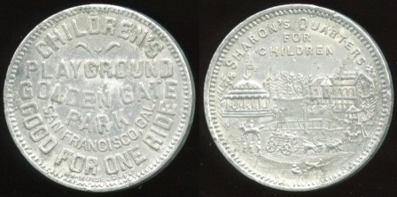

26 CHILDREN’S / PLAYGROUND / GOLDEN GATE / PARK / SAN FRANCISCO, CAL. / GOOD FOR ONE RIDE / (sm: L.H. MOISE. S.F.) // Sharon’s Quarters / For / Children / (park scene), al rd 29mm. CA 760A $80. ………………………………….…... G4-MB $80

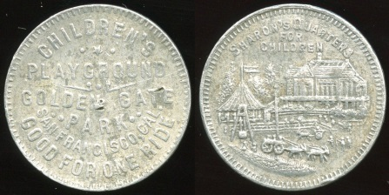

27 CHILDREN’S / PLAYGROUND / GOLDEN GATE / PARK / SAN FRANCISCO, CAL. / GOOD FOR ONE RIDE // Sharon’s Quarters / For / Children / (park scene), al rd 29mm. CA 760B $65. ……………………..….. G3-MB $65

===== Colorado =====

28 CO 690B $25 Manitou Springs …………………………………….... G5-MB $25

===== Florida =====

29 FL 300D $20 Gainesville ….. G3-MB $20

30 FL 380C $10 Jacksonville …. G3-MB $10
31 FL 380F $25 ……….…........... G3-MB $25

32 FL 380G $25 ……….………... G3-MB $25
33 FL 380H $10 ……….……....... G3-MB $10

34 FL 380J $10 ………..……...... G3-MB $10

===== Georgia =====

35 GA 360B $15 East Point .….. G2-MB $15

===== Idaho =====

36 ID 440A $25 Lewiston ……... G3-MB $25

37 ID 440E $25 ……..………..…. G3-MB $25

38 ID 440G $12.50 ………..... G3-MB $12.50

39 ID 440H $20 ………..……..…. G4-MB $20

40 ID 440I $25 ……………..……. G4-MB $25

41 ID 440J $10 ……………....…. G4-MB $10

===== Illinois =====

42 IL 150C $25 Chicago …….… G5-MB $25

43 IL 150I, thick $40 ………….… G3-MB $40

44 IL 150I, thin $40 ………..….… G4-MB $40

45 IL 150W $35 ……………….… G4-MB $35

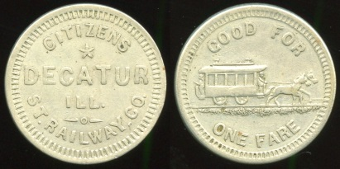

46 CITIZENS / DECATUR / ILL. ST. RAILWAY, CO. // Good For / (horsecar) / One Fare, wm rd 23mm. IL 195B $150. Recut die provides the comma before CO. G5-MB $150

47 IL 220B $40 Dogtown Ferry G5-MB $40

48 IL 220C $50 .……………..….. G5-MB $50

49 IL 220E $35, dings .………..... G2-MB $35
50 IL 235A $10 East Dubuque .. G3-MB $10

51 IL 235C $20 ………................ G4-MB $20

52 IL 235D $20 ……………......... G5-MB $20

53 IL 305A $20 Forest Park …... G5-MB $20

54 IL 305B $15 ………..……....... G5-MB $15

55 IL 320A $20 Freeport ………. G4-MB $20

56 IL 320B $10 ……………….…. G3-MB $10

57 IL 320C $10 …………...….…. G3-MB $10

58 IL 460A $40 Kankakee ......... G4-MB $40

59 IL 460B $25 …...………....….. G5-MB $25

60 IL 460C $15 …...…………….. G4-MB $15

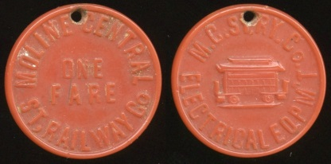

61 MOLINE CENTRAL / ONE / FARE / ST. RAILWAY CO // M.C. St .Ry. Co. / (streetcar) / Electrical Eqpm’t, carmine ce rd 23mm, hole added 12:00. IL 580A $100 …. G4-MB $100

62 IL 580B $60 …..…………..…. G5-MB $60

63 IL 580C $60 …..………..….… G3-MB $60

64 IL 580D $60 ……….........…… G4-MB $60

65 IL 600C $45 Mt. Carmel ….... G5-MB $45

66 IL 720A $40 Quincy .............. G4-MB $40

Bid the amount you are willing to pay for each lot—there will be no bid reduction except for bids of $250 or greater.

Illustrations are of the actual lot, but may not be actual size for larger items—check the listing itself for size information or see color images at http://collector-ca.smugmug.com

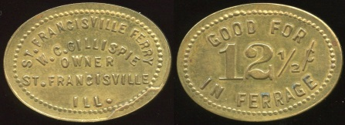

67 ST. FRANCISVILLE FERRY / W.C. GILLISPIE / OWNER / ST. FRANCISVILLE / ILL. // Good For / 12½¢ / In Ferrage, br ov 31x22mm. IL 768C $90 …….….. G5-MB $90

68 IL 795A $15 Springfield ….... G5-MB $15

69 IL 795B $15 …..… …..…........ G3-MB $15

70 IL 795E $20 ………...…....….. G4-MB $20

71 IL 795F $25 ………...…....….. G4-MB $25

72 IL 999V $15, coppery Passes G2-MB $15

===== Indiana =====

73 IN 85A $35 Bedford……….... G5-MB $35

74 IN 85B $35 …………..…..….. G4-MB $35

75 IN 180A $20 Columbus ........ G5-MB $20

76 IN 275A $50 Enterprise ……. G3-MB $50

77 IN 275B $60 …………............ G4-MB $60

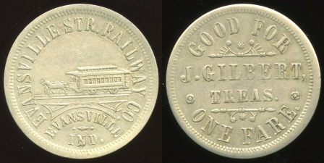

78 EVANSVILLE STR. RAILWAY CO. / (horsecar) / EVANSVILLE / IND. // Good For / J. Gilbert, / Treas. / One Fare., wm rd 25mm. IN 280A $75 ……….................…. G4-MB $75

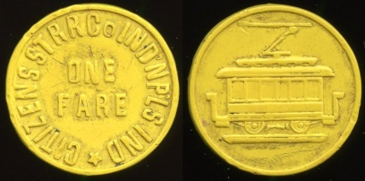

79 CITIZENS ST RR CO INDNPLS IND / ONE / FARE // (streetcar), yellow ce rd 22mm. IN 460A $500 ….......................…... G4-MB $500

80 IN 510A $50 Kokomo …….... G4-MB $50

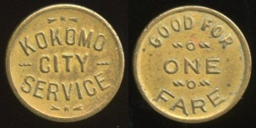

81 KOKOMO / CITY / SERVICE // Good For / One Fare, br rd 16mm. IN 510C $75 ……………………………………… G4-MB $75

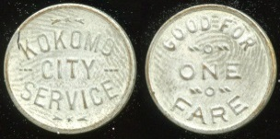

82 KOKOMO / CITY / SERVICE // Good For / One Fare, wm-washed br rd 16mm. IN 510D $85 …………………….………….. G4-MB $85

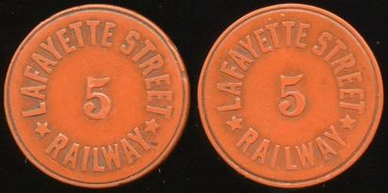

83 LAFAYETTE STREET / 5 / RAILWAY // (same), brownish red ce rd 23mm. IN 520A $75. ............................................. G3-MB $75

84 IN 650A $15 Mount Vernon G3-MB $15

85 IN 650B $15 …………………. G3-MB $15

86 IN 930C $15 Vincennes ….... G3-MB $15

87 IN 960B $15 Washington ….. G5-MB $15

88 IN 980E $10 Whiting ……..... G4-MB $10

===== Iowa =====

89 IA 30C $60 Ames ................. G4-MB $60

90 IA 150A $15, holed; 150B $10 Cedar Rapids Lot of 2 pcs. ..……….…. G3-MB $25

91 IA 390A $15 Fort Madison … G3-MB $15

92 IA 390B $15 ……….……........ G4-MB $15

93 IA 640L $50 Muscatine …..... G4-MB $50

94 IA 640M $50 ………………….. G3-MB $50

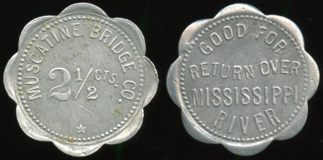

95 MUSCATINE BRIDGE CO. / 2½ CTS. // Good For / Return Over / Mississippi / River, al sc-8 29mm. IA 640O $75 ….…... G4-MB $75

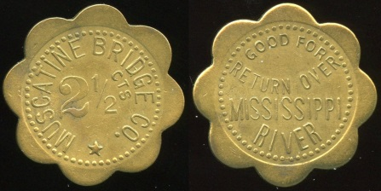

96 MUSCATINE BRIDGE CO. / 2½ CTS. // Good For / Return Over / Mississippi / River, br sc-8 29mm. IA 640Qc $75 …...... G5-MB $75

97 IA 640Sb $20 ………………... G4-MB $20

===== Kansas =====

98 KS 40E $20 Atchison ………. G4-MB $20

99 KS 550Aa $35 Leavenworth G4-MB $35

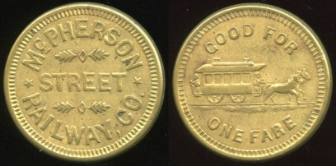

100 MCPHERSON / STREET /RAILWAY, CO. // Good For / (horsecar) / One Fare, br rd 23mm. KS 640D $125 ………... G5-MB $125

===== Kentucky =====

----- Louisville -----
101 KY 510O $10 ……..….…….. G5-MB $10

102 KY 510Q $30 ……….….…... G4-MB $30

103 KY 510R $60 ………...…….. G3-MB $60

104 KY 510U $50 …………...….. G4-MB $50

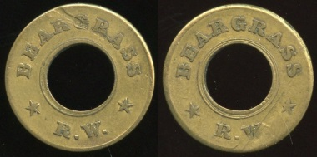

105 BEARGRASS / (c/ham) / R.W. // (same), br rd 21mm, scrape both O&R. KY 510Z $85. ………………………………..…….. G2-MB $85

106 KY 510AB $50, edge clip .... G3-MB $50

107 KY 510AC $35 ……………... G3-MB $35

108 KY 510AW $15 ………...….. G4-MB $15

109 KY 510AX $15 ..………….... G3-MB $15

110 KY 510AY $15 …….....……. G3-MB $15

111 KY 510BG $10 …................. G4-MB $10
----- Louisville Concluded -----

112 KY 680H $25 Paducah …… G3-MB $25

113 KY 680I $25 ………..…..…... G3-MB $25

114 KY 710A $10 Pikeville...…... G5-MB $10

===== Maryland =====

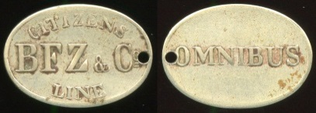

115 CITIZENS / BFZ & CO / LINE // Omnibus, (Baltimore), wm ov 22x16mm, small hole 3:00. MD 60B $150. ...………………... G3-MB $150

116 MD 60K $10 ………….….…. G5-MB $10

117 MD 60L $12.50 ............... G3-MB $12.50

118 MD 60M $12.50 ……....... G4-MB $12.50

119 MD 60N $15….…………..….. G4-MB $15

120 MD 60X $35 ………….....…. G3-MB $35

121 MD 60Z $10 ……..….…...…. G3-MB $10

122 MD 300A $10 Chevy Chase G4-MB $10

123 MD 940A $20 Towson ….... G3-MB $20

124 MD 940C $20 …………….... G4-MB $20

===== Massachusetts =====

125 MA 260A $20 Fall River ….. G4-MB $20

126 MA 505A $10 Milford ……... G3-MB $10

127 MA 505B $30 …………….… G4-MB $30

128 MA 550C $10 New Bedford G3-MB $10

129 MA 550D $10 ………………. G4-MB $10

130 MD 550K $12.50 ………... G3-MB $12.50

131 MA 550P $35 …………..…... G5-MB $35

===== Michigan =====

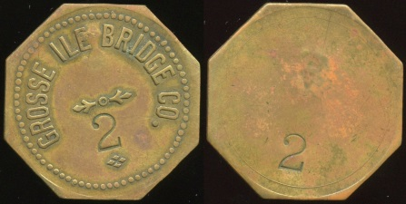

132 GROSSE ILE BRIDGE CO. // (c/s), br oc 36mm. MI 395Aa-2 $75 ..…........ G3-MB $75

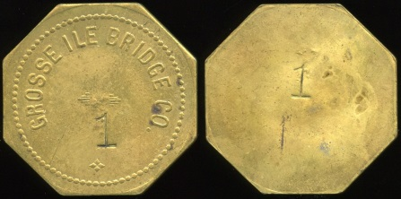

133 GROSSE ILE BRIDGE CO. // (c/s), br oc 39mm. MI 395Ba-1 $75 ………... G3-MB $75

134 MI 395Bb-3 $10 ………...…. G4-MB $10

135 MI 395C-2 $35 …………..…. G4-MB $35

136 MI 395C-4 $35 ………..……. G4-MB $35

137 MI 395D-1 $15 ………..……. G4-MB $15

138 MI 395E $30 ……….....……. G4-MB $30

139 MI 470Ba $15 Houghton …. G3-MB $15

140 MI 470Bb $15, pc missing ... G1-MB $15

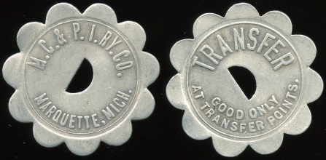

141 M.C. & P.I. RY. CO. / (c/o sm) / MARQUETTE, MICH. // Transfer / (c/o) / Good Only / At Transfer Points., al sc-11 35mm. MI 605Ab $75 ………….……...…….. G4-MB $75

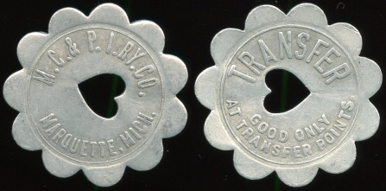

142 M.C. & P.I. RY. CO. / (c/o ht) / MARQUETTE, MICH. // Transfer / (c/o) / Good Only / At Transfer Points., al sc-11 35mm. MI 605Bb $75 …………….…...…….. G3-MB $75

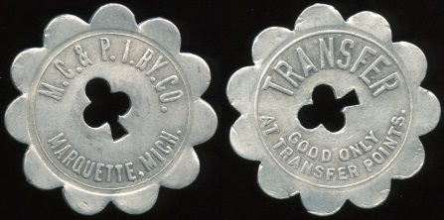

143 M.C. & P.I. RY. CO. / (c/o club) / MARQUETTE, MICH. // Transfer / (c/o) / Good Only / At Transfer Points., al sc-11 35mm. MI 605Db $100 …………,,………… G3-MB $100

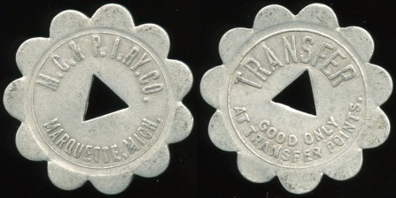

144 M.C. & P.I. RY. CO. / (c/o tri) / MARQUETTE, MICH. // Transfer / (c/o) / Good Only / At Transfer Points., al sc-11 35mm. MI 605Fb $75 ……………………… G3-MB $100

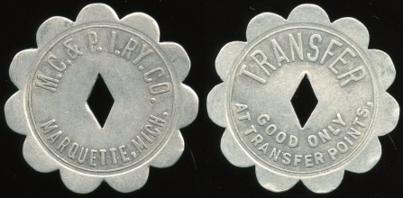

145 M.C. & P.I. RY. CO. / (c/o dd) / MARQUETTE, MICH. // Transfer / (c/o) / Good Only / At Transfer Points., al sc-11 35mm. MI 605Ha $85 ………………..……… G3-MB $85

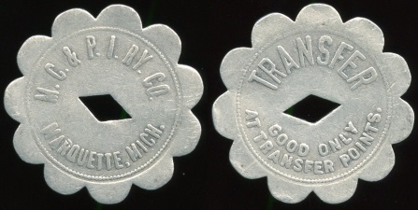

146 M.C. & P.I. RY. CO. / (c/o dd) / MARQUETTE, MICH. // Transfer / (c/o) / Good Only / At Transfer Points., al sc-11 35mm. MI 605Hc $85 ………………..……… G3-MB $85

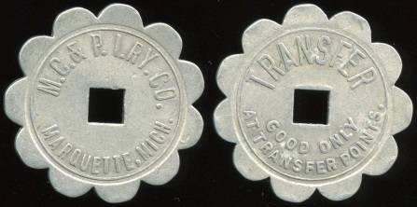

147 M.C. & P.I. RY. CO. / (c/o sq) / MARQUETTE, MICH. // Transfer / (c/o) / Good Only / At Transfer Points., al sc-11 35mm. MI 605Ia $75 ……………..…..……… G3-MB $75

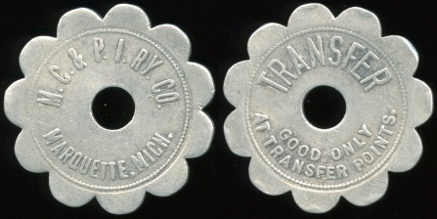

148 M.C. & P.I. RY. CO. / (c/h) / MARQUETTE, MICH. // Transfer / (c/h) / Good Only / At Transfer Points., al sc-11 35mm. MI 605Jc $75 …………….…..……… G3-MB $75

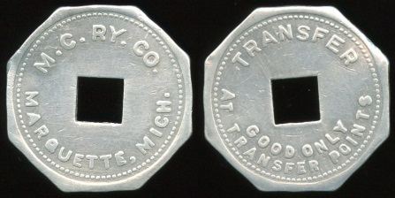

149 M.C. RY. CO. / (c/o sq) / MARQUETTE, MICH. // Transfer / (c/o) / Good Only / At Transfer Points, al oc 25mm. MI 605Kb $75 ……………………………………… G3-MB $75

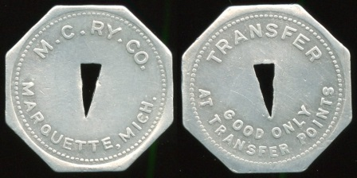

150 M.C. RY. CO. / (c/o tri) / MARQUETTE, MICH. // Transfer / (c/o) / Good Only / At Transfer Points, al oc 25mm. MI 605La $75 ……………………………………… G3-MB $75

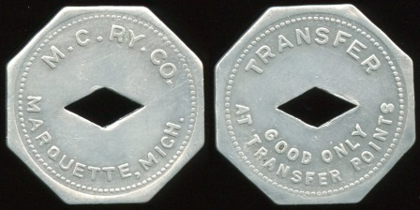

151 M.C. RY. CO. / (c/o dd) / MARQUETTE, MICH. // Transfer / (c/o) / Good Only / At Transfer Points, al oc 25mm. MI 605Ma $75 ……………………………………… G4-MB $75

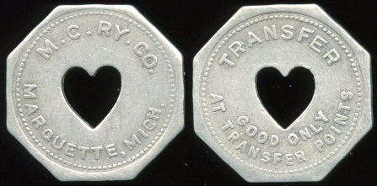

152 M.C. RY. CO. / (c/o ht) / MARQUETTE, MICH. // Transfer / (c/o) / Good Only / At Transfer Points, al oc 25mm. MI 605Oa $75 ……………………………………… G3-MB $75

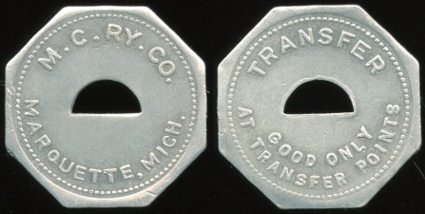

153 M.C. RY. CO. / (c/o sm) / MARQUETTE, MICH. // Transfer / (c/o) / Good Only / At Transfer Points, al oc 25mm. MI 605Pa $75 ……………………………………… G4-MB $75

===== Minnesota =====

154 MN 540A $25, holed Minneapolis ……………………………………… G2-MB $25

155 MN 540Cb $20 …………….. G3-MB $20

===== Mississippi =====

156 MS 720E $10, 5mm sq c/o Pascagoula …………………………………….... G3-MB $10

157 MS 720E $10, 6mm sq c/o.... G5-MB $10

158 MS 720Fa $10 ..………….... G3-MB $10

===== Missouri =====

159 MO 140A $30 Cape Girardeau ……...........................................…. G5-MB $30

160 MO 440R $15 Kansas City G5-MB $15

161 MO 440S $15 ……..….……. G5-MB $15

===== Nebraska =====

162 NE 360B $30 Fremont ….… G3-MB $30

163 NE 700E $30 Omaha ..…... G4-MB $30

===== New Hampshire =====

164 NH 30A $20 Andover ….… G5-MB $20

===== New Jersey =====

165 NJ 185A $60, military Dover G4-MB $60

166 NJ 185B $60, military …….. G4-MB $60

167 NJ 185C $60, military …..... G5-MB $60

168 NJ 997I $30 Zone Checks .. G4-MB $30

169 NJ 997J $30 ……..…………. G4-MB $30

170 NJ 997L $30 …….…………. G5-MB $30

===== New Mexico =====

171 NM 810A $10 Santa Fe .…. G5-MB $10

172 NM 810B $10 ...…...……….. G5-MB $10

173 NM 810C $10 …..…….....…. G4-MB $10

===== New York =====

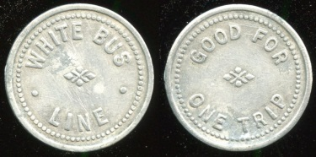

174 WHITE BUS / LINE // Good For / One Fare, (Binghamton), al rd 20mm. NY 10M $75 ………………………………...……. G4-MB $75

175 NY 300A $50 Geneva ...….. G4-MB $50

176 NY 385A $20 Hudson......... G4-MB $20

177 NY 629C $10 Brooklyn …... G3-MB $10

178 NY 629H $10 ……………..... G3-MB $10

179 NY 629I $15 ………….…..... G4-MB $15

180 NY 629K $10 ……………..... G4-MB $10

181 NY 629KA $35 ……….…..... G5-MB $35

182 NY 630La $35 Manhattan .. G4-MB $35

183 NY 630Lb $50, rim damage G2-MB $50

184 NY 630Lc $20 ……….…...... G3-MB $20

185 NY 630Ld $40 ……….…...... G4-MB $40

186 NY 630V $45 ………...…...... G5-MB $45

187 NY 695A $15 Oswego ….... G4-MB $15

188 NY 780Ba $17.50 Rochester ….............................................. G3-MB $17.50

189 NY 730Bb $17.50 ........... G3-MB $17.50

190 NY 780C $45 ……....…….… G4-MB $45

191 NY 945A $12 Watertown … G3-MB $12

===== North Carolina =====

192 NC 160A $20 Charlotte .. … G5-MB $20

193 NC 710A $17.50 Roxboro G3-MB $17.50

===== Ohio =====

194 OH 15A $17.50 Alliance G3-MB $17.50

195 OH 15B $17.50 ………… G4-MB $17.50

196 OH 35B $30 Athens ........… G4-MB $30

197 OH 35C $10 ………………... G4-MB $10

198 OH 125B $25 Canton …….. G4-MB $25

199 OH 125C $20 ….…….......… G5-MB $20

200 OH 166A $30 Cincinnati CW G3-MB $30

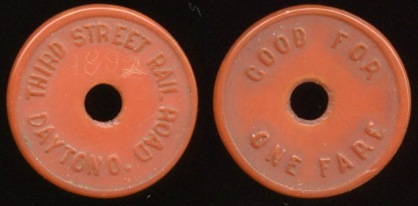

201 THIRD STREET RAIL ROAD / (c/h) / DAYTON O. // Good For / (c/h) / One Fare, carmine ce rd 23mm, 1882 lightly scratched onto O. OH 230D $75 …..…....... G3-MB $75

202 OH 230H $50 ……..…......… G5-MB $50

203 OH 230P $20 …..………..…. G3-MB $20

204 OH 230Q $20 ……….....…... G5-MB $20

205 OH 440B $25 Lancaster ..... G4-MB $25

206 OH 475D-28 $12.50 Lorain ………………………………..… G3-MB $12.50

207 OH 475D-29 $12.50 …… G3-MB $12.50

208 OH 475D-30 $12.50 …… G3-MB $12.50

209 OH 660B $25 North Olmstead ……………………………………… G3-MB $25

210 OH 660C $20 …………….... G4-MB $20

211 OH 660D $20 …………….... G4-MB $20

212 OH 860Bb $20 Toledo …… G3-MB $20

===== Oklahoma =====

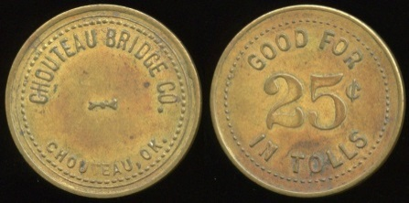

213 CHOUTEAU BRIDGE CO. / CHOUTEAU, OK. // Good For / 25¢ / In Tolls, br rd 28mm. OK 190C $200 ……………..…... G4-MB $200

214 OK 380B $10 Guthrie Adult crossed out, written by company: UNDER / 12 / CHILD Scarce! …………………………... G3-MB $10

215 OK 380C $10 reprint blue. ... G5-MB $10

216 OK 610A $20 Norman ……. G4-MB $20

217 OK 610B $10 ..……….….…. G4-MB $10

218 OK 860D $15 Tulsa ………. G4-MB $15

===== Oregon =====

219 OR 80B $20 Baker …….…. G4-MB $20

220 OR 160D $20 Corvallis …... G4-MB $20

221 OR 160F $20 ……….......…. G5-MB $20

222 OR 160G $20 ……….......…. G5-MB $20

223 OR 340A $17.50 Hood River …………………………………... G5-MB $17.50

224 OR 420A $15 La Grande … G3-MB $15

===== Pennsylvania =====

225 PA 15C $40 Allentown …… G5-MB $40
.
226 PA 15N $15 …………......…. G4-MB $15

227 PA 180A $20 Charleroi ..…. G4-MB $20

228 PA 195A $50 Clairton …..... G4-MB $50

229 PA 195B $25 …….….…....... G3-MB $25

230 PA 195D $20 …….….…....... G5-MB $20

231 PA 195E $20 …….….…....... G5-MB $20

232 PA 195F $15 …….….…....... G5-MB $15

233 PA 195I $20 …….…..…....... G5-MB $20

234 PA 195J $50 …….….…....... G4-MB $50

235 PA 400B $15 Freeland …... G3-MB $15

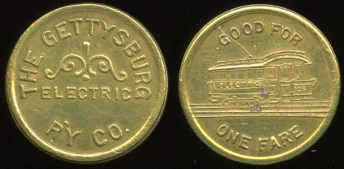

236 THE GETTYSBURG / ELECTRIC / R’Y CO. // Good For / (streetcar) / One Fare, br rd 23mm. PA 405A $75 ……..…….. G4-MB $75

237 PA 425A $30 Greentree …. G4-MB $30

238 PA 495A $60 Johnstown … G5-MB $60

239 PA 495B $60, scratches R .. G3-MB $60

240 PA 495C $60 …..……..….... G4-MB $60

241 PA 495F $50 …..….…..….... G3-MB $50

242 PA 515B $10 Kittanning ….. G4-MB $10

243 PA 526IA $20 Marietta & Maytown Turnpike ………………………….. G3-MB $20

244 PA 645A $20 Minersville …. G3-MB $20

245 PA 645B $30 .…………….... G3-MB $30

246 PA 725D $10 Oil City ..…… G3-MB $10
247 PA 725H $12.50 …..…… G3-MB $12.50

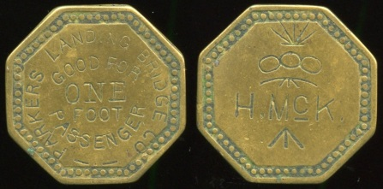

248 PARKER’S LANDING BRIDGE CO. / GOOD FOR / ONE / FOOT / PASSENGER // H. McK (all incuse O&R), br oc 26mm. PA 745D $75. ………………………... G3-MB $75

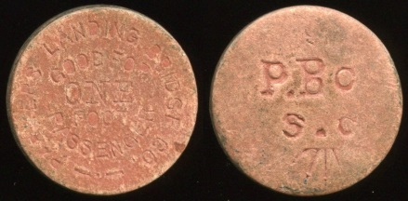

249 PARKER’S LANDING BRIDGE CO. / GOOD FOR / ONE / FOOT / PASSENGER // P. Bc / S. C (all incuse O&R), red fiber rd 24mm. PA 745E $75. …………... G3-MB $75

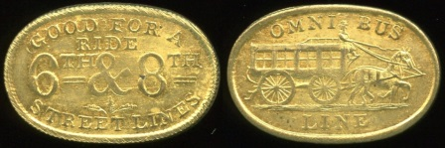

250 GOOD FOR A / RIDE / 6TH & 8TH / STREET LINES // Omni Bus / (horsecar) / Line, br ov 26x17mm. PA 750G $25 Gem condition! …………………………. G5-MB $25

251 PA 750L $50 ….……....….... G3-MB $50

252 PA 750N $50 ….……....….... G4-MB $50

253 PA 750O $45 ….……...….... G5-MB $45

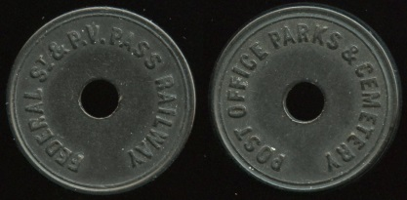

254 FEDERAL ST & P.V. PASS RAILWAY / (c/h) // Post Office Parks & Cemetery / (c/h), (Pittsburgh), black vu rd 23mm. PA 765I $85 ………………………………….…... G4-MB $85

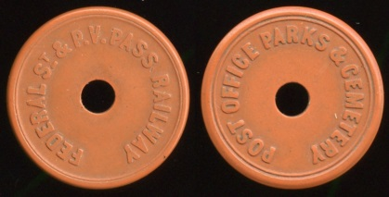

255 FEDERAL ST & P.V. PASS RAILWAY / (c/h) // Post Office Parks & Cemetery / (c/h), (Pittsburgh), brown vu rd 23mm. PA 765JI $75 ………………………………….…... G4-MB $75

256 PA 965Ca $15 W. Elizabeth G3-MB $15

257 PA 965Cb $30 ……...…....... G4-MB $30

258 PA 965Da $50 ……...…....... G3-MB $50

===== South Dakota =====

259 SD 260A $20 Deadwood .... G4-MB $20

260 SD 370A $35 Fort Meade, military ……………………………………… G3-MB $35
261 SD 370B $45, military …..... G5-MB $45
===== Tennessee =====

262 TN 375C $35 Jackson ….... G3-MB $35

263 TN 375D $50 ………………. G4-MB $50

264 TN 430A $12.50 Knoxville ………………………………….. G4-MB $12.50

265 TN 430B $15 ..…………....... G3-MB $15

266 TN 430Ga $20 ..……….…… G4-MB $20

267 TN 430Gb $20 ..……….…… G5-MB $20

268 TN 430H $20 ..……..….…… G5-MB $20
4
269 TN 710B $25 Oak Ridge …. G4-MB $25

===== Texas =====

270 TX 531C $35 Laredo ……... G4-MB $35

271 TX 531D $25 …….........…… G4-MB $25

272 TX 710C $45 Paris …….…. G4-MB $45

273 TX 710D $35 ………………. G4-MB $35

274 TX 890A $35 Taylor ….…… G3-MB $35

275 TX 965D $50 Weatherford G3-MB $50

276 TX 965J $25 ……………….. G5-MB $25

277 TX 965K $35 ..….…….....…. G5-MB $35

===== Vermont =====

278 VT 520A $10 Newport ..….. G4-MB $10

===== Virginia =====

279 VA 600G $15 Norton ..….... G3-MB $15

280 VA 600H $15 ……….....….... G3-MB $15

===== Washington =====

281 WA 300Aa $50 Everett .….. G4-MB $50

282 WA 340A $35 Grand Coulee G4-MB $35

283 WA 755A $20 Richmond Beach ……………………………………… G3-MB $20

===== West Virginia =====

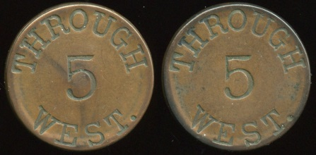

284 THROUGH / 5 / WEST. (a/i) // (same), (Wheeling), cu rd 28mm. WV 890D $100 …………………………………….. G3-MB $100

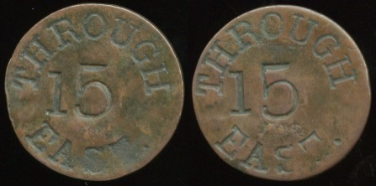

285 THROUGH / 15 / EAST. (a/i) // (same), cu rd 28mm. WV 890H $100 …….. G3-MB $100

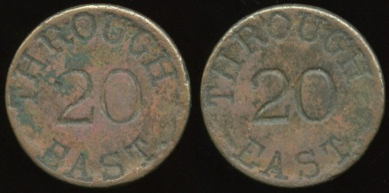

286 THROUGH / 20 / EAST. (a/i) // (same), cu rd 28mm. WV 890K $100 …….. G3-MB $100

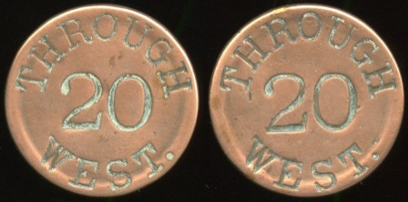

287 THROUGH / 20 / WEST. (a/i) // (same), cu rd 28mm. WV 890L $100 …. G3-MB $100

===== Wisconsin =====

288 WI 180E $40, porosity, dent Eau Claire ………………………………...……. G2-MB $40

289 WI 360Aa $60 La Crosse ... G4-MB $60

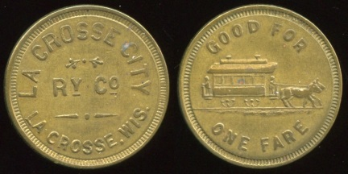

290 LA CROSSE CITY / RY CO / LA CROSSE, WIS. // Good For / (horsecar) / One Fare, br rd 24mm. WI 360B $100. ………………………….…………. G4-MB $100

291 WI 410A $35 Madison ……. G3-MB $35

292 WI 410B $15 ……………….. G4-MB $15

293 WI 410C $50 ……………….. G3-MB $50

294 WI 410E $10 ……………….. G4-MB $10

295 WI 410J $50 ………….…….. G4-MB $50

296 WI 440B $15 Marshfield …. G3-MB $15

297 WI 500B $50 Merrill ………. G4-MB $50

298 WI 510D $12.50 Milwaukee …………………………..…….... G5-MB $17.50

299 WI 510F $20, pitted ……….. G2-MB $20

300 WI 510H $10 .….........…….. G5-MB $10

301 WI 790A $15 Sheboygan ... G5-MB $15

302 WI 980A $20, dent Wisconsin Rapids ……………………………………... G3-MB $20

Bid the amount you are willing to pay for each lot—there will be no bid reduction except for bids of $250 or greater.

Please be sure your advance bids are submitted in time to meet the closing deadline of Saturday, November 30. No telephone bids will be accepted, but inquiries can be made about high bids for individual lots for which you have previously submitted written bids of $50 or greater and bid bumping of such bids will be allowed on Sunday, December 1.

Illustrations are of the actual lot, but may not be actual size for larger items—check the listing itself for size information or see color images at http://collector-ca.smugmug.com

In the event of a tie winning bid amount, the earliest submitted bid will be awarded the lot.

PART 2
SAN FRANCISCO
EXTRAVAGANZA!
This special section consists entirely of a wide variety of exonumia from San Francisco or closely related to that great “City by the Bay.”

MERCHANT TRADE TOKEN

303 B & R / SMOKE / SHOP / S.F. // Good For / 5¢ / In Trade, br rd 21mm. Listed SFO 80B15 R, 2K-2916. …………..…. G5-($8-$16)

304 COR. SECOND & MINNA STS. / C. & P. / BAR / (sm: PATRICK & CO. S.F.) // Good For / 5¢ / Drink, br rd 21mm. Listed SFO 80C8 R, 1K-456. ………………...……..…. G3-($8-$16)

305 1600 MARKET ST. / (monogram: CWH) / 1000 VALENCIA ST. // Good For / 1 / Drink, br rd 24mm. Listed 1K-632. ..….…. G5-($8-$16)
306 DUDLEY / STONE / SCHOOL // Bread / & / Milk, (San Francisco), al rd 21mm. Listed SFO 80D58 R, 1K-719. .............. G3-($8-$16)

307 FIORAYANTI / SOCIAL / CLUB / SAN FRANCISCO // Good For / One / Drink, br oc 21mm. Listed 1K-835.………..…. G5-($8-$16)

308 GOLDEN GATE / CAFE / FILLMORE / & / TURK STS. // Good For / 10c / In Trade, al rd 19mm. Listed 1K-970. ….…...... G5-($8-$16)

309 GOVE / CAL. & FILLMORE // (star), br rd 21mm. Unlisted! …………........ G3-($16-$32

310 HERBERT’S / (sm: MOISE S.F.) // (blank, 2 slots for telephone use), (San Francisco), br rd 21mm. Listed 1K-1104. ....... G4-($16-$32)

311 THE HOFBRAU / 1116 / FRANKLIN ST. / 5¢ / 18 OZ GLASS OF BEER // Good For / 5 / Cents / In Trade, br rd 21mm. Listed 1K-1126. ………..................................…….. G5-($8-$16

312 IRVINE / & / JACHENS / NAME PLATES / AND / BADGES / SAN FRANCISCO // Good Luck / (goose with egg inscribed: Golden) / Chain Coin 1935, al rd 17mm, die crack obverse. Listed SFO 80I20 R, 1K-1227. ………………………..………….. G5-($16-$32)

313 DROP THIS IN YOUR / TELEPHONE / & RING UP / KLINKNER / FOR / MORE / MAIN 403 // (uniface), br rd 21mm. Listed SFO 80K36 R. ……………........…...… G3-($8-$16)

314 DROP A NICKEL IN THE / SLOT / AND BUY YOUR / RUBBER / STAMPS ETC / OF / KLINKNER & CO. / 320 SANSOME ST. / S.F. // Red Rubber Stamps / Stencils / Steel Stamps / checks / Badges / Burning Brands Etc., bz rd 21mm. Listed SFO 80K38 R. ……………………………..........… G3-($8-$16)

315 DROP THIS IN YOUR / TELEPHONE / & RING UP / KLINKNER / FOR / MORE / MAIN 403 // (within shield: Made By / C.A. Klinkner / & Co. / 320 Sansome St. / S.F. Cal.), br rd 21mm. Listed SFO 80K40 R, 1K-1356. ………………………….......…...… G3-($8-$16)

316 C.A. KLINKNER & CO. / STENCILS / STEEL STAMPS / RUBBER / STAMPS / CHECKS, BADGES / AND / BOX BRANDS / 320 SANSOME ST. S.F. // (Lord’s Prayer), al rd 28mm. Listed SFO 80K50 V, 1K-1349, HK-246. ………………………..... G3-($8-$16)

317 AUGUST KOEHNCKE / 2808 / GREENWICH / ST. // 5¢ / In Trade, br rd 21mm. Unlisted! ..................…. G3-($8-$16)

318 CHARLIE LANDIS / 43 – 3RD ST. / SAN FRANCISCO // Good For / 25¢ / In Trade, br rd 24mm. Listed 2K-3696. ….....…. G5-($8-$16)

Each lot is expected to have a sales price of $10.00 or greater. A minimum bid of $5.00 applies to each lot unless specified otherwise.

319 PHONE MAIN 400 / MOISE / 320 / SANSOME ST. / THE MAN WHO / MAKES THESE / CHECKS // Good For / 5¢ / When You / Return With Bottle / (sm: L.H. Moise S.F.), al rd 25mm. Listed SFO 80M141 R. ………...…..…………………...… G4-($16-$32)

320 PHONE MAIN 400 / MOISE / THE MAN WHO / MAKES / THESE CHECKS // Good For / 5¢ / When You / Return With Bottle, al rd 25mm. Listed SFO 80M142 R, 1K-1717. ………….…..………………....… G4-($16-$32)

321 MOISE / KLINKER / CO. / STAMPS / STENCILS / SIGNS / SAN FRANCISCO (a/i) // (uniface), br rd 15mm. ……........ G5-($8-$16)

322 O.F. / CLUB / S.F. // Good For / 2½¢ / In Trade, al sc-12 22mm. Listed 2K-3993. …………………………..………… G3-($8-$16)
323 OCCIDENTAL BAR / 601 / MONTGOMERY ST. / COR. CLAY / SAN FRANCISCO, CAL. // Good For / 2½¢ / In Trade, br oc 26mm. Listed SFO 80O14 R, 2K-3988. …….……………….….…… G5-($8-$16)
324 OSTERLOH’S / ARCADE / ZEHLEINE // Good For / 1 / Cent / In Trade, br rd 20mm. Listed 2K-4035. ………………… G4-($8-$16)

325 OSTERLOH’S / PENNY / ARCADE // Good In / Penny / Machines, br rd 19mm. Listed SFO 80O49 V, 1K-1937. G3-($8-$16)

326 PATRICK AND MOISE-KLINKNER CO. / (figure) / PATCO / LUCKY / TOKEN / SAN FRANCISCO // Badges / Box Brands / Rubber Stamps / Stationers / Stencils / Checks / Signs, bz rd 34mm. Listed SFO 80P50 S, 1K-2056. …………………………………..… G3-($8-$16)

327 QUALITY CIGAR STORE / J.W. / LEVY / 198 / O’FARRELL ST / S.F. CAL. // Good For / 2½ / Cents / In Trade, al rd 19mm. Unlisted! …………………………..…....…. G3-($16-$32)

328 THE ROYAL BAR / 2356 / MISSION / STR. // Good For / One / Drink, br rd 21mm. Listed SFO 80R57 R, 1K-2247. G3-($8-$16)

329 STAR NOVELTY / 1167 / MA (c/o B) ET. / S.F. / MACHINE CO. / (sm: IRVINE S.F.) // Office / S. / (c/o) F / 25 / 1167 Mkt. St. / (sm: Irvine S.F.), wm rd 24mm. Listed SFO 80S121 R, 1K-2478. ……...…….……...… G3-($8-$16)

330 TULLY RUBBER STAMP WORKS / 82 / STEVENSON / ST. / SAN / FRANCISCO, / CAL. // Rubber Stamps / 10¢ / Per Line . Quick Service, br rd 21mm. Listed SFO 80T64 R, 1K-2600. …………………..…..… G4-($8-$16)

331 WESTERN NOVELTY CO. / 50 / IN TRADE // (4 horse bits), bz rd 31mm. Unlisted! ………….…..…..…..… G4-($8-$16)

332 Y-M-I / BUILDING / 50 / OAK ST. / SAN FRANCISCO // Redeemable In Merchandise / Y-M-I / 5c / Token, al rd 21mm. Listed SFO 80Y1 R, 1K-2799. ……….....…… G5-($8-$16)

333 Similar but 10c 18mm. Listed SFO 80Y2 V, 1K-2800. …………….......…… G5-($8-$16)

334 534½ / GEARY ST. / S.F. // (value 11 domino), al rd 21mm. Listed SFO 80#10 R, 1K-846. …………………......…… G5-($8-$16)

----- All-Different Multiple Piece Lots -----

335 Atlas Novelty Co. – 7 different pcs. ………………………………………..... ($8-$16)

336 B & L Novelty Co. – 9 different pcs. ………………………………………..... ($8-$16)

337 Bentham’s Novelties & Slot Machines – 4 different pcs. …………… ..…….....… ($8-$16)

338 Bradford Novelty Machine Co. – 13 different pcs. ….............................… ($8-$16)

339 Coast Novelty Co. – 8 different pcs. ……………………………………….…. ($8-$16)

340 Charles Fey & Co. – 10 different pcs. ………………………………………..… ($8-$16)

341 Klinkner stock tokens – 16 different pcs. ……………………...……………....… ($16-$32)

342 Mills Novelty Co. 5¢ size – 50+ different pcs. …...................................…...… ($16-$32)

343 Mills Novelty Co. 2 Bits & 4 Bits – 13 different pcs. ….....................…...… ($16-$32)

344 L.H. Moise telephone – 6 different pcs. ………………………………………….. ($8-$16)

345 Moise-Klinkner telephone – 30+ different pcs., varieties/designs. ….……..…. ($16-$32)

346 Novelty Machine Works – 15 different pcs. ……………………......…….....… ($8-$16)

347 Patrick & Co. – 20+ different pcs. ………………………………………… ($16-$32)

348 A.D. Renfro – 4 different pcs. ($8-$16)

349 Royal Novelty Co. – 20+ different pcs. ………………………………………… ($16-$32)

350 Western Novelty Co. – 4 different pcs. ………………………………………….. ($8-$16)

351 San Francisco token maker 1 to 3 letter legends – 50+ different pcs. .......… ($16-$32)

352 (Lot withdrawn)

MASONIC / FRATERNAL

353 SAN FRANCISCO LODGE #3 / (elk head) / B.P.O.E. // Grand Lodge / Convention / San Francisco / July 14-18 / 1963, al rd 32mm. Listed SFO 80E26 M, 1K-761. .. G4-($8-$16)

354 SAN FRANCISCO / (elk head) / B.P.O.E. LODGE #3 // National / Convention / San Francisco / July 12 To July 15 / 1970, purple al rd 29mm. Listed 2K-3278. .....… G5-($8-$16)

355 (incuse on Masonic keystone with 1 in center: S F/ CHP.) // One / Penny, cu rd 28mm. ….……………..............… G3-($8-$16)

356 SAN FRANCISCO CHAPTER NO 1 R.A.M. / ONE / PENNY / SAN FRANCISCO, CAL. // (Masonic symbols), cu rd 30mm. ………………..……………..…..… G4-($8-$16)

357 SAN FRANCISCO CHAPTER NO 1 R.A.M. / ONE / PENNY / SAN FRANCISCO, CAL. // (Masonic symbols), cu rd 31mm. Distinctively different die work from previous lot. ……………………………...… G5-($8-$16)

358 SAN FRANCISCO CHAPTER NO. 1, R.A.M. / CHARTERED JULY 28, / ONE / PENNY / 1854 / SAN FRANCISCO, CALIF. // (Masonic symbols), cu rd 32mm. G4-($8-$16)

359 CALIFORNIA CHAPTER NO 5 / (keystone) / R.A.M. // One / Penny, br rd 29mm. ……………………..…..… G4-($8-$16)

360 CALIFORNIA CHAPTER NO 5 R.A.M. / (CA State Seal design) . ONE PENNY // (ribbon panel) / A.I. 2385 / (to left: Chart / Ered) (Masonic keystone) (to right: Apr. 30, / 1855) / San Francisco, cu rd 31mm. .…. G4-($8-$16)

361 CALIFORNIA CHAPTER NO 5 R.A.M. / (CA State Seal design) . ONE PENNY // (ribbon panel) / A.I. 2385 / (to left: Chart / Ered) (Masonic keystone) (to right: Apr. 30, / 1855) / San Francisco, cu rd 31mm. Distinctively different die work from previous lot. .…………………………………….. G5-($8-$16)

362 Same, but (ribbon panel, incuse: R.J. Nasser. 10.4.21) …..……....….... G3-($8-$16)

363 Same, but (ribbon panel, incuse: O.J. Spindler) …….......................….. G3-($8-$16)

364 Same, but (ribbon panel, incuse: Charles H.J. Truman) ….………….....….. G3-($8-$16)

365 MISSION CHAPTER NO 79 R.A.M. / CONSTITUTED / APRIL 27, / (pyramid with symbols) / CHARTERED APR. 18 / A.I. 24 29 / SAN FRANCISCO // One / (Masonic symbols) / Penny, cu rd 30mm. ..……....… G4-($8-$16)

366 KING SOLOMON’S CHAPTER / (Masonic keystone with 95 in center) / R.A.M. // One / Penny, cu rd 31mm. ………….… G3-($8-$16)

367 GOLDEN GATE CHAPTER NO. 121, R.A.M. / CHARTER GRANTED MAY 10, / ONE / PENNY / 1917 / SAN FRANCISCO, CALIFORNIA // (Masonic symbols), cu rd 32mm. ………………………...… G4-($8-$16)

368 GOLDEN GATE CHAPTER NO 121, R.A.M. / (chest, two angels) / SAN FRANCISCO, CAL. // Chartered May 10, 1917. / (Masonic keystone) / One Penny, cu rd 31mm. ………………………....… G4-($8-$16)

369 MISSION LODGE NO. 169 / F. & A.M. / 1863-1963 / SAN FRANCISCO / CALIFORNIA / CENTENNIAL // (F&AM symbols), antiqued wm rd 35mm. .……..……..…...… G5-($8-$16)

370 MISSION LODGE NO. 169 / F. & A.M. / 1863-1988 / SAN FRANCISCO / 125TH. ANNIVERSARY // (F&AM symbols), antiqued bz rd 38mm. .……..…………...… G5-($8-$16)

371 ARGONAUT LODGE NO. 461 / F. & A.M. / (symbols) / SAN FRANCISCO // Reunion / Class / 1921 / May 28th 1925, cu rd 34mm. .……..…………………..…..…...… G5-($8-$16)

372 DISTRICT GRAND LODGE NO 4. I.O.B.B. / BENEVOLENCE BROTHERLY LOVE AND HARMONY / (Torah) / HONOR TOKEN // (I.O.B.B. emblem), wm rd 36mm. Bnai Brith. ..……………….…..… G3-($8-$16)

MEDAL

373 (Santa Fe logo) / SAN / FRANCISCO / CHIEF // Inaugural Trip / (front of locomotive inscribed: Santa Fe) / June 6, 1954, br rd 32mm. …………….…………...… G5-($8-$16)

374 OVER A CENTURY OF SERVICE / 1869 (rail spike) 1969 / SOUTHERN PACIFIC CO // (swirls), cu rd 26mm. ………...... G5-($8-$16)

375 SAN FRANCISCO NAVAL SHIPYARD / 27-OCT / NAVY DAY / 1947 // Our Service For Ships Means Ships For Service / (anchor), al rd 38mm. ………….…………...… G5-($8-$16)

376 AIRPOWER PANORAMA / AIR / FORCE / ASSOCIATION / 1955 / NORTHRUP / AIRCRAFT / INC. / SAN FRANCISCO, CALIF. // Lower Costs Mean More Air Force Per Dollar / (fighter plane) / Northrup / F-89D, al rd 32mm. ...…….……………………..…...… G5-($8-$16)

377 Similar but chrome-plated bz, thick, holed 12:00. …….…………..………..… G3-($8-$16)

378 AIR FORCE ASSOCIATION / (planet & space ship) / SAN FRANCISCO 1960 // (within oval: The / Marquardt / Corporation), al rd 38mm. …………….…………...… G3-($8-$16)

379 (extended loop) / WOMEN MARINES / (Marine Corps emblem) / SAN FRANCISCO 1968 / 25TH / 50TH ANNIVERSARY // (uniface), antiqued wm rd 29mm. G4-($8-$16)

380 Bay Area Rapid Transit: Trans-Bay Tube Last Section Lowered 1969; From Original Aluminum Steel Contact Rail 1970; Opening Festival 1973; 25th Anniversary of Transbay Service 1999. Lot of 4 pcs. ……………………………..…….. G5-($16-$32)

KNIGHTS TEMPLAR
29TH TRIENNIAL CONCLAVE – 1904

Note: Judging from the very impressive selection of attractive badges for this event being offered here, it must have been a well-attended and outstanding affair with participation from KT chapters all across the country. Each of these attractive, colorful, unusual, imaginative and often complex badges is pictured on my photo hosting site accessible at:
http://collector-ca.smugmug.com

381 Hanger: KT emblem // (pin); ribbon: black/white; badge: SAN FRANCISCO / SEPT. 1904 / EUREKA COMMANDERY / (cross) / 1835 / EUREKA, CAL. // (uniface), gilt imprint on wood, Maltese cross 63mm; overall 77x129mm. Highly unusual! G4-($16-$32)

382 Hanger: KT design // (pin); ribbon: black/white; badge: MARYSVILLE / COMMANDERY NO 7 / (attached cross/crown, red/gold) / MARYSVILLE, CALA. / SAN FRANCISCO SEPT. / 1904 // (incuse: The Pettibone Bros. / Mfg. Co. / Cin’ti O., wm shield 36x41mm; overall 50x104mm. G5-($16-$32)

383 Hanger: SAN FRANCISCO // (pin) / Newark, N.J.; badge: DEO ET VERITATE / (emblem) / NO. 11 OAKLAND KT // Triennial Conclave / (tree) / 1904, (CA), bz shield 43x51mm; overall 75x46mm. G5-($16-$32)

384 Hanger: SAN FRANCISCO / 1904 // (pin); badge: (bear) / (two knights on horse) / NO 1 / KT / CALIFORNIA COMMANDARY / (emblem) // (incuse: Shreve & Co. / San Francisco / Makers), (San Francisco CA), blue/green/red enamel on bz irr ov 36x42mm; overall 36x60mm. ………………..…….. G5-($16-$32)

385 Hanger: (bear) / GOLDEN GATE NO 15 K.T. / SAN FRANCISCO // (pin); badge: (bear) / (shield) / PAO ORDINE FIDE ET PATRIA // KT / CALIFORNIA COMMANDARY // (incuse: Shreve & Co. / San Francisco / Makers), (CA), bz 8-pt star 41x41mm; overall 41x57mm. ……………………………..…….. G5-($16-$32)

386 Badge: SAN FRANCISCO / SEPT. 1904. / PACIFIC COMMANDERY NO 3 / (figures w/upraised arms) / SONORA, CAL. // (pin) / The / Whitehead & Hoag Co. / Newark, N.J.; w/hanging (bear), bz shield 37x40mm; overall 37x61mm. ......…………...…….. G5-($16-$32)

387 Hanger: COLORADO // (pin) / The Whitehead & Hoag Co. / Newark, N.J.; ribbon: black/white w/gold imprint: SAN FRANCISCO / 1904; badge: GRAND COMMANDERY / K.T. / COLORADO / ORGANIZED / (cross & crown) / MARCH 14, 1876 // (Maltese cross emblem), (Denver), bz rd 38mm; overall 50x100mm. ………………………………….… G5-($16-$32)

388 Hanger: (cross) / NEW HAVEN NO 2 / CONN. // (pin); badge: (incuse: 1904) / 29TH TRIENNIAL / CONCLAVE / (enameled design w/wording) / SAN FRANCISCO / CAL. / 1904 / bz Maltese cross 35x35mm w/hanging wooden oval ball; overall 35x87mm. ….. G5-($16-$32)

389 Hanger: (bear) / SAN FRANCISCO // (pin); badge: (cross/crown) / DISTRICT OF COLUMBIA / (shield w/eagle) / KNIGHTS TEMPLAR // (incuse: C.C. Braxmar Co. / 10 / Maiden Lane / New York), bz Maltese cross 39x39mm; overall 44x67mm. .. G5-($16-$32)

390 Hanger: LINCOLN PARK COM’DY. / NO. 64 K.T. CHICAGO // (pin); ribbon: black/white, additional ribbon included appears as though it was the original ribbon inscribed in gold: TWENTY-NINTH / TRIENNIAL / SAN FRANCISCO / 1904 ; badge: TRIENNIAL ENCAMPMENT SAN FRANCISCO / (red-enameled cross inscribed HOG / IN SIGNO / VINCES) / 1904 // (uniface), gilt br irr rd 32mm; overall 35x81mm. ..……..…….. G4-($16-$32)

391 Hanger: (crown) / K 29TH TRIENNIAL CONCLAVE T / SAN-FRANCISCO, CAL. SEPT. 1904 // (pin); badge: PORTLAND COMDY, NO 2 / (complex design) / PORTLAND, MAINE // (incuse: J.A.M. & Co.); gilt bz Maltese cross 39x39mm; overall 43x66mm. ………………..…….. G5-($16-$32)

A dollar amount range is provided is for bidding guidance only. Lots may sell for at a level above or below the indicated amount.

392 Hanger: (cross & crown) / BOSTON COMMANDARY / K T // (pin) / (incuse: Geo. E. Homer / Boston, Mass.); badge: 29TH TRIENNIAL CONCLAVE / 19 (harbor scene) 04 / SAN FRANCISCO // (uniface),(MA), br embossed pot 34x35mm; overall: 36x55mm. ………………………………....... G5-($16-$32)

393 Hanger: JOSEPH WARREN / BOSTON COMMANDARY // (pin) / (incuse: Boston Regalia Co.); badge: SAN FRANCISCO / (ornate KT emblem) / 1904 // (uniface), (MA), wm 31x39mm; overall 35x54mm. ………………………………….... G4-($16-$32)

394 Hanger: (cap) / (swords) / SAN FRANCISCO / 1904 (black/white enameled) // (pin); badge: CAMBRIDGE COM’D’Y / K (green/white/black enamel tree / WASHINGTON ELM) T / NO. 42 // The / C.M. Robbins Co. / Makers / Attleboro, Mass. / U.S.A.,(MA) , bz Maltese cross 32x32mm; overall 51x58mm. ……....…….. G5-($16-$32)

395 Hanger: (crown) / COEUR DO LION // (pin); badge: COMMANDERY / K T (red enamel) / (wm monument attached) / CHARLESTOWN, MASS. / SAN FRANCISCO CALIFORNIA / 1904 // (incuse: F.I. Gorton / S. Attleboro, Mass. / Maker.), irr ov 36x54mm; overall 45x76mm. ……....…….. G4-($16-$32)

396 Hanger: HIGH DE PAYENS (black enamel) // (pin); badge: COMMANDERY / TRIENNIAL / 29TH / (shield) / ENCAMPMENT / 1904 / FORWARD / MELROSE MASS. // (uniface), red/white/black enamel bz Maltese cross 28x28mm; overall 38x58mm. ……......................................….. G4-($16-$32)

397 Hanger: (on cross shape: 29TH / TRIENNIAL / CONCLAVE / 1904) // (pin); badge: (cross) / GRAND COMDY. STATE OF MICHIGAN / (MI State Seal) // (uniface), br 8-pt star 44x50mm; overall 93x50mm. ……………………………..…….. G5-($16-$32)

398 Hanger: (ear of corn inscribed: NEBRASKA) // (pin); ribbon: (black/white w/green imprint: SAN FRANCISCO / SEPT. 5-9 / 1904; badge: MOUNT TABOR COMMANDERY / NO. 9 / K (shield, cross w/inscription) / DOMINUS IN OMNIBUS / FREMONT, NEBRASKA // (NE State Seal), bz rd 35mm; overall 48x93mm. …. G4-($16-$32)

399 Hanger: CIN’TI / CINCINNATI / REED / DAYTON / PALESTINE / SPRINGFIELD / GRAND ENCAMPMENT / OF / KNIGHTS TEMPLARS / SAN FRANCISCO 1904 // (pin); ribbon: black/white; badge: embossed 8-point star, attached OHIO, seals for Cincinnati, Palestine, and Reed, 72x72mm; overall 72x140mm. Impressive! ….... G5-($16-$32)

400 Hanger: (variety of emblems of OR) // (pin) / The Whitehead & Hoag Co. / Newark, N.J.; badge: 1904 / K (seal for GRAND COMMANDERY / OREGON) T / SAN FRANCISCO // The Whitehead & Hoag Co. / Newark, N.J., bz cross 35x47mm; overall 44x73mm. ..……………...…….. G5-($16-$32)

401 Hanger: (bear) / SAN FRANCISCO 1904 // (pin); badge: (helmet) / ALLEN / KNIGHTS TEMPLAR / (emblem) / ALLENTOWN. PA. / COMRY NO 20 // (incuse: The / C.C. Braxmar Co. / 10 / Maiden Lane / New York), bz ornate Maltese cross 33x42mm; overall 39x67mm. ………………………….………... G5-($16-$32)

402 (ashtray, embossed) (cross & crown) / 29TH TRIENNIAL CONCLAVE / 1904 / SAN FRANCISCO, CAL. / PITTSBURGH COMMANDERY NO 1. K.T. / WARRANTED-GENUINE / (logo MF) / ROOFING TIN // (blank), tin re 119X81mm. …... G5-($16-$32)

Bid the amount you are willing to pay for each lot—there will be no bid reduction.

403 Hanger: SAN FRANCISCO / 19 (CA State Seal) 04 // (pin); badge: BALDWIN / COMDY. / NO 22 / WILLIAMSPORT, / (Maltese cross emblem) / PENNA. // (uniface, antiqued wm keystone 38x45mm; overall 49x73mm. ………………….…... G4-($16-$32)

404 Hanger: PAWTUCKET / R I / HOLY SEPULCHER / K (lamb) T / COMMANDERY / 8; badge: SAN FRANCISCO ’04 / (large building) / OLD SLATER MILL / 1793 / FIRST COTTON MILL / IN AMERICA // (incuse: C.M. Robbins Co. / Makers / Attleboro. Mass. U.S.A., br shield 41x45mm; overall 41x84mm. …………………………….……... G4-($16-$32)

405 Previous 24 lots (381 through 404) as a single collection lot. A winning bid for this lot must exceed the total of high bids for the 23 lots included. A rare opportunity! Collection of 23 pcs. …..…….……... G4/5-($500-$1000)

PPIE & RELATED 1915

406 Pinback badge: FOR PRESIDENT ROBERT H. BEAN / (head of man) // (pin) /, backpaper The Whitehead & Hoag Co., sepia celluloid rd 32mm; ribbon: blue, inscribed in white: BOSTON / CHAPTER / A.I.B. / SAN FRANCISCO / 1915; badge: (MA State Seal, enameled white/blue) // The Whitehead & Hoag Co. / Newark, N.J., br sc-8 37mm; overall 37x105mm. AIB = American Institute of Banking. Most unusual construction, gem condition! ……………………... G5-($16-$32)

407 Hanger: EXPOSITION / EISTEDDFOD / SAN FRANCISCO // (pin); badge: Y GWIR YN ERBYN Y BYD / (four circular designs), rd 44mm; overall multicolor imprint, 65x44mm. ……………………………………. G5-($16-$32)

408 Hanger: GOLDEN JUBILEE / UNITED ANCIENT ORDER OF DRUIDS / 1915 / SAN FRANCISCO // (pin); badge: (very ornate design) // (incuse: The Albert C. Gamler Co. / Jewelers / San Francisco, br shield 37x42mm; overall 50 x73mm. ……………. G5-($16-$32)

409 Hanger: (mission bell tower) / GENERAL GRAND CHAPTER / SAN FRANCISCO 1915 // (pin); ribbon: red; badge: (two part [1] GRAND CHAPTER OF NEW YORK, / (sunset) // (incuse: Dieges & Clust / Makers, triangle w/red enamel, [2] embossed eagle, standing figures, shield w/enamels; overall 47x134mm. Possibly Order of the Eastern Star, Order of Triangles. ………………………. G5-($16-$32)

410 Hanger: (bear) / SAN FRANCISCO / 1915 // (pin); badge; (designs and extensive fine wording) // Replica / Of / Pike’s Peak Plate / Souvenir / Triennial Assembly / 1915., bz tri 32x27mm; overall 63x32mm. G5-($16-$32)

411 Hanger: (bear) / I.O.O.F. 1915 // (pin); badge; (ornate design with FLT) // Sovereign / Grand Lodge / I.O.O.F. / Souvenir / 91st Session / San Francisco / Sept. / 1915 (small: Greenduck Co.), wm irr ov 36x46mm; overall 36x82mm. ……………….……... G4-($16-$32)

412 Hanger: (eagle) / SAN FRANCISCO / 19 15 / K. OF P. // (pin); ribbon: blue/yellow/red printed in gold: REPRESENTATIVE K OF P / GRAND LODGE; badge: PANAMA PACIFIC INTERNATIONAL EXPOSITION / 1915 / (city, bay scene) / SAN FRANCSICO // The Albert S. Samuels Co. / Jewelers / San Francisco., br rd 33mm; overall 48x89mm. …….. G4-($16-$32)

Please be sure your advance bids are submitted in time to meet the closing deadline of Saturday, November 30. No telephone bids will be accepted, but inquiries can be made about high bids for individual lots for which you have previously submitted written bids of $50 or greater; bid bumping of such bids will be allowed on Sunday, December 18.

413 Hanger: (bear) / RINCON PARLOR / (shield w/blue enamel: NSGW / 72) // (pin) / (bar suggesting there may have originally been a ribbon); badge: 19 SAN FRANCISCO 15 / ADMISSION DAY / (shield w/white enamel, bear) / (seal: building / OLD SAILORS HOME) (seal: building / MAIL DOCK) / (seal: building / FERRY BUILDING) // (incuse: Shreve & Co.), br irr ov 41x50mm; overall 55x91mm. ……………………………………. G4-($16-$32)

414 Hanger: (bear) / STANFORD PARLOR / 76 // (pin); ribbon: red; badge: 1915 1875 / (harbor view, sunset) / NSGW (flag) (US flag) / NSGW // Roy A. Lee / San Francisco., br w/red/white/blue enamel shield 43x53mm; overall 49x103mm. ……………. G4-($16-$32)

415 Hanger: 36TH TRIENNIAL CONVOCATION GEN. GRAND CHAPTER / (city, harbor scene) / SAN FRANCISCO, AUG. 20-31, 1915 // (pin) / The Whitehead & Hoag Co. / Newark, N.J.; ribbon: red; badge: R.A.M. / GRAND CHAPTER OF OHIO / (Masonic keystone, white enamel) // The Whitehead & Hoag Co. / Newark, N.J., br irr ov 35x35mm; overall 41x81mm. ……………... G5-($16-$32)

416 (lapel pin) Standing bear holding gold enameled map of California) / (on panel w/red enamel: SAN FRANCISCO / 1915) // (incuse: Shreve & Co. / San Francisco) // (stud/clutch), overall 24x46mm. Beautiful! G5-($16-$32)

417 (medal) ARBETET ADLAR / (standing female figure, two seated figures holding shields) / (sm, incuse: Geo. Larson) // Panama Pacific International Exposition / (Exposition scene) / San Francisco 1915, antiqued bz rd 51mm. Swedish medal. ……. G5-($32-$64)

418 (table medal) PANAMA-PACIFIC INTERNATIONAL EXPOSITION SAN FRANCISCO / (building) / AWARD OF HONOR / AND GOLD MEDAL / THE CLEVELAND / FOLDING MACHINE CO. MCMXV // (standing nude male & female figures) / Divine Disivncta Ivnxit Homo, bz rd 70mm, scattered nicks, dents. G4-($32-$64)

419 (large lucky penny) SOUVENIR SAN FRANCISCO 1915 / (shield, bell, eagle) / OFFICIAL SOUVENIR / (sm: DESIGN PATENTED / FEB 9 1914 / CA MC CANN PATENTED) / PANAMA-PACIFIC INTERNATIONAL EXPOSITION // (Indian head) / Lucky Penny / 1915, bz-plated wm rd 74mm, a few dents & dings. …. G5-($16-$32)

420 (large lucky penny) SOUVENIR / PENNY / OF / PANAMA PACIFIC / EXPOSITION / SAN FRANCISCO / 1915 // (Indian head) / Lucky Penny / 1915, bz-plated wm rd 71mm, a few dents & dings. ……………. G5-($16-$32)

421 (large lucky penny) PANAMA-PACIFIC INTERNATIONAL EXPOSITION / (building) / TOWER OF JEWELS / SAN FRANCISCO 1915 // (Indian head, headband inscribed: Freedom), bz-plated wm rd 76mm, a few dents & dings. ………………………… G5-($16-$32)

I.O.O.F.

422 Hanger: (bear) / GOLDEN JUBILEE / SOUVENIR // (pin); badge: (eagle) / I.O.O.F. // (five circles w/designs) / 1849 1899 / CALIFORNIA // (incuse: A.W. Stott. Eng. S.F.), bz oc 53mm; overall 53x88mm. G5-($16-$32)

423 Hanger: (clip) ; ribbon: purple; badge: SOVEREIGN / GRAND LODGE / I.O.O.F. / SOUVENIR / 80TH / SESSION / SAN FRANCISCO, / SEPT. 1904 // (3 links) / (bay scene), antiqued wm irr ov 39x41mm ; overall 44x136mm. ……………..……… G4-($16-$32)

A dollar amount range for Estimated Value when provided is for bidding guidance only. Lots may sell for an amount above or below the indicated Estimated Value.

424 Hanger, embossed: DELEGATE, ce w/green print // (pin); ribbon: green/pink w/gold imprint: REBEKAH / ASSEMBLY I.O.O.F / OF / CALIFORNIA / SAN FRANCISCO, 1921 // W.S. Menke & Co. / San Francisco, Cal.; badge: (encased b/w building photo, gold bezel) // (plated tin), rd 45mm; overall 66x121mm. ……………..……… G4-($16-$32)

MISCELLANEOUS

425 (button) S.F. POLICE / (design) // (attachment loop) / (incuse: Waterbury Button Co.), br rd 15mm; similar, reverse (incuse: B. Pasquale Co.) / (loop) / S. Fran., Cal., bz rd 23mm; SF / (steam powered fire wagon) / FD // (attachment loop) / (incuse: Waterbury Button Co. / Conn), silver-plated ?? rd 23mm, 2 pcs; similar, reverse (incuse: Extra Quality), 15mm, 4 pcs. Lot of 8 pcs. ….. G5-($8-$16)

426 (fob) THE W LORAIN / CRANES / SHOVELS / DRAGLINES / MOTO-CRANES / (moto-crane loading truck) // Coast / Equipment Co. / 444 Eighth Street MA-1-5740 / San Francisco, California / (sm: Metal Arts Co. Roch. N.Y.), wmp-bz 36mm, attached to leather fob strap. ……….……… G3-($16-$32)

427 (hanging badge) PORTOLA FESTIVAL / (bust of Portola) / 1769 1948 / SAN FRANCISCO / (swimmers) // (blank), wmp-bz approximately rd 31mm. ……… G4-($16-$32)

428 (ribbon) (red/white/green pl piece affixed to white ribbon with pin, imprinted in black: S.F. / MEXICO / PAVILION / 1939; overall 24x56mm. ………………....…… G5-($16-$32)

429 (ticket book) Blue cover, imprinted in gold with GGIE emblem and additional unreadable legend; cardboard cover w/black imprint: SEASON / TICKET / BOOK / ADULT; inside cover has issuance information and photo of woman; 1 page of 5 tickets remains in stapled booklet. overall 64x131mm. … G2-($16-$32)

430 (trowel) al blade incuse: PRESIDIO LODGE / NO. 354 / (emblem) / F. & A.M. / SF CAL // (eye) / F.E. Caler / Raised / July 27-1905 / F.G. Watson / WM, overall 61x170mm. …………………………...………… G5-($8-$16)

431 (trowel) br blade incuse: PRESENTED / TO / DANIEL CALVIN RICE / BY / PYRAMID LODGE / NO 562 / F. & (emblem) A.M. / SAN / FRANCISCO / CALIF. // Raised / Nov. 28 1950, overall 53x170mm. ……… G5-($8-$16)

PART 3
EXONUMIA IN
GENERAL
A great selection of saloon tokens, tokens from many different states, an exceptional presentation of rare California tokens, and a nice group of tokens from foreign counties.

SALOON
SALOON TOKENS OF THE UNITED STATES, Al Erickson (2008

PRE-PROHIBITION CALIFORNIA SALOON TOKENS, Duane H. Feisel (2004)

===== California =====

432 COSMOPOLITAN / 1910 / SALOON // Amador City / 25 / In Trade / Gallo Bros., br rd 24mm. Listed F-4a EV6, E-5 $30-35. ……………................................. G4-($32-$64)

Illustrations are of the actual lot, but may not be actual size —check the listing itself for size information. Color pictures of all lots pictured here as well as those indicated by an underlined italic lot number are posted to my photo hosting website http://collector-ca.smugmug.com

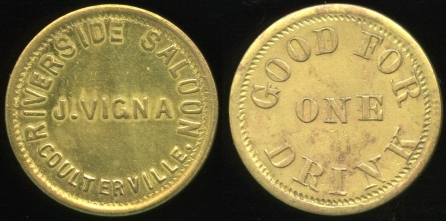

433 RIVERSIDE SALOON / J. VIGNA / COULTERVILLE, // Good For / One / Drink, br rd 25mm. Listed Feisel 3 EV8. ……………..…………..……. G4-($250 - $500)

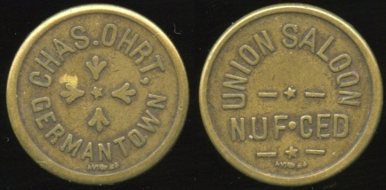

434 CHAS. OHRT, / GERMANTOWN / (sm: RVINE S.F.) // Union Saloon / Nuf Ced / (sm: Rvine S.F.), br rd 23mm. Listed Feisel 1 EV9. Extremely rare locality later renamed Artois in 1918. ..…………………. G3-($500 - $1000)

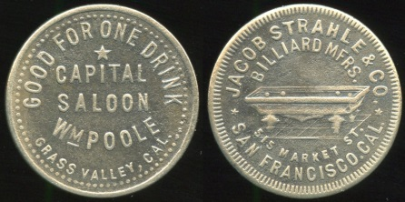

435 GOOD FOR ONE DRINK / CAPITAL / SALOON / WM POOLE / GRASS VALLEY, CAL. // Jacob Strahle & Co. / Billiard Mfrs. / (billiard table) / 515 Market St. / San Francisco, Cal., wm rd 24mm. Listed Feisel 2 EV9. …….………..…………...…. G3-($500 - $1000)

436 DELMONTE / SALOON / L.A. DANBENBIS // Good For / A 10¢ / Drink, (Hollister), br rd 21mm. Listed F-2 EV6, E-2 $35-65. ………….................... G3-($64-$125)

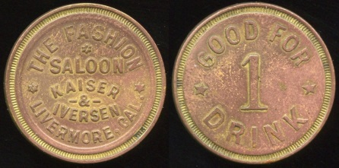

437 THE FASHION / SALOON / KAISER / & / IVERSEN / LIVERMORE, CAL. // Good For / 1 / Drink, br rd 25mm. Listed Feisel 3 EV8. …………………………..….... G4-($250- $500)

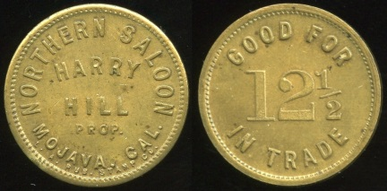

438 NORTHERN SALOON / HARRY / HILL / PROP. / MOJAVA, CAL. / (sm: L.A. RUB. STAMP CO.) // Good For / 12½ / In Trade, (Mojave), br rd 24mm. Listed Feisel 4 EV8. ………………………..…….... G4-($250 - $500)

Please be sure your advance bids are submitted in time to meet the closing deadline of Saturday, November 30. In the event of a tie high bid amount, the earliest submitted bid will be awarded the lot.

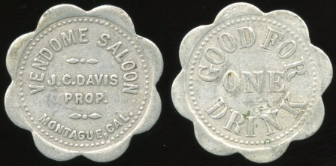

439 VENDOME SALOON / J.C. DAVIS / PROP. / MONTAGUE, CAL. // Good For / One / Drink, al sc-8 28mm. Listed Feisel 10 EV8. ……………………………...... G5-($250 - $500)

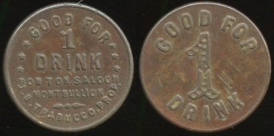

440 GOOD FOR / 1 / DRINK / BON TON SALOON / MONT BULLION / J.B. TRABUCCO, PROP. // Good For / 1 / Drink, br rd 21mm, rich brown patina. Listed Feisel 1 EV8. Rare locality! .....… G4-($500 - $1000)

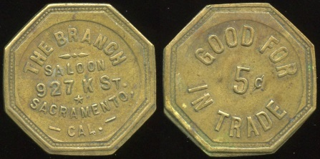

441 THE BRANCH / SALOON / 927 K ST. / SACRAMENTO, / CAL. // Good For / 5¢ / In Trade, br oc 27mm. Listed Feisel 7 EV7. ………………………….…… G3-($250 - $500)

442 GOLDEN GATE SALOON / (vertical: 500) C (vertical: K ST) / SAC. CAL. // Good For / 5¢ / In Trade, br rd 21mm, light scratch R. Listed F-25 EV5, E-44 $15-30. G3-($16-$32)

443 LAFAYETTE SALOON / 5ٴ¢ / 320 K. ST. // (same), (Sacramento), br rd 21mm. Listed F-41, E-42. …….………………...... G3-($8-$16)

444 OLD MISSION / SALOON / SAN JUAN. // Good For / 5¢ / Drink, (San Juan Batista), br rd 21mm. Listed F-1 EV6, E-1 $40-75. ……………………………..…..... G3-($32-$64)

===== Colorado =====

445 THE TOPIC SALOON / 1890 / LEADVILLE / COLO. // Good For / $100 / In Trade, br rd 35mm. Listed LE 1057. ………………………...……..….... G4-($8-$16)

===== Montana =====

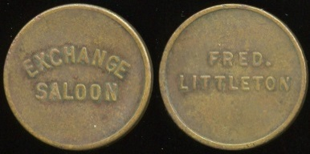

446 EXCHANGE / SALOON // Fred. / Littleton, (Billings), br rd 21mm. Attribution by Greever’s On-Line Data Base. Unlisted! ………………………………… G3-($125-$250)

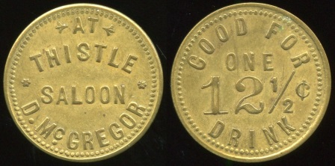

447 AT / THISTLE / SALOON / D. MCGREGOR // Good For / One / 12½¢ / Drink, (Butte), br rd 25mm. Attribution by Greever’s On-Line Data Base. Unlisted! ………...…………….………… G4-($125-$250)

===== Oregon =====

448 MT. HOOD / (mountain scene) / SALOON // Good For / 5c / In Trade., (The Dalles), br rd 21mm. Listed E-1. ………..….. G4-($16-$32)

===== Unlocated =====

Note: Most of these unlocated saloon tokens should be identifiable based on the inscription.

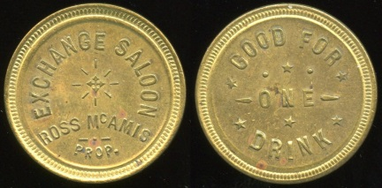

449 EXCHANGE SALOON / ROSS MCAMIS / PROP. // Good For / One / Drink, br rd 25mm. …………………….…..………. G5-($125-$250)

450 THE FAIR VIEW / SALOON // Good For / 1 / Drink, br rd 19mm. ……....… G3-($32-$64)

451 GRAIN BELT / SALOON // 5, br rd 19mm. Grain Belt beer was brewed in Minneapolis. ………………....... G3-($32-$64)

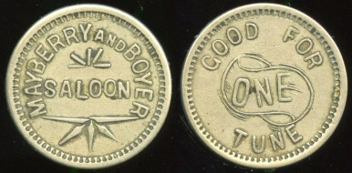

452 MAYBERRY AND BOYER / SALOON // Good For / One / Tune, wm rd 25mm. …………………………..……. G3-($125-$250)

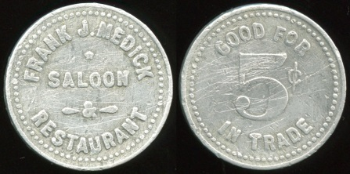

453 FRANK J. MEDICK / SALOON / & / RESTAURANT // Good For / 5¢ / In Trade, al rd 25mm, light scratches. …. G3-($125-$250)

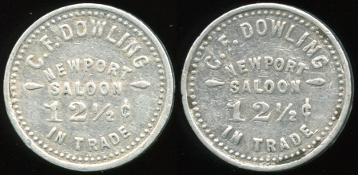

454 C.F. DOWLING / NEWPORT / SALOON / 12½¢ / IN TRADE // (same), al rd 23mm. CO, MI, UT? ..……….................... G3-($125-$250)

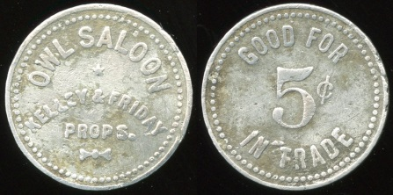

455 OWL SALOON / KELLEY & FRIDAY / PROPS. // Good For / 5¢ / In Trade, al rd 25mm. ……………………….. G3-($125-$250)

456 SPRY’S / SALOON // Good For / 5¢ / In Trade, al rd 25mm, scratches. G3-($32-$64)

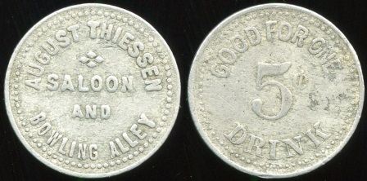

457 AUGUST THIESSEN / SALOON / AND / BOWLING ALLEY // Good For One / 5¢ / Drink, al rd 25mm. ……….... G3-($125-$250)

458 GOOD FOR / 5¢ / IN TRADE / AT THE / TIROL SALOON // 5, al rd 25mm, dinged up. ……………………………….…… G2-($32-$64)

459 UNION / J.D. / SALOON // Good For / 5¢ / In Trade. al rd 19mm. ........... G3-($64-$125)

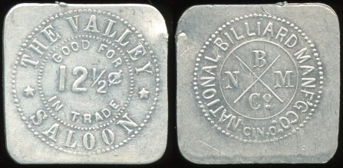

460 THE VALLEY / GOOD FOR / 12½¢ / IN TRADE / SALOON // National Billiard Manf’g Co. / B / N M / Co / Cin. O., al sq 26 mm. ………………………......……… G4-($64-$125)

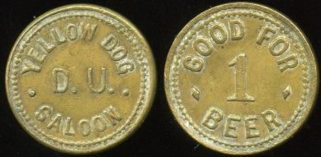

461 YELLOW DOG / D.U. / SALOON // Good For / 1 Beer, br rd 21mm. ....... G4-($64-$125)

POOL/BILLIARD

UNITED STATES POOL AND BILLIARD PARLOR TOKENS, Mike Gross (2008)

===== California =====

462 CARSON’S / SALINAS, / CAL. / POOL ROOM / (sm: MOISE K. CO.) // Good For / 5¢ / In Trade, br rd 21mm. Listed G-6 $15-25. ………..…………........................ G3-($16-$32)

===== Colorado =====

463 EDDY & POST / VICTOR / BILLIARD / HALL // Good For / 25¢ / In Merchandise, al sc-10 30mm. Listed G-7, VI525-25b. ................................................... G3-($16-$32)

464 J.C. DIECKMANN / BILLIARD / HALL / WEST CLIFF // Good For / 5¢ / In Trade, br rd 21mm, tiny rim nick. Listed G-1, WE275. ................................................... G3-($16-$32)

===== Idaho =====

465 CAREY POOL HALL / CAREY / IDAHO // Good For / 5¢ / In Trade, al rd 22mm. Listed G-2 $15-25, Pincock R5 EV6. .. G4-($16-$32)
===== Montana =====

466 COMBINATION / BILLIARD / PARLOR / LIVINGSTON, / MONT. // Good For / 12½¢ / In Trade, br hx 28mm. Listed G-3g. G4-($8-$16)

===== Oklahoma =====

467 J.C. BILLIARD PARLOR / COLLINSVILLE, / OKLA. // Good For / 2½ / Cts / In Trade, br rd 19mm. Listed G-1, 110. ........................ G4-($16-$32)

468 YUKON / SNOOKER / PARLOR / YUKON, OKLA. // Good For / 5¢ / In Trade, al rd 22mm, reverse die crack Listed G-1, 270. ………........................................ G5-($32-$64)

A dollar amount range is provided is for bidding guidance only. Lots may sell for at a level above or below the indicated amount.

===== Utah =====

469 JAX BILLIARD ROOMS / (c/ham) / * // Good For / 5¢ / (c/h) / In Trade, (Cedar City, UT), br rd 21mm. Listed G3-$10-15. ………………………………....... G4-($16-$32)

===== Washington =====

470 JOHN ERICKSON / POOL / ROOM / MARYSVILLE / WN. // Good For / 5¢ / In Trade, br rd 21mm. Listed R2, Gross 2e $5-10. ………………………...…….... G3-($8-$16)

471 BRUNSWICK BILLIARD / PARLOR / 1213 / FIRST AVE. / SEATTLE // Good For / 5¢ / In Trade, br rd 21mm. Listed, G-23 $5-10. ……………………………………... G3-($8-$16)

472 THE SHASTA / BILLIARDS / CIGARS / YAKIMA, / WASH. // Good For / 10¢ / In Trade, al oc 26mm. Listed G-9 $1-5, Erickson R4. ……………………………………... G3-($8-$16)
ALABAMA
ALABAMA TRADE TOKENS, Roy J. Wood (1995)

473 T.A. HATTER & SON / CREOLA, / ALA. // Good For / 1¢ / In Merchandise, br rd 18mm; 5¢ 20mm; 25¢ 26mm; 50¢ 28mm; $100 31mm; 10¢ / In / Merchandise 25mm. Listed 19 1-1 thru 1-100. Set of 6 pcs. ….... G5-($32-$64)

474 C, BURKART / & CO. / HANCEVILLE, / ALA. // Good For / 5¢ / In / Merchandise, br rd 20mm. Listed 197 2-5. …........ G3-($16-$32)

475 BLACK DIAMOND COAL MINING CO. / JOHNS / ALA. / (c/o dd) // Good For / $100 / (/co) / In Merchandise, al rd 31mm. Listed 220 1-10, 1457 B100. ……………..… G3-($8-$16)

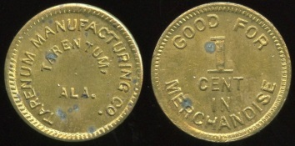

476 TARENTUM MANUFACTURING CO. / TARENTUM, / ALA. // Good For / 1 / Cent / In / Merchandise, br rd 19mm. Listed 389 1-1. ……………….………..……….... G5-($32-$64)

ALASKA
ALASKA AND YUKON TOKENS, Private Coins of the Territories, Ronald J. Benice (third edition 2010)

477 CHICK-N-BURGER / ANCHORAGE / ALASKA / PALMER HIGHWAY // Good For / 25¢ / In Trade, blue al rd 26mm. G5-($8-$16)

478 GOOD FOR ONE CENT IN TRADE / 1 / ARRC // (same), (Palmer), al oc 22mm, dinged up a bit. Listed 1.A $50. …...... G3-($32-$64)

479 Similar but 5 rd 21mm. Listed 1.B. $50. ……………………………………. G4-($32-$64)

ARIZONA / A.T.
ARIZONA TRADE TOKENS, Peter Spooner (2010)

480 EDWARDS USED CYCLE PARTS / 13220 N. / CAVE CREEK RD. / 992-7071 // 25c (across: In Trade); (Phoenix), al rd 29mm; 50c 32mm;, $100 br 35mm. Unlisted set of 3 pcs! ………………..…..……….. G5-($32-$64)

481 HENDERSON ARCHERY CENTER / 1534 / W. VAN BUREN / PHOENIX, AZ./ 258-4194 // 25c (across: In Trade), br rd 29mm. Listed PHO-350C R9 $20. ….... G5-($16-$32)

482 FRED A. MAY / (c/ham) / PRESCOTT, ARIZ. // Good For 12½¢ In Trade / (c/h), br rd 21mm. Listed PRE-510 R3 $10. G5-($8-$16)

Be sure to check all the different listing categories if you have a specific state or topical collecting interest. This mail bid sale offers a wide variety of material.
ARKANSAS
ARKANSAS MERCHANT TOKENS, Tom H. Robinson (1985)

483 SAVE AT THE SAMPLE STORES / BENTONVILLE / AND / ROGERS / ARKANSAS // Every Dollar Spent Earns 3% Interest / Worth / 3¢ / In Trade, al rd 32mm. Listed 1270 Ba-03. ……………. G3-($16-$32)

484 FOSTER / & / GRAYSON / EMERSON, ARK. // Good For / 8¢ / In Merchandise, br rd 25mm. Listed 1990 A-08. ….… G5-($16-$32)

485 RIPLEY BROS. / EUREKA / SPRINGS / ARK. // Good For / One Pint / Milk, al rd 25mm. Listed 1-50 R-0. …………..….... G3-($32-$64)

486 J.A. NORTH / & CO. / FT. SMITH / ARK. // Good For / 2½ / Cents / In Trade, al rd 19mm. Listed AN-2½. ……….. G3-($16-$32)

487 E.J. MEGOWN / GREEN FOREST / ARK. // Good For / 1 / Loaf / Bread, al rd 22mm. Unlisted! ….………..…..…….... G3-($32-$64)

488 HELENA WEST HELENA / SCHOOL / LUNCH // (uniface), br rd 29mm. Listed 2450 T-x. ….…………………....…….... G3-($8-$16)

489 JOHN K. GIBSON / LAURATOWN, / ARK. // Good For / 10 / In / Merchandise, al rd 25mm, worn. Listed 2750 Aa-10. ……………………………………. G2-($16-$32)

490 GEO. E. MARKLE / MARKLES / MILL / ARK. // Good For / 25¢ / In / Merchandise, al rd 25mm. Listed A-25. ………........ G3-($8-$16)

491 REX / PINE / BLUFF, / ARK. // Good For / 10¢ / In Trade, al sc-12 26mm. Listed 3500 BP-10. ……………..………… …. G3-($8-$16)

492 SPRINGDALE CANNING CO. / 2 / SPRINGDALE, / ARK. // Sprague Canning Machinery Co. / Chicago., br rd 25mm. Listed 3870 F-02. ………..….……….... G4-($16-$32)

493 MEYER STORE CO. / INC. / WALNUT RIDGE, / ARK. // Good For / 5¢ / In / Merchandise., al rd 21mm. Listed 4190 C-05. ……….……………………...….... G4-($16-$32)

CALIFORNIA
CATALOGUE OF CALIFORNIA MERCHANTS TOKENS, Stephen Album, (1971, 1974, supplement 1975); CALIFORNIA TOKENS, Charles V. Kappen (1976; supplement 1997)

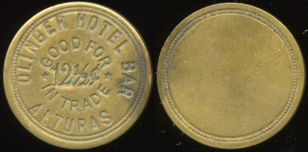

494 OLINGER HOTEL BAR / GOOD FOR / 12½¢ / IN TRADE / ALTURAS (a/i) // (uniface), br rd 24mm. Unlisted! ...... G3-($250 - $500)

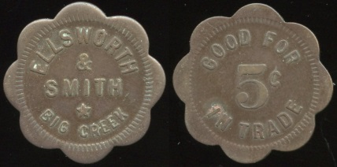

495 ELLSWORTH / & / SMITH / BIG CREEK // Good For / 5¢ / In Trade, br sc-8 24mm. Listed FRE 08A R, 1K-1. … G3-($125 - $250)

Illustrations are of the actual lot, but may not be actual size —check the listing itself for size information. Color pictures of all lots pictured here as well as those indicated by an underlined italic lot number are posted to my photo hosting website http://collector-ca.smugmug.com

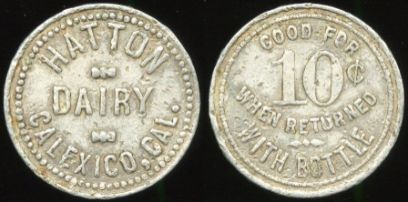

496 HATTON / DAIRY / CALEXICO, CAL. // Good For / 10¢ / When Returned / With Bottle, al rd 25mm. Listed 2K-8. Popular desert locality! …………..……….. G3-($125 - $250)

497 CHICO / (c/o sq) INN // Good For 5¢ In Trade / (c/o), br rd 21mm. Listed BUT 20U S, 1K-27. ………………..……….…. G5-($8-$16)

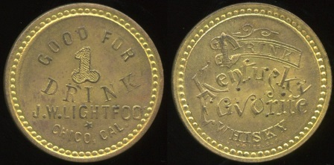

498 GOOD FOR / 1 / DRINK / J.W. LIGHTFOOT / CHICO, CAL. // Drink / Kentucky / Favorite / Whisky / (sm: L.H. Moise. S.F.), br rd 28mm. Listed 2K-149. Obverse struck off center so proprietor name appears as Lightfoo! ...…… G5-($250 - $500)

499 SILVER DOLLAR / DRINKS / FOOD / INDUSTRY // 50c (across: In Mdse.), (City of Industry), al rd 32mm. Listed 2K-9. ……………………….………..…. G4-($16-$32)

500 WALKER’S / CAFE / COALINGA, / CALIF. // Good For / 10¢ / In Trade, al rd 25mm. Listed 2K-73. ….....….. G5-($16-$32)

501 GRANDVIEW / FARM / PHONE / 565 / PRODUCTS / COMPANY // Good For / One / Quart Of Milk, (Corona), al rd 26mm. Unlisted! ……………….…….…. G5-($8-$16)

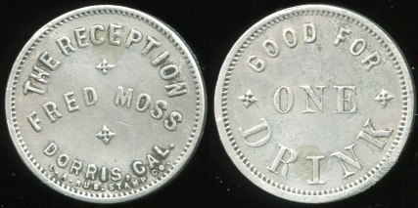

502 THE RECEPTION / FRED MOSS / DORRIS, CAL. / (sm: L.A. RUB. STAMP CO.) // Good For / One / Drink, al rd 23mm. Listed 2K-15. ……………………... G3-($250 - $500)

503 MONK’S RECREATION HALL / DURHAM, / CALIF. // Good For / 10¢ / In / Merchandise, al rd 24mm. Listed BUT 25D R, 1K-5. ……………………..…….. G5-($16-$32)

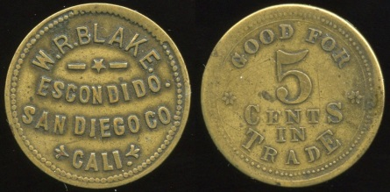

504 W.R. BLAKE. / ESCONDIDO. / SAN DIEGO CO. / CALI. // Good For / 5 / Cents / In / Trade, br rd 24mm. Listed 2K-29 with errors. ……………………………..… G3-($250 - $500)

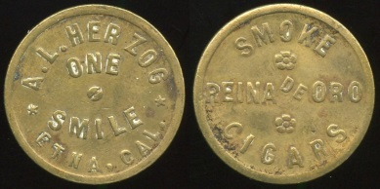

505 A.L. HERZOG / ONE / SMILE / ETNA, CAL. // Smoke / Reina De Oro / Cigars, br rd 26mm. Listed 2K-23. …..... G3-($125 - $250)

506 ALEXANDER B. STEWART / EXETER, / CALIF. // Good For / 10¢ / In / Merchandise, al rd 24mm. Listed TUL 28M R, 1K-16. ………………………...………..... G5-($16-$32)

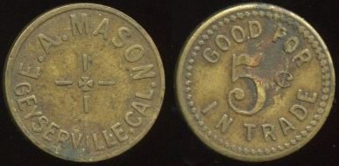

507 E.A. MASON / GEYSERVILLE, CAL. // Good For / 5¢ / In Trade, br rd 21mm. Listed SON 36D R, 1K-5. …..…… G3- ($125 - $250)

508 MAINERO & CASTELLA / GILROY // Good For / 25¢ / In Trade, al rd 18mm. Listed SCL 35AU V, 1K-43. ……........... G5-($8-$16)

509 J.W. HUMBLE / CIGARS / & / TOBACCOS / GRIDLEY, CAL. // Good For / 5¢ / In Trade, br rd 21mm, O&R c/s H. Listed BUT 35S S, 1K-14. ……………. G3-($16-$32)

510 CORNER CIGAR STORE / JOHN DOTTINGER / HOLLISTER. // Good For / 5¢ / In Trade, br rd 21mm. Listed SBT 40F S, 1K-7. ................................................ G3-($8-$16)

511 GARCIA BROS. / HOLLISTER // I Owe You A / 10¢ / Drink, br rd 21mm. Listed SBT 40M S, 1K-16. ……..................... G4-($8-$16)

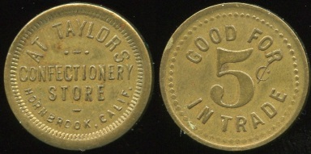

512 AT TAYLORS / CONFECTIONERY / STORE / HORNBROOK, CALIF. // Good For / 5¢ / In Trade, br rd 21mm. Listed 2K11. ……………………………… G4-($125 - $250)

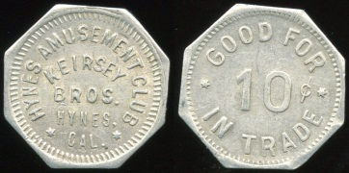

513 HYNES AMUSEMENT CLUB / KEIRSEY / BROS. / HYNES, / CAL. // Good For / 10¢ / In Trade, al oc 20mm. Listed LA 430B R, 1K-2. ………………………………. G3-($125 - $250)

514 JIM’S CORNER / (c/ham) / JACKSON, CAL // Good For / 5 (c/h) ¢ / In Trade, br rd 21mm. Listed AMA 45BC S, 1K-32. …..…………………………..…... G3-($16-$32)

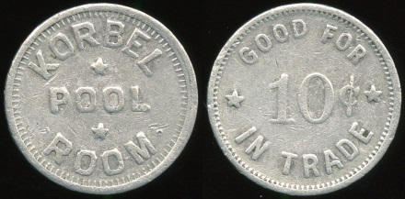

515 KORBEL / POOL / ROOM // Good For / 10¢ / In Trade, al rd 23mm. Listed 1K-1, Gross 1 $75-$100. ……………..… G3-($125 - $250)

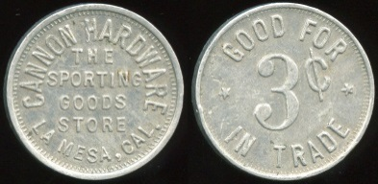

516 CANNON HARDWARE / THE / SPORTING / GOODS / STORE / LA MESA, CAL. // Good For / 3¢ / In Trade, al rd 21mm. Listed SDI 50B R, 1K-4. …. G3-($125 - $250)

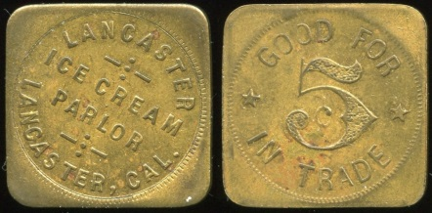

517 LANCASTER / ICE CREAM / PARLOR / LANCASTER, CAL. // Good For / 5¢ / In Trade, br sq 24mm. Unlisted! ….. G3-($250 - $500)

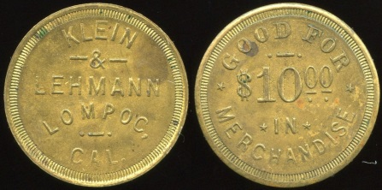

518 KLEIN / & / LEHMANN / LOMPOC, / CAL. // Good For / $10.00 / In Merchandise, br rd 29mm. Unlisted! ……….... G4-($250 - $500)

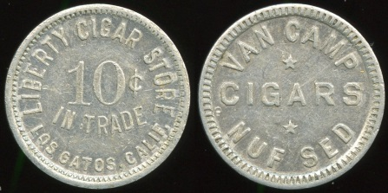

519 LIBERTY CIGAR STORE / 10¢ / IN TRADE / LOS GATOS, CALIF. // Van Camp / Cigars, al rd 25mm. Listed 2K-46. ……………………………….. G5 - ($64 - $125)

520 FEATHER RIVER CREAMERY CO. / PHONE 1181 / MARYSVILLE // Good For / 1 / Quart / Milk, al rd 24mm. Listed YUB 55W R, 1K-25. ……………………….….. G5-($16-$32)

521 PALACE LUNCH / (c/ham) / MARYSVILLE, CALIF. // (same), wm rd 21mm. Listed YUB 55AZ S, 1K-61. ….... G5-($8-$16)

522 WARE’S SERVICE STORES / MAXWELL, CALIF. // Good For / 5¢ / In Trade, br rd 21mm. Listed COL 55D R, 1K-5. ……………………………………. G5-($16-$32)

523 CHUNG KEE SUN FAT CO. / 511 / 14TH ST. / MERCED, CAL. // One Yan / $ / Good For In Trade, al rd 38mm. Unlisted! ..……..…………………….……. G3-($32 - $64)

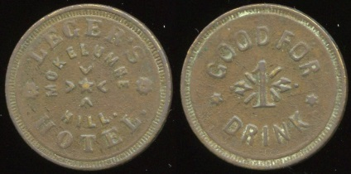

524 LEGER’S / MOKELUMNE / HILL. / HOTEL. // Good For / 1 / Drink, br rd 24mm. Unlisted! …………...……. G3-($250 - $500)

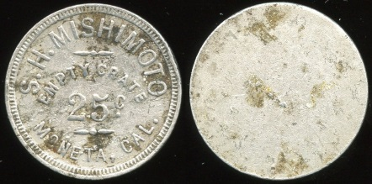

525 S.H. MISHIMOTO / EMPTY CRATE / 25C / MONETA, CAL. // (blank), al rd 24mm, mild porosity. Listed 2K-3. ……….... ($125 - $250)

526 HOP YICK / W // Good For / 5¢ / In Trade, (Pajaro), wm rd 21mm, porosity, rim nick. Listed 1K-8. ....................... G2-($8-$16)

527 YEE ON / W // Good For / 5¢ / In Trade, (Pajaro), wm rd 21mm. Listed 1K-11. …….............................................. G3-($8-$16)

528 U.C. // Good For / 10¢ / On Return / Of Bottle, (Palo Alto), al oc 26mm. Unlisted shape for 1K-52. …………..….... G5-($8-$16)

529 W.A. BOYES / PRINCETON, / CAL. // Good For / 5¢ / In Trade, br rd 21mm. Listed COL 65C S, 1K-3. ………….…. G3-($32-$64)

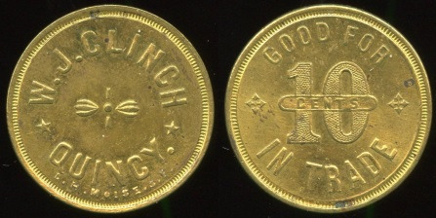

530 W.J. CLINCH / QUINCY. / (sm: L.H. MOISE. S.F.) // Good For / 10 (across: Cents) / In Trade, br rd 25mm. Listed 2K-9. ……………………………..... G5-($125 - $250)

531 SACRAMENTO HOTEL / 10 / REDDING // (uniface), br rd 18mm. Unlisted! ……………………………..…..... G5-($16-$32)

532 Similar but 50 21mm. ...... G5-($16-$32)

533 Similar but 2.00 24mm. .... G5-($16-$32)

534 Previous three lots as a single lot. Winning bid must exceed the total of the high bids for the three lots. ….......….... ($64-$125)

535 STEWART / BILLIARD / HALL / REEDLEY, CAL. // Good For / 5¢ / In Trade, al ov 32x21mm;. Listed FRE 74P C, 1K-8, Gross 3a $25-50. ……………..….…... G5-($16-$32)

536 Similar but 10¢ oc 27mm. Listed FRE 74R S, 1K-10, Gross 3c $25-$50. ……………………...……..…….. G5-($16-$32)

537 BLOOMINGTON’S / GOOD / FOR / PRIZE / SACRAMENTO, CALIF. // (same), br rd 21mm. Listed SAC 75B19 R, 1K-49. ……………………………..……… G5-($8-$16)

538 C.F. LAUFFER / 2000-O // Good For / 5c / In Trade, (Sacramento), br rd 21mm. Listed SAC 75L20 V, 1K-371. ……........ G3-($8-$16)

539 F. TODD / (c/ham) / SAN DIEGO / (sm: LA RUB STP CO) // Good For 5¢ In Trade / (c/h), br rd 21mm. Listed SDI 75T5 R, 1K-341. …….............................................. G4-($8-$16)

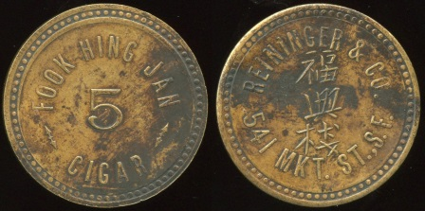

540 FOOK HING JAN / 5 / CIGAR // Reininger & Co. / (Chinese characters) / 541 Mkt. St., S.F., (San Francisco), br rd 33mm, dark patches. Unlisted! Reininger & Co. was a token maker. ……..……....... G3-($64 - $125)

541 D.H. LAFFERTY & SON / SANGER, / CAL. / (sm: L.H. MOISE. S.F.) // Good For / 5¢ / In Trade, br rd 21mm, coppery areas, porosity. Listed FRE 78I S, 1K-6. ……………………………………. G2-($16-$32)

542 MILLS / SOLEDAD, CAL. // Good For / 5¢ / In Trade, br rd 21mm, dark, porosity, crude c/h. Listed MNT 80F R, 1K-13. ……………………………………... G2-($8-$16)

543 BONA & BIASOTTI / (c/o crescent) // 5¢ / (c/o) / In Trade, (Sutter Creek), br rd 21mm. Listed AMA 84C S, 1K-5. …..... G3-($16-$32)

544 EUREKA / BAR / HOTEL // V.R. / Main / St. / Sutter Creek, br rd 21mm. Listed AMA 84H R, 1K-11. …………………. G3-($16-$32)

545 JOHN P. KNUDSEN / (c/ham) // Good For 10¢ / (c/h) / In Trade, (Watsonville), wm rd 21mm. Listed SCZ 95EC V, 1K-110, ….................................................. G3-($8-$16)

546 YEE KEE / W // Good For / 5¢ / In Trade, (Watsonville), wm rd 21mm. Listed 1K-213. …….............................................. G3-($8-$16)

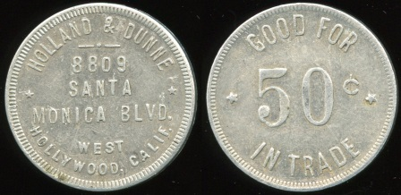

547 HOLLAND & DUNNE / 8809 / SANTA / MONICA BLVD. / WEST / HOLLYWOOD, CALIF. // Good For / 50¢ / In Trade, al rd 31mm. Unlisted! ………… G4-($125 - $250)

548 WHITTIER SANITARY DAIRY / 130 SO. / COMSTOCK / ST. / WHITTIER, / CALIF. // One Pint / Pasteurized Milk, al rd 24mm. Unlisted! ……….......……….…. G3-($16-$32)

549 YOLO POST 77 / (c/ham) // American / (c/h) / Legion, (Woodland), br rd 21mm. Listed in error YOL 96D V. ……............ G4-($8-$16)

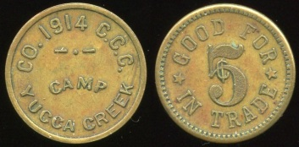

550 CO. 1914 C.C.C. / CAMP / YUCCA CREEK // Good For / 5¢ / In Trade, br rd 19mm. Listed TUL 98A R, 1K-1. Civilian Conservation Corps! …… G3-($125 - $250)

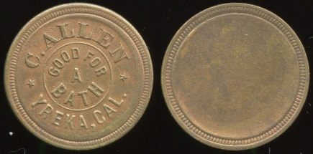

551 C. ALLEN / GOOD FOR / A / BATH / YREKA, CAL. // (uniface), br rd 23mm. Listed SIS 98A R, 1K-1. ……....… G4-($125 - $250)

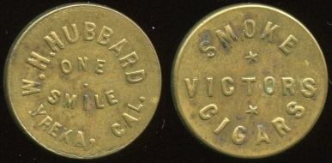

552 W.H. HUBBARD / ONE / SMILE / YREKA, CAL. // Smoke / Victors / Cigars, br rd 21mm. Listed SIS 98AI R, 1K-16. …….…………...…….……… G4-($125 - $250)

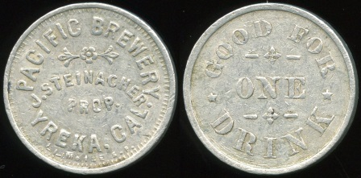

553 PACIFIC BREWERY / J. STEINACHER / PROP. / YREKA, CAL. / (sm: L.H. MOISE S.F. // Good For / One / Drink, al rd 24mm. Listed 2K-93. ……………………… G3-($250 - $500)

COLORADO
COLORADO MERCHANT TRADE TOKENS, Stuart M. Pritchard, Jr. (2004)

554 SANDY / BENNETT / COLO. // Good For / 25¢ / In Trade, al pt 27x27mm. Listed BE375 $4-8. ........................................... G5-($8-$16)

555 4-40 CLUB / DELTA, / COLO. // Good For / 50¢ / In Trade, br sq 26mm. Listed DE550-50 $4-8. ………………….....……..... G5-($8-$16)

556 WHEEL BAR / ESTES PARK / COLO. / RAIN CHECK // 50c (across: In Trade), br rd 32mm. Listed ES191 $4-8. Variety – bottom of COLO. aligns mid-R. .............. G5-($8-$16)

557 WHEEL BAR / ESTES PARK / COLO. / RAIN CHECK // 50c (across: In Trade), br rd 32mm. Listed ES191 $4-8. Variety – bottom of COLO. aligns tip of R. ............ G5-($8-$16)

558 PENROSE PHARMACY / J.F. WRIGHT / PENROSE, / COLO. // Good For / 5¢ / In Sundries, al oc 20mm. Listed PE 210-5 $4-8. ………………………….....……..... G5-($8-$16)

559 WASATCH STORE COMPANY // Good For / 5¢ / In Trade, (Somerset), al rd 21mm. Listed SO150-5a $4-8. ............... G3-($8-$16)

560 FOX & JONES / SWINK, / COLO. // Good For / 5¢ / In Trade, br rd 21mm. Listed SW160 $8-16. ……………….....……..... G3-($16-$32)

561 COLUMBIA / CIGAR / STORE / 117 N. / COMMERCIAL / ST. / TRINIDAD, COLO. // Good For / $100$ / In Trade, al rd 36mm. Listed TR342-100 $4-8. ............. G5-($8-$16)

562 EDDY & POST / VICTOR, / COLO. // Good For / 25¢ / In Trade, al sc-4 28mm. Listed VI531-25 $4-8. ................. G4-($8-$16)

CONNECTICUT

563 JOE’S TAVERN / 136 / MAIN ST. / DEEP RIVER, CONN. // Good For / 10¢ / In Trade, al rd 24mm. …………………….…. G5-($16-$32)

564 TURF CLUB, INC. / 2243 / MAIN / ST. / HARTFORD, CONN. // Good For / 10¢ / In Trade, br rd 18mm. ………..…. G4-($16-$32)

565 BRUNSWICK / HOTEL / 11 FIRST / ST. / SEYMOUR, CONN. // Good For / 5¢ / In Trade, br rd 20mm. ………..…. G4-($16-$32)

566 CO-OP / FOOD / STORE / STAFFORD SPRINGS, CONN. // 10c (across: In Trade), al rd 32mm. ……………..……...… G5-($16-$32)

GEORGIA
GEORGIA TRADE TOKENS, R. D. Partin & J. D. Partin (1990)

567 J.H. JOHNSON & SON / 25¢ / IN HANDS / OF / EMPLOYEES / ONLY / FOLKSTON, GA. // Good For / 25¢ / In Trade / Not / Transferable, al rd 26mm. Listed 2030 B-25. …………………..…………....…. G3-($16-$32)

568 SUNSHINE DAIRIES / MILK / AND / ICE CREAM / MACON, GA. // Good For / 1 / Quart / Sweet Milk, br rd 28mm. Listed 2625 AT-qt. ………………………..…..……... G4-($16-$32)

HAWAII
HAWAIIAN MONEY STANDARD CATALOG, 1991 Second Edition, Donald Metcalf & Ronald Russell.

569 HILO DOLLAR / QUEEN / LILIUOKALANI / (bust facing) / 1838-1912 / HAWAII / THE BIG ISLE // Aloha / (scenes and descriptive wording) / Hilo, br rd 39mm, reeded edge. …………………………… G5-($16-$32)

570 Hawaiian municipal trade dollar, Maui, The 50th State, U.S.A. 1959, $1.00 In Trade, br rd 39mm. Lot of 2 pcs. ….. G5-($16-$32)

Each lot is expected to have a sale price of $10.00 or greater. A minimum bid of $5.00 applies to each lot unless specified otherwise.

IDAHO
IDAHO TOKENS FOR COLLECTORS, Hollis B. Pincock, Jr. (Third edition 2004)

571 A WEST / (horseshoe) / AMERICAN FALLS, IDA. // Good For / 10¢ / In Trade, al rd 21mm. Listed. ……...…..……… G3-($8-$16)

572 T.A. HAYES / CIGARS / TOBACCO & / CANDIES / BLACKFOOT, IDA. // Good For / 10¢ / In Trade, br rd 21mm. Listed. ……..…………………….………. G3-($16-$32)

573 P.O. LIMINS / L / CASCADE, IDA. // Good For / 5¢ / In Trade, br rd 21mm. Listed. …….…………………..…..………. G4-($8-$16)

574 ED. ALLEN / ELK RIVER, IDA. // Good For / 5¢ / In Trade, br rd 21mm. Listed. …………………….…….....……. G3-($16-$32)

575 GEORGE’S PLACE / GRANGEVILLE, / IDA. // Good For / 5¢ٴ / In Trade, br rd 21mm. Listed R4 EV5. ……….….....…. G4-($16-$32)

576 F.F. LISHER / (c/o star) / LAPWAI, IDA. // Good For / 5¢ / (c/o) / In Trade, br rd 21mm. Listed. ………………..….......… G5-($16-$32)

577 LAVA-HOT SPRINGS / AT / THE / MISSION / IDAHO // Good For / 12½¢ / In Trade, br rd 21mm. Listed. ...... G4-($16-$32)

578 JNO. J. JARVIS / GENERAL / MERCHANDISE / 1912 / MIDDLETON, IDAHO // Good For / 50 / In Merchandise, al rd 30mm. Listed. ..……………...…..….…. G3-($16-$32)

579 BEN ROSS / MOUNTAIN / HOME, / IDAHO // Good For / 12½¢ / In Merchandise, br rd 21mm. Listed. ………...… G4-($16-$32)

580 SLEIGHT’S CASH STORE / GENL. MDS. / PEGRAM / IDAHO. // Good For / 50¢ / In Trade, al sc-8 29mm. Listed. ... G5-($16-$32)

581 WILSON’S / 12½¢ / ROBERTS, IDAHO. // (same), br rd 21mm. Listed. G4-($16-$32)

582 RAMMELL / GROCERY / TETONIA, / IDAHO // Good For / 25¢ / In Trade, al rd 26mm. Listed. ........................... G3($32-$64)

583 LUIS PEILA & CO. / N.P. HOUSE / WALLACE, IDAHO // Good For / 12½¢ / In Trade, al sc-8 29mm. Listed. ... G3-($32-$64)

ILLINOIS
TRADE TOKENS OF ILLINOIS, Ore H. Vacketta (second edition 1983)

584 DALE’S TAP / 188 N. / SCHUYLER / BRADLEY, ILL. 60915 // Good For / 25¢ / In Drinks, al rd 29mm. Unlisted! .. G5-($8-$16)

585 BEAU MONDE / (key) / CLUB // 514 / Diversey / 100 / Chicago / Ill., gilt br rd 38mm. Listed Chi B28. ………………….. G4-($8-$16)

586 CIRO’S / CHICAGO // Good For / One / Dollar / In Merchandise, wm rd 38mm. Listed Chi C74. ……………..………….,, G5-($8-$16)

587 DAUPHIN / STANDARD / SERVICE / MAIN / & / QUINCY / SAVANNA, ILLINOIS 61074 // 50c (across: In Trade), br rd 32mm. Unlisted! ……………….....…..... G5-($8-$16)

588 DEPARTMENT / B.H. KOLLMEYER / SIGEL. / STORE // Good For / 25¢ / In Merchandise, al oc 25mm. Unlisted! …………………………...…..…... G3-($16-$32)

INDIANA
INDIANA TRADE TOKENS, Lloyd E. Wagaman (1981)

589 ART’S / PLACE / ARCOLA, IND. / PH. 625-8071 // Good For / 45¢ / In Trade, br rd 35mm. Listed A-3800. ……..…... G5-($8-$16)

590 H.L. MOODY & CO. / (c/ham) / INDIANAPOLIS / IND. // Machines & Sales Boards / (c/h) / Leased On / Profit Sharing basis, br rd 21mm. Listed I-4500 R9. ……..………………………............ G4-($8-$16)

591 O.A. WILLIAMS MFG. CO. / (c/ham) / INDIANAPOLIS, / IND. // (same), wm rd 21mm. Listed I-7160 R7. ........... G4-($8-$16)

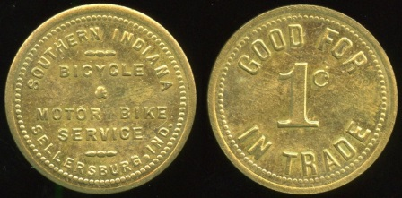

592 SOUTHERN INDIANA / BICYCLE / & / MOTOR BIKE / SERVICE / SELLERSBURG, IND. // Good For / 1¢ / In Trade, br rd 25mm. Listed S-1500. Only listing for locality! ……………………..…………… G5-($64-$125)

KENTUCKY

593 J. KEES & SON / HOTEL / ALEXANDRIA, KY. // Good For / 5¢ / In Trade, br ov sc-32 28x24mm. ……...... G3-($16-$32)

594 CROLEY HARDWARE / & / GROCERY / CO. / BARBOURVILLE, KY. // Good For / 5¢ / In Merchandise, wm rd 20mm. G3-($16-$32)

595 W.E. HARDWICK / CENTRAL CITY, / KY. // Good For / 2½¢ / In Trade, br rd 22mm, rim cut. …………………………... G3-($8-$16)

596 CLINT ROSS / ALEXANDRIA PIKE / COLD SPRING, / KY. // 5¢, br rd 23mm. ………………………….………… G4-($16-$32)

597 LOUIS CLOSS / GOOD FOR / 5¢ / IN TRADE / DALE. KY. // (drinking glass), br rd 25mm. …………….................... G3-($16-$32)

598 BAUMANN’S / CAFE / 640 6TH AVE. / DAYTON, KY. // Good For / 5¢ / In Trade / (sm: Wright & Son Cin’ti O.), al shield 27x28mm. ………………..…..... G3-($16-$32)

599 C.W. TABOR, / ELLIOTSVILLE / KY. // Good For / 5¢ / In . Merchandise, al rd 20mm. ................................................... G4-($16-$32)

600 SHADOAN & TATE / GEN’L MDSE / AND / COUNTRY / PRODUCE / FRAZIER, KENTUCKY // Good For / 5 / In Merchandise, al rd 19mm. ……………………. G3-($16-$32)

601 FORD NUNNELLEY / GEORGETOWN / KY. // Good For / 5¢ / In Trade, al sc-8 29mm. …………..……………..….....….. G3-($16-$32)

602 GRANADA / 5¢ / HIGHLAND / HGHTS, KY. (a/i) // (blank), al rd 32mm. G3-($16-$32)

603 BLACKROGGE / & BRO. / HOPKINSVILLE, KY.// 2½, wm rd 16mm. ……………………………….…... G5-($16-$32)

604 BRING US YOUR / PRODUCE / WE RAISE THE PRICE / C.D. SCOTT / KUTTAWA, KY. // Good For / $100 / In / Merchandise, al rd 35mm. …... G4-($16-$32)

605 JIM BURKE / CAFE / 119 / N. MILL ST. / LEXINGTON, KY. // This Check & / 10¢ / Good For / One Bottle Of Beer, al sc-8 29mm. …................................................ G5-($16-$32)

606 NAVARRE / CAFE / MAYSVILLE, KY. // Good For / 5¢ / In Trade, br rd 20mm. ………............................……….. G3-($16-$32)

607 S.P. O’LEE / (c/ham) / NICHOLASVILLE, KY. // Good For 5¢ In Trade / (c/h), br rd 19mm. ……………………….…. G3-($16-$32)

608 OLIVE HILL FIRE BRICK CO. INC. / OLIVE HILL, / KY. // Good For / 5 / In Merchandise, al rd 19mm. …... G3-($16-$32)

609 GENE’S TEXACO SERVICE / PHONE / 7-9105 / LAUREL ST. & KY. AVE. / PINESVILLE, / KY. // Good For / 10¢ / In Trade, br oc 22mm. ..………… G5-($16-$32)

610 HARLAN – RIDGEWAY MINING CO. / 50 / RIDGEWAY, KY. // Good For / 50 / In Merchandise, al rd 31mm. ...…. G5-($16-$32)

611 JOE’S PLACE / SOUTH / FORK, / KY. / (sm: WRIGHT CIN. O.) // Good For / 5¢ / In Trade, br rd 21mm, scattered coppery patches. …………………………..……..... G5-($16-$32)

612 F.D. GIRTEN / UNIONTOWN / KY. // Good For / 5¢ / In Trade, br hx 22mm. ………………………..…..…...… G3-($16-$32)

LOUISIANA
LOUISIANA TRADE TOKENS, Louis Crawford & Glyn Farber (second edition 1986)

613 ROMAIN MECHE & SON / ARNAUDSVILLE, LA. // Good For / 25¢ / In Merchandise, br rd 26mm. Listed 392-C-25. ……………………......….…..…... G5-($16-$32)

614 JACKSON MALL CINEMA / ADMIT / 1 / CHILD // (blank), (Baton Rouge), br rd 25mm. Unlisted! …………...….……..…. G5-($8-$16)

615 JACKSON MALL CINEMA / ADMIT / 1 / ADULT // (blank), (Baton Rouge), wm rd 29mm. Unlisted! ………..…..…. G5-($8-$16)

616 ST. VINCENT DEPAUL SOCIETY / (cross) / SPES NOSTRA / CONFERENCE / ST. JOSEPH / BATON ROUGE, LA. // Good For / 25c / Groceries, al rd 35mm. Listed 651 S/2-25a. ………………………..… G5-($8-$16)

617 ST. VINCENT DEPAUL SOCIETY / (cross) / SPES NOSTRA / CONFERENCE / ST. JOSEPH / BATON ROUGE, LA. // Good For / 25c / Groceries, al rd 35mm. Listed 651 S/2-25b. ………………….…..… G4-($16-$32)

618 GREATER BATON ROUGE / STATE FAIR // Jaycee Project / Admit / One, bz rd 27mm. Listed 651 G/3a. ..…….. G5-($8-$16)

619 GREATER BATON ROUGE / STATE FAIR // Jaycee Project / Admit / One, wm rd 27mm. Listed 651 G/3b. ..…….. G5-($8-$16)

620 KENILWORTH CINEMA / ADMIT 1 CHILD // (blank), (Baton Rouge), br rd 25mm. Unlisted! ……..….…………….... G5-($8-$16)

621 KENILWORTH CINEMA / ADMIT 1 ADULT // (blank), (Baton Rouge), wm rd 29mm. Unlisted! ……..………... G5-($8-$16)

622 ANN’S HAIR FASHION / 1129 / GILBERT / DRIVE, / B.C. / PHONE: / 746-6636 // 10c (across: In Mdse.), (Bossier City), al rd 26mm. Unlisted! ……………..…..….…. G5-($8-$16)

623 PLANTATION / CLUB / CENTRAL, LA. // Good For / 5¢ / In Trade, al sc-8 29mm. Listed 1687 B-05. ……………....………. G3-($8-$16)

624 BUILDING CONTRACTOR / M.L. / HENEGAR / PHONE / 644-4817 / GONZALES, LA. / REMODEL & REPAIR // 10c (across: In Drinks), al rd 26mm. Unlisted! ……………………………………... G5-($8-$16)

625 GUENARD DRUG CO. LTD. / LAKE / PROVIDENCE / LA. // Good For / 50 / In Merchandise, br sc-12 33mm. Listed 4809 A-50. ..……..…………..……....…. G4-($16-$32)

626 ROYAL TOY STORE / LIMIT / 1 / TOKEN / 124 EXCHANGE PLACE, NEW ORLEANS, LA. // Good For / 5¢ / In Trade, al rd 32mm. Listed 6293 R/360. …………….. G5-($8-$16)

627 O.J. MIRE CO., INC. / 5¢ / THIBODAUX, LA. // Good For / 5¢ / In Merchandise, al rd 22mm. Listed 8337 P-05. .………………………………..…. G4-($16-$32)

MICHIGAN
MICHIGAN TRADE TOKENS, Paul A. Cunningham (1988)

628 JOE PARKER / JOE / ANN ARBOR, MICH. // Good For / 5 / (sm: Pat. / July 1899) / In Trade, bimetallic rd 19mm. Listed 40P2A $10. …………………….....….... G3-($16-$32)

Note that advance bids close on November 30 for this Mail Bid Sale.

MINNESOTA

629 KOKIES / LUNCH / STEWART, / MINN . // Good For / 5¢ / In Trade, br rd 22mm. ……………………………..…..... G4-($16-$32)

MISSISSIPPI
BROZENES & DOODLUM, PRIVATE MONEY IN MISSISSIPPI, George P. Chatham (1990)

630 E.C. JOULLIAN PACKING CO. / BILOXI, / MISS // Not Transferable / 1 / Cup, br sc-12 22mm. Listed 12-AA. ...….…... G3-($16-$32)

631 KING & ANDERSON INC. / DICKERSON / MISS. // Good For / 25¢ / In Trade, al rd 27mm. Listed 01-D25. ..…....…. G5-($8-$16)

632 CASEY’S / MENDENHALL, / MISSISSIPPI // Good For / 1¢ / In Trade, al rd 17mm. Listed 01-A01B. ..…..…. G5-($8-$16)

633 ROSELAWN / DAIRY // Good For / 1 / Pint / Milk, (Natchez), al rd 21mm. Listed NATC 24 R10. …………..…..... G3-($16-$32)

634 THE C. & R. STORES, INC. / GENERAL / MERCHANTS / PICAYUNE, MISS. // 100, br rd 38mm. Listed 04-A100. ...… G5-($16-$32)

MISSOURI

635 HOLY GHOST / CAFE / BERKLEY, MO. // (same), br rd 26mm. .….….... G5-($16-$32)

636 EVERT’S / CAFE / CARROLLTON, MO. // Good For / 10¢ / In / Merchandise, al rd 18mm. ………..…...….….…….. G5-($16-$32)

637 PALISCH STORE CO. / FROHNA, MO. // Good For / 10¢ / In Merchandise, al oc 22mm. ………….....……………..…...…. G3-($16-$32)

638 JEWELL BROS / GOLDEN / CITY, / MO. // Good For / 5¢ / In Trade, al rd 19mm. ………………………...……....… G5-($16-$32)

639 J.W. SHARP / MERCANTILE / CO. / HARWOOD, / MO. / 1919 // Good For / 10 / In Trade, br rd 21mm. .….…..…... G3-($16-$32)

640 J.F. KELLER / JOPLIN, MO. // 1¼ / Yards, al oc 25mm, overall medium porosity. …………………………………….. G3-($8-$16)

641 F.D. HALL / KIRKSVILLE, MO. // Good For / 5¢ / In Trade, br oc 25mm. ……………………………………. G5-($16-$32)

642 HARRISON & CRANE / GENERAL / MERCHANDISE / MINEOLA, MO. // Good For / 5¢ / In / Merchandise, br rd 20mm. ………………………..………..… G3-($16-$32)

643 HUFF’S / HI-WAY 71 NORTH / NEVADA, / MO. // Good For / 5¢ / In Trade, br oc 20mm. .……………………..…...…..…... G3-($16-$32)

644 H.L. CALLICOTT / 10¢ / MDSE / PORTLAND, MO. // Good For / 10¢ / Merchandise, al rd 21mm. ..….. G3-($16-$32)

645 FARMERS MERC/ CO. / RHINELAND, / MO. // Good For / 25¢ / In Merchandise, al rd 28mm. ………………..………... G4-($16-$32)

646 C.F. GERHARTER / SHAWNEETOWN, / MO. // Good For / 1¢ / In / Mdse,, br oc 18mm. ……………………….....……..… G4-($16-$32)

MONTANA
MONTANA TOKEN COLLECTORS REFERENCE MANUAL, Roy D. Rubick (2008)

647 THE CORNER / M. & K. / BUTTE. // Good For / 1 / Drink Or Cigar, br rd 21mm, dark. Listed EV5. ………......... G3-($16-$32)

648 GOOD FOR / 10C / WHEN RETURNING / HALF GAL. JUG / ELS’ TAVERN / 51 EAST QUARTZ / BUTTE / (union bug) // (blank), black imprint green cdbd rd 38mm. Listed EV3. …………………………....... G5-($8-$16)

Illustrations are of the actual lot, but may not be actual size for larger items—check the listing itself for size information or see color images at http://collector-ca.smugmug.com

NEVADA
NEVADA TRADE TOKENS, Len Hoskins-John Schilling-Hal Dunn (1990).

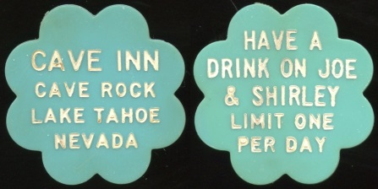

649 CAVE INN / CAVE ROCK / LAKE TAHOE / NEVADA // Have A / Drink On Joe / & Shirley / Limit One / Per Day, white incuse imprint on blue pl sc-8 30mm. Not a late modern token. Unlisted locality! ………..….. G3-($64-$125)

OHIO
OHIO MERCHANT TOKENS, Second Edition, Gaylor Lipscomb (1994)

650 N.E.L.A. / (c/ham) / 1913 // (same), (Cleveland), al rd 20mm. Unlisted in series. ………………..……………............ G4-($8-$16)

651 JOHN H. WEBER / 220 / LAKE ST. // Good For / ¢25¢ / In Trade., (Cleveland), al rd 29mm. Unlisted value CL5050. Also attributed to Minneapolis, MN. … G5-($8-$16)

652 (c/ham) / 303 TROY ST. // Good For / 5 (c/h) ¢ / In Trade, (Dayton), br rd 21mm. Unlisted! .................................... G4-($8-$16)

OKLAHOMA / OT / IT
OKLAHOMA EXONUMIA, R.W. Chadwick (2007)

653 DEAN NOVELTY CO. / (c/ham) / MUSKOGEE, OKLA. // Good For 5¢ In Trade / (c/h), br rd 21mm. Listed 410 $5. ……………………………………... G4-($8-$16)

OREGON
OREGON TRADE TOKENS, James Hemphill (1992); supplement, Mike Gross, (2001)

654 HILLSBORO / COMMERCIAL / CLUB // Good For / 5¢ / In Trade, br rd 21mm. Listed R2. …………………….......…….. G3-($8-$16)

655 CENTRAL / (c/o C) / CAFÉ // Good For 25c In Trade / (c/o), (Klamath Falls), al rd 31mm. Unlisted value! … ….... G3-($8-$16)

656 J.C. MARQUAM / MARQUAM / ORE. // Good For / 5¢ / In Trade, br rd 21mm. Listed R5. ……………………..……...... G3-($16-$32)

657 VALE / TRADING / CO. / VALE, OREGON // Good For / 10¢ / In / Merchandise, al rd 18mm, porosity. Listed R4. G3-($16-$32)

TEXAS
TEXAS TRADE TOKENS, Jerry Adams (2009), compiled listings 1973, 1979, 1984, 1993, 1997 and others

658 (facsig: LEO. B. MILLS) / (c/ham) / 1518 FIRST AV. DALLAS, TEX. // Valueless Pleasure Check / (c/h), wm rd 21mm. Unlisted in wm. .......................... G4-($8-$16)

UTAH
UTAH TRADE TOKENS, H. Robert Campbell (2013)

659 WASATCH / (c/o star) / DAIRY FARM // Good For 1 / (c/o) / Quart Of Milk, (Murray), al sc-8 29mm. Listed S $20-30. .. G4-($16-$32)

WASHINGTON
WASHINGTON STATE TRADE TOKENS, Al Erickson (1998)

660 ABERDEEN / CIGAR / STORE / ABERDEEN, WASH. // Good For / ¢5¢ / In Trade, br rd 21mm. Listed R4. .. G3-($8-$16)
661 THE CLIMAX / CIGAR / STORE / ABERDEEN. // Good For / 5¢ / In Trade, br rd 21mm. Listed R5. …………….... G3-($8-$16)

662 BOWLING & CASS / (c/o cross) / ABERDEEN, / WN. // Good For / 5¢ / In Trade, br rd 21mm. Listed R6. ………... G3-($8-$16)

663 ROYAL CIGAR STORE / (c/o star) / ABERDEEN, WASH. // Good For 5¢ In Trade / (c/o), br rd 21mm. Listed R5. .... G3-($8-$16)

664 FOWLER / BROS / ARLINGTON // Good For / 5¢ / In Trade, br rd 21mm. Listed R4. …………………………………..…. G3-($8-$16)

665 FRANK ODELL / (c/o tri) / BLAINE, / WASH. // Good For / 5¢ / In Trade, br rd 21mm. Listed R5. …………….... G3-($8-$16)

666 AIRPORT RESTAURANT / KING COUNTY AIRPORT (BOEING FIELD) / 6900 AIRPORT WAY, SEATTLE // Good For / 12½¢ / In Trade, black imprint blue pl re 49x25mm. Listed R5. ….………………...... G4-($16-$32)

667 CLUB CIGAR / STORE / 1503 HEWITT / EVERETT, WN. // Good For / 5¢ / In Trade, br rd 21mm. Listed R6. ………..…. G4-($8-$16)

668 JOHN POZAR / GRAND COULEE CLUB // Good For / 5¢ / In Trade, br rd 21mm. Listed R5. …………………..……..……. G3-($8-$16)

669 HOWE SOUND CO. / HOLDEN, / WASH. / CHELAN DIVISION // Good For / 50¢ / In Trade Only, al rd 31mm, wavy. Listed R7. ……………………………………. G3-($16-$32)

670 PASTIME CLUB / PUYALLUP / WASH. // Good For / 5¢ / In Trade, br rd 20mm. Listed R4. ……………………………….. G4-($8-$16)

671 F & F / 116 OCCIDENTAL // F & F / ¢5¢ / In Trade, (Seattle), br rd 21mm. Listed. ……………………..…..…….….... G3-($8-$16)

672 OLIVE WAY DINETTE / 1708 / BELLEVUE / AVE. / SEATTLE // Good For / 5¢ / In Trade, br rd 21mm. Listed. ……………………………………... G3-($8-$16)

673 A.B. PHEMING / SEATTLE, / WASH. // Good For / 5¢ / In Trade, al rd 21mm. Listed. ….…………………..……………... G5-($8-$16)

674 WASHINGTON ATHLETIC CLUB / W // Good For / $500 / In Trade, (Seattle), al rd 38mm. Listed. …………..……... G3-($8-$16)

675 ZERO BUFFET / LOUIS SPITZ, / PROP. / 214 / JEFFERSON / ST. / SEATTLE, WASH. // Good For / 5¢ / In Trade, br rd 24mm. Listed. .…………………..………...…..…. G3-($8-$16)

676 TERMINAL / HOTEL / JOE BEUZER / PROPRIETOR / SO. WENATCHEE, / WASH. // Good For / 25¢ / In Trade, br rd 26mm. Listed R1. .……………...…....…. G3-($8-$16)

677 TACOMA / (elk head) / ELKS // Good For / 5¢ / In Trade, br rd 21mm. Listed R4. ….................................................. G4-($8-$16)

678 FRED’S / SMOKE SHOP / 921 PACIFIC AVE. // Good For / 5¢ / In Trade, (Tacoma), br rd 21mm. Listed R6. ..…………. G4-($8-$16)
679 PEARCE’ CAFE / 1325 / BROADWAY, / TACOMA, / WASH. // Good For / 5¢ / In Trade, br rd 21mm. Listed R5. ……..…. G4-($8-$16)

680 TONASKET PASTIME / TONASKET, / WASH. // Good For / 25¢ / In Trade, br rd 24mm. Listed R4. …….………... G3-($8-$16)

UNATTRIBUTED MAVERICK
Mavericks: 2nd Edition, A Digital Aid to Attributing Maverick Tokens, Tony Chibarro & Randy Partin. (2nd edition CD-ROM data base). “Unlisted” denotes that the piece is not included on this CD, while “Listed” denotes that the token is listed, but not attributed.

681 GOOD FOR IN TRADE / 25 (across: CENTS) / (Chinese character within diamond) / M.L. CO. // (same), br rd 24mm. Schimmel lists a 50 Cents value. ….…….. G5-($16-$32)

A dollar amount range is provided is for bidding guidance only.
CANADA

682 SAFETY FIRST / (on bell: THE / BELL / TELEPHONE / CO. OF CAN.) / LAST AND ALWAYS // Always Think / Stop! / Is It / Safe / ? / Prevent Accidents, bimetallic w/al frame bz center rd 34mm. ………....….... G4-($32-$64)

683 THE ENTERPRISE CO. / (c/ham) / MONTREAL CANADA // Good For / 5¢ (c/h) In / Trade, br rd 21mm. .................. G3-($8-$16)

684 A.W.M. KELLY / GENERAL / MERCHANT / HARDY, SASK. // Good For / 5¢ / In / Merchandise, al rd 22mm. Unlisted by Tannahill for listed merchant. ... G3-($32-$64)

685 Similar but 25¢ 29mm. Unlisted! …………………..……..…...……. G3-($32-$64)

FOREIGN

686 (Bolivia) PAGARA A LA VISTA DANIEL M. QUIROGA / (within wreath: CINCO / CENTA- / VOS.) // Departmento De Cochabamba / (fountain), wm rd 16mm, reeded edge. Listed Rulau Coc 11. Gem! ……………………,,…………..… G5-($16-$32)

687 (Costa Rica) HACIENDA GUAYBOS / A.G.S. // (cloth sack labeled: Oropesa / London), al rd 22mm. Unlisted! G5-($16-$32)

688 (Ceylon) GEORGE STEUART & CO / 1843 / CEYLON // (characters) Wekande (characters) / (coffee drying scene) / (characters) Mills (characters), bz rd 29mm, reeded edge. …………….…….. G4-($32-$64)

689 (Cuba) CENTRAL SANTA LUCIA / (palm tree) / GIBARA // Vale Por Una Racion / (monogram: RLS) / 1884, wm rd 19mm. Listed Rulau Ori 27. …………..……… G3-($16-$32)

690 Similar Media Racion 1886, 17mm, dinged up. Listed Ori 32. ……… G2-($8-$16)

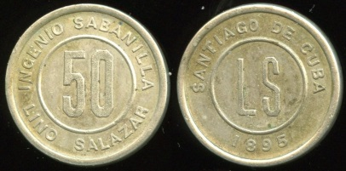

691 (Cuba) INGENIO SABANILLA / 50 / LINO SALAZAR // Santiago De Cuba / LS / 1895. wm rd 22mm. Listed Rulau Ori 90. ………….……………………..... G4-($64-$125)

692 (Curacao) J X CO // 1 / Stuiver, wm rd 15mm. Listed Rulau Cur 5. ..… G3-($32-$64)

693 (El Salvador) LUIS C. RUIZ / AHUACHAPAN // Los Tres Cipreses / ½ / Cajon / Suntecuma. / (sm: L.H. Moise S.F.), bz rd 28mm, punched center of C. Unlisted! ……………………………….…… G3-($16-$32)

694 (El Salvador) FINCA MATILDE // Medio / Real, br rd 19mm. Listed Rulau Slv 5. ………………………………...…. G4-($16-$32)

695 (El Salvador) SANTA EMILIA CO. / 5 / EL SALVADOR / (sm: P. & M.K.) // (same, no signature), br rd 21mm. Rulau unlisted! ……….………………..……….… G3-($32-$64)

696 (France) CASINO MARIE-CHRISTINE / 20 / LE HAVRE // (monogram: CH), br rd 26mm. ………………................. G3-($16-$32)

697 (Guatemala) ROMUALDO PACHECO / 1 / REAL / 1880 // Las Delicias / Costa Cuca, wm rd 20mm. Unlisted Rulau! G3-($16-$32)
698 (Guatemala) ViJ // Las Mercedes, bz rd 20mm. Listed Rulau Gma 338. G3-($16-$32)
699 (Guatemala) EL ROSARIO BOLA DE ORO. / (tree) / 1872 / COSTA CUCA. // Mariano De J. Anguiana / ½ / Guatemala, wm rd 21mm. Listed Rulau Quz 5. G4-($16-$32)
700 (Honduras) LAFFITE Y DEVAUX / LA CEIBA / HONDURAS // Debemos Al Portador / ½ / Real, br rd 29mm. Listed Rulau Atl 16. ……………………………….…… G3-($32-$64)
701 (Honduras) J. HIRIGOYEN / HONDURAS / SALADO // Se Recibe / (sailboat) / Por ½ Real, br rd 24mm. Rulau listed Atl 33. ………….....…..…. G3-($32-$64)

702 (Honduras) J.A. AYBAR / 6¼ / CENTAVOS / PUERTO CORTES / HONDURAS // Se Recipe Por / 6¼ / Centavos, wm rd 19mm. Rulau listed Crt 18. …....…………………………..…. G4-($32-$64)

703 Similar but 12½ 24mm. Unlisted! ……………………………..…..… G4-($32-$64)

704 (Honduras) N. HOWELL & CO. / UTILLA / HONDURAS // Debemos Al Portador / ½ / Real, br rd 25mm. Rulau unlisted! ………………………..………….. G3-($32-$64)

705 (Jamaica) JAMAICA / STREET / CAR COY LD // One / 1 / Fare, wm oc 19mm. Smith listed 420A. …............................. G3-($8-$16)

706 (Mexico) F.J. KEOGH / (c/ham) / NACO, SONORA, MEXICO // Good For 5¢ / (c/h) / In Trade, br rd 21mm. Rulau unlisted! ……………………………..….… G4-($16-$32)

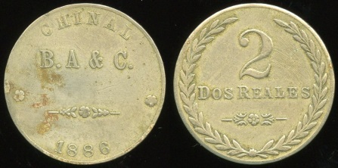

707 (Mexico) CHINAL / B.A & C. / 1886 // (within wreath: 2 / Dos Reales, wm rd 26mm. Rulau listed Tab 4 with errors. …………………………..…...... G3-($64-$125)

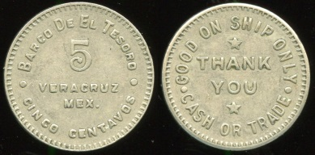

708 (Mexico) BARCO DE EL TESORO / 5 / VERA CRUZ / MEX. / CINCO CENTAVOS // Good On Ship Only / Thank / You / Cash / Or / Trade. Ship of the Treasure! Rulau unlisted! ………………….…. G4-($64-$125)

709 (Mexico) FICHA CONVENCIONAL / PARA LAS / FINCAS / DE / A.L. PEON // (within wreath: 10 / 1914), wm rd 21mm. Listed Rulau Yuc 191. ………. G3-($32-$64)

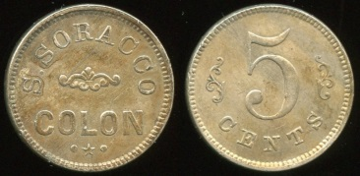

710 (Panama) S. SORACCO / COLON // 5 / Cents, wm rd 20mm. Listed Rulau Col 65. ……………………………….…. G4-($64-$125)

711 (Panama) CIA. / PAN. / DE F. Y L. // Cents / 10 / Silver, wm rd 18mm. Rulau unlisted! …………………….…. G3-($16-$32)

712 (Peru) HACIENDA PUENTE / (c/ham) / 1878 / SANTA // Vale / 10 / (c/h) / Centavos / Dionisio Derteano, wm rd 23mm, obverse worn. Rulau Anc 2. …….….…. G2-($16-$32)

713 (Philippines) SOUTHEASTERN COLLEGE / 5 / PASAY CITY // Canteen / 1963, bz rd 18mm. ……..………. G3-($8-$16)

714 (Puerto Rico) HACIENDA / 2 / ALMUD / VEGA REDONDA // (same), br rd 32mm. Rulau Lsm 15. …………..….…. G4-($16-$32)

COAL
EDKINS CATALOGUE OF UNITED STATES COAL COMPANY STORE SCRIP, (Volume I Exclusive of West Virginia), Bill Williams & Steve Ratliff (1997); National Scrip Collectors Association, companion Volume II, second edition (1984)

===== West Virginia =====

715 BARNETT – RUMBLE CO. / 10 // Good For / 10 / In Trade, (Seth), bimetallic rd 25mm. Listed 2555 B10 R9. G3-($32-$64)

LUMBER
CATALOGUE OF LUMBER COMPANY STORE TOKENS, Terry N. Trantow, assisted by Bill Williams, (Second Edition 1998)

716 (hanging badge) (clip hanger) / (saw blade shaped hanger with reverse pin, wm 41x7mm: E.C. ATKINS & CO. / WARRANTED AAA CAST STEEL / INDIANAPOLIS, IND.) / badge, wm saw toothed rd 31mm: (suspension loop) / INDIANA RETAIL LUMBER DEALERS ASSOCIATION / INDIANAPOLIS JAN. 10.11.1905 / (tower) // Established / 1857 / (facing male bust) / E.C. Atkins). Quite an unusual badge! ....................... G5-($16-$32)

717 GENUINE FOUR LEAF CLOVER / SUTHERLAND / LUMBER / CO. / 19TH & WYOMING / K.C., MO. / GOOD LUCK // (blank), red imprint on clear plastic with metal collar rd 30mm. Listed Tantrow 1174G R4, Most unusual! ………....……... G5-($16-$32)

MILITARY
MILITARY TOKENS OF THE UNITED STATES, Volume I (Domestic Issues), (1997); Volume II (Overseas Issues), (1998), Paul A. Cunningham

===== Arkansas =====

718 POST EXCHANGE / 5¢ / 1 ST ARK. INF. // (same), al rd 21mm. Listed AR240a. ..……………………………..…... G3-($32-$64)

===== California =====

719 N.C.O. CLUB / MARCH / FIELD / CALIFORNIA // Good For / 10¢ / In Trade, br rd 19mm. Listed CA600b $25. G3-($16-$32)

720 N.C.O. / CLUB / MOFFETT / FIELD // Good For / 10c / In Trade, al rd 18mm. Listed CA1000b $25. ……...………..... G5-($32-$64)

721 NALF / MONTEREY / CALIF. / COMMISSIONED OFFICERS MESS // Good For / 1 / Free / Drink, wd/black imprint rd 38mm. Naval Auxiliary Landing Field. Unlisted! …………………....…. G5-($32-$64)

722 U.S. SUBMARINE VETERANS OF WWII / GOOD FOR / ONE DRINK / “CONNING TOWER” / SAN FRANCISCO / CHAPTER // Wood Nickel / (Indian head), wd/blank imprint rd 38mm. A congressionally chartered veterans organization. Unlisted! ………..............................…..…. G5-($32-$64)

===== Georgia =====

723 ELEVENTH CAVALRY / 5 / POST EXCHANGE // 5, (Fort Oglethorpe), al rd 21mm, rim nicks. Listed GA350a. …………………..…...………….. G3-($32-$64)

===== Illinois =====

724 C.P.O. CLUB / GREAT LAKES / ILL. // Good For / 10¢ / In Trade, al rd 25mm. Listed IL140. ………..…..……..…….. G3-($64-$125)
===== Indiana =====

725 POST EXCHANGE / FT. BENJ. HARRISON // 5 / (c/s 4), br rd 21mm. Listed IN100a. …………….….....…….. G3-($32-$64)

===== Kentucky =====

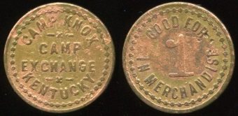

726 CAMP KNOX / CAMP / EXCHANGE / KENTUCKY // Good For / 1 / In Merchandise, br rd 18mm, coppery. Listed KY130. ……………..………..…..…….. G3-($125-$250)

===== Louisiana =====

727 N.C.O. CLUB / B.A.F.B. // Good For / 5¢ / In Trade, (Barksdale AFB), br rd 22mm. Listed LA30d. …………….……..…….. G4-($16-$32)
===== Missouri =====

728 GOOD ONLY / AT / 4TH INFANTRY / POST EXCHANGE / 5¢ / IN TRADE / WOOD / T.C. // 5, (Fort Leonard Wood), al rd 21mm. Listed MO200a. …..……..…….. G3-($32-$64)

===== Ohio =====

729 COMPETITOR’S / MESS / CAMP PERRY, O. // (same), al rd 26mm. Listed OH110. …………………..…….. G3-($32-$64)

===== Rhode Island =====

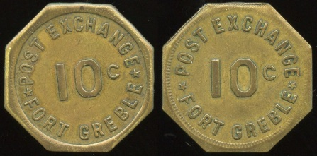

730 POST EXCHANGE 10C / FORT GREBLE // (same), br oc 26mm. Listed RI170d. …………..……..………...…….. G3-($64-$125)

===== South Dakota =====

731 P.X. BUS ONLY / U.S. ARMY / FT. MEADE, S.D. // Good For / 5¢ / In Trade, br rd 26mm. Listed SD180a, Atwood-Coffee 370A. …………….………..……..…….. G3-($32-$64)

===== Texas =====

732 FORT HOOD / EXCHANGE // Good For / 10¢ / When / Returned / With Empty Bottle, al rd 25mm. Listed TX1270a. ….. G3-($32-$64)

===== Virginia =====

733 LANGLEY AIR FORCE / BASE / VIRGINIA // Redeemable In trade / 25¢ / At / N.C.O. Club, gilt br rd 25mm. Listed VA110a. ………….……………..…..…….. G5-($32-$64)

===== Cuba =====

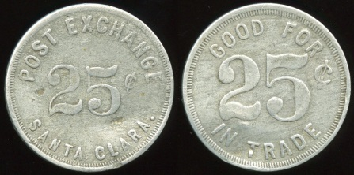

734 POST EXCHANGE / 25¢ / SANTA CLARA. // Good For / 25¢ / In Trade, al rd 29mm, dent. Listed CU190. G3-($125-$250)

===== Ships =====

735 SHIP’S SERVICE / U.S.S. / CUYAMA // Good For / 25¢ / In Trade, al rd 21mm, many small nicks. Listed SH160c. ... G2-($32-$64)

Please be sure your advance bids are submitted in time to meet the closing deadline of Saturday, November 30. In the event of a tie high bid amount, the earliest submitted bid will be awarded the lot.

ENCASED COIN
CALIFORNIA ENCASED AND STICKERED COINS, Duane H. Feisel (2003)

Note: Al frame unless otherwise noted.

===== Alabama =====

736 ZAMORA TEMPLE, B’HAM, ALA. / GEO. A. MATTISON, JR. / (cent 1949) / (to left: FOR / IMPERIAL) (sword & star) (to right: OUTER / GUARD) // KMANGB / IB / GL, hs 35x41mm. ………………………..….…..…... G5-($16-$32)

===== California =====

737 SMITH AND PATTERSON / 2½ MI. SO. ROSEVILLE / (cent 1946) / HARDWARE FURNITURE STORE // KM / AYW / H / GL, (Citrus Heights), hs 35X41mm. Listed F-1. ..………………………..…......…. G4-($16-$32)

738 PENNEY (hole) BUICK CO. / 1347 L ST. FRESNO / (cent 1955D) / BE PENNEY WISE // KM / AYW / H / GL, rd 35mm. Listed F-12. ..…………………..……..…......…. G3-($8-$16)

739 VALLEY INSURANCE SERVICE / ALL KINDS OF INSURANCE / (cent 1946) / PH. 3-1131 / 1933 MERCED (hole) FRESNO // KMANBG / IB / GL, hs 35X40mm. Listed F-20. ..………………………..…......…. G4-($16-$32)

740 FORTUNE CLUB / LEGAL CARD GAMES / (cent 1946) / 15510 S. WESTERN / GARDENA (hole) CALIF. // KMANGB/ IB / GL, hs 35X40mm. Listed F-2. ....... G3-($16-$32)

741 GOOD FOR A DOLLAR WHEN OPENING ACCOUNT / ROGER - HOLMES / (cent 1935) / JEWELERS / 6326 HOLLYWOOD BLVD // KMANGB / IB / GL, (Hollywood), rd 35mm. Listed F-11. ……………………………………. G4-($16-$32)

742 DUANE H. FEISEL / BOX 1302 / LOS ALTOS, CA 94022 / (cent 1977D) / 415-941-2690 / (to left: GOOD / FOR) (hole) (to right: ONE / DRINK) // KMANGB / IB / GL, hs 35x41mm. Listed F-1a. ..…...…. G5-($8-$16)

743 DEARDEN’S FURNITURE CO. / 712-718 SO. MAIN ST. / (cent 1929) / LOS ANGELES, CAL. / LONG TERMS – NO INTEREST CHARGES // Good For $1.00 / Down Payment / (cent) / On Any Purchase / Of $10.00 Or More, rd 31mm. Listed F-46. ………………………………….... G4-($16-$32)

744 DEPENDABLE DICALITE / (to left: SILVER / ANNIVERSARY) (quarter 1954) (to right: SILVER / ANNIVERSARY) / 1930 – 1955 // Dependable Dicalite / (quarter) / Diatomite Materials, (Los Angeles), gilt bz rd 38mm. Listed F-48. ……………………. G4-($32-$64)

745 A.E. NUGENT CO. / (cent 1947D) / 400 S. LA BREA / LOS ANGELES 36, CALIFORNIA // KMANGB, rd 35mm. Unlisted! ……………………….. G5-($8-$16)

746 HIGA’S AUTOM. TRANSMISSIONS / 3100 BEVERLY BVD. / (cent 1964D) / MONTEBELLO RA 3-5822 / (hole) // KMANGB / IB / GL, hs 36x41mm, nicks, scrape. Listed F-1. ..……………….……….……. G3-($8-$16)

747 MARTIN POLLARD CO. / (cent 1948) / 5430 LANKERSHIM BLVD. / NORTH HOLLYWOOD, CALIF. // KMANGB, rd 35mm, edge clip. Listed F-2. ……..…. G4-($16-$32)

748 RAIN * NEWELL’S * CHECK / 497 SAN MATEO AVE. / (cent 1978D) / 588-4100 / SAN BRUNO, CA // KMANGB / IB / GL, hs 35X41mm. Listed F-5. …….…... G5-($8-$16)

749 JOY’NT (hole) CLUB / MISSION 7-5230 / (cent 1947) / 4414 THIRD ST. / SAN FRANCISCO // KMANGB / IB / GL, hs 35x40mm. Listed F-42. …..……. G3-($8-$16)

A dollar amount range is provided is for bidding guidance only. Lots may sell for at a level above or below the indicated amount.
750 WM. VOLKER & CO. / KANSAS CITY / (cent 1925) / DENVER HOUSTON DALLAS / SAN FRANCISCO – LOS ANGELES – SEATTLE // KMANGB / IBGL, rd 32mm. Listed F-75. 7 cities, 5 states! G3-($16-$32)

751 RANDOLPH’S JEWELERS / DIAMOND 4-2631 / (cent 1960D) / SAN MATEO (hole) CALIF. // KMANGB / IB / GL, hs 36x41mm. Listed F-3. ..………....…………. G4-($16-$32)

752 VULCA (hole) SEAL / (emblem) (quarter 1962D) (emblem) / LUNDAY – THAGAARD OIL CO. // 1937 (hole) 1962 / To / (quarter) / 25th Anniv. (all incuse black filled O&R), (South Gate), chrome-plated ?? rd 38mm. Listed F-3. ……………………… G4-($32-$64)

===== Colorado =====

753 BROMSTEAD’S / “IT’S DIFFERENT” / (cent 1947) / 1545 BROADWAY / DENVER // KMANGB / IB / GL, hs 35x40mm. …………………………….……… G5-($16-$32)

754 BROMSTEAD’S / “IT’S DIFFERENT” / (cent 1948) / 1545 BROADWAY / DENVER // KMANGB, rd 35mm, worn, hole added 5:00 position. ………………..………... G2-($8-$16)

755 FIDELITY NATIONAL INSURANCE COMPANY / (cent 1950D) / DENVER // KMANGB / IB / GL, rd 35mm. .. G5-($16-$32)

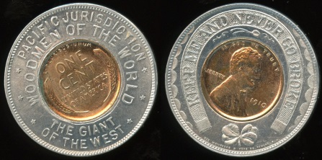

756 PACIFIC JURISDICTION / WOODMEN OF THE WORLD / (cent 1910) / THE GIANT / OF THE WEST // KMANGB / (cent) / (sm: The Whitehead & Hoag Co. Newark. N.J.), (Denver) , rd 35mm. …………... G5-($32-$64)

757 SOUVENIR (hole) OF / PIKES PEAK / (cent 1950D) / ALTITUDE 14,110 FT. / COLORADO // KMANGB / IB / GL, hs 35x41mm. …………………….... G3-($16-$32)

758 UNLIMITED HOME TELEPHONE / 4 CENTS PER DAY / C.T. CO. (missing cent 1901) PUEBLO / BUSINESS TELEPHONES / 5 CENTS PER DAY. // GL / KM / AP, rd 38mm. ………………………..….……..... G3-($32-$64)

759 ROYAL (hole) GORGE / WORLD’S HIGHEST BRIDGE / (cent 1954D) / ALTITUDE 6900 FT. / COLORADO // KMANGB / IB / GL, hs 35x41mm. ……..…….……... G3-($16-$32)

===== Connecticut =====

760 SAVITT / (to left: SAVE / MONEY AT) (cent 1935) (to right: JEWELERS / 40 ASYLUM ST. / (to left: GOOD / FOR) $100 (to right: ON $10.00 / PURCHASE) // KMANGB, (New Haven), rd 35mm. ……… G4-($16-$32)

===== Illinois =====

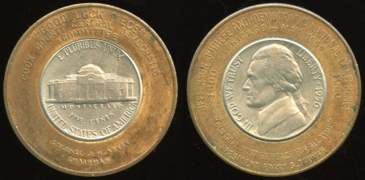

761 “GOOD LUCK PIECE” / COOK COUNTY CENTRAL DEMOCRATIC / COMMITTEE / (nickel 1950) / COLONEL J.M. ARVEY . CHAIRMAN // Jefferson Jubilee And Democratic National Conference / Chicago – May 1950 / 1800 (nickel) 1950 / “Our Goal Must Be Peace For All Time” / President Harry S. Truman, bz rd 35mm. Quite an amazing encasement! ……….………... G5-($64-$125)

762 PLANT / COLUMBIANA SEED / (cent 1946) / COLUMBIANA SEED CO. / ELDRED, ILLINOIS // KMANGB / IB / GL, hs 35x40mm. …………………..………..……... G5-($16-$32)

763 HANNA CITY ELEV. CO. / (cent 1946) / H. C, HEINTZMAN, MGR. // KMANGB, rd 35mm. ………………..……….... G3-($16-$32)

764 GOOD FOR $1.00 SAVINGS ACCOUNT – BANK AND SAVE / SECURITY NATIONAL BANK / (cent 1930) / 1102 BROADWAY / ROCKFORD, ILL. // KMANGB / IB / GL, hs 35x40mm. ……………..……..... G5-($32-$64)

===== Iowa =====

765 LINCOLN SEED & FEED CO. / (cent 1946) / SIOUX CITY’S PET SHOP / 3RD AND PEARL // KM / AYW / H / GL, rd 35mm. ……………………..……………… G5-($8-$16)

===== Kansas =====

766 (raised lettering: EARN MORE / WITH / VICKERS / OIL) // (3 prongs holding nickel 1964D), (Wichita), translucent plastic triangle 51x44mm. Unusual! …….…... G5-($16-$32)

===== Maryland =====

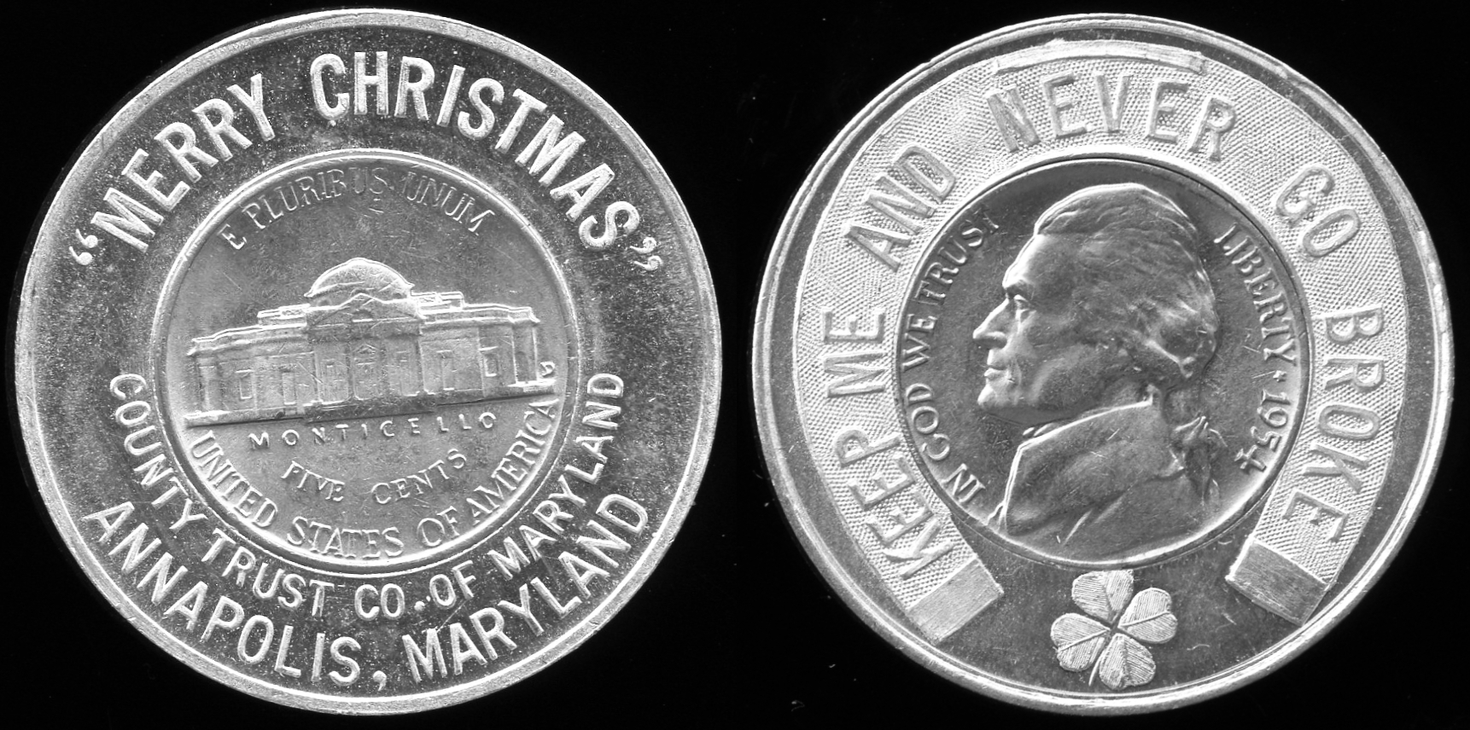

767 “MERRY CHRISTMAS” / (nickel 1954D) / COUNTY TRUST OF MARYLAND / ANNAPOLIS, MARYLAND // KMANGB, rd 35mm. ………..………….……... G5-($32-$64)

===== Massachusetts =====

768 BAKER BROS. / (cent 1944D) / THE ALWAYS BUSY SHOE STORE. / BROCKTON. // KMAAHM, rd 35mm. ……………………...…………..... G3-($16-$32)

===== Missouri =====

769 WM. VOLKER & CO. / KANSAS CITY – DENVER / (cent 1918) / WINDOW SHADES / HOME FURNISHINGS. // KM / AYW / H / GL, rd 32mm. Two states! …….... G3-($16-$32)

770 WORLD’S FAIR / 19 (cent 1904) 04 / ST. LOUIS // KMANGB, rd 35mm. .. G5-($16-$32)

771 ROBERT’S CLOTHING CO. / (cent 1949) / 4009 CHOUTEAU AVE. / (hole) // KM / AYW / H / GL, (St. Louis), rd 35mm. .…. G5-($8-$16)

===== Nebraska =====

772 JONES BARREL CO. / (cent 1945) / 1409 NO. 20TH / JA. 2231 // Victory / (cent) / V-E Day May 8 / V-J Day Sept 2 / World / Peace, (Omaha), rd 35mm. .……….…… G5-($8-$16)

773 MEMBERSHIP / CARD / (cent 1950D) / NORTHRUP – JONES COFFEE CLUB // KMANGB, (Omaha), rd 35mm. .. G5-($8-$16)

===== Nevada =====

774 LAS VEGAS, NEVADA / (cent 1968D) / (hole) // KMANGB / IB / GL, hs 35x41mm. ………………………....………... G5-($16-$32)

775 ELDORADO CLUB / LAS VEGAS , NEV. / ROULETTE (cent 1948D) CRAPS-21 / RACE (hole) BOOK // KMANGB / IB / GL, hs 34x40mm. ................................ G3-($16-$32)

776 SILVER CITY CASINO / LAS VEGAS / (cent 1975) / THE FUN SPOT OF THE STRIP / (hole) // KMANGB / IB / GL, hs 36x41mm. ……………..…………..………… G5-($16-$32)
777 Similar but (cent 1975D) G5-($16-$32)

778 BRIGHT (hole) SPOT RENO / (cent 1972D) / WHERE THE JACKPOTS ARE // KMANGB / IB / GL, hs 35x40mm. G5-($8-$16)

779 BREAK THE BANK AT HAROLD’S CLUB / AND YOU WILL HAVE PLENTY / (cent 1946) / RENO, NEVADA // KMANGB / IB / GL, hs 35x40mm. ……………….………. G5-($8-$16)
===== New Hampshire =====

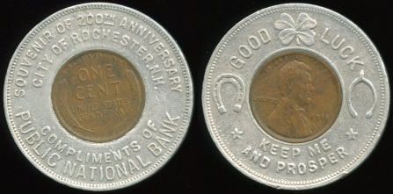

780 SOUVENIR OF 200TH ANNIVERSARY / CITY OF ROCHESTER, N.H. / (cent 1918) / COMPLIMENTS OF / PUBLIC NATIONAL BANK // Good Luck / (cent) / Keep Me / And Prosper, rd 38mm. ……....…... G4-($64-$125)

===== New York =====

781 CAPLAN BROS. (hole) FURNITURE CORP. / 234 S. PEARL ST. / (cent 1952D) / 42ND / ANNIVERSARY // KM / AYW / H / GL, (Albany), rd 35mm. ………..….... G3-($8-$16)

782 WESTCHESTER COMMERCIAL SCHOOL / PREPARE HERE FOR SUCCESS / (cent 1929) / DAY AND EVENING SESSIONS / NEW ROCHELLE, N.Y. // KMANGB, rd 35mm. ………..... G4-($16-$32)

===== Ohio =====

783 BELPRE HIGH SCHOOL BAND / HOMECOMING 1948 / (cent 1947) (hole) // KMANGB / IB / GL, hs 35x40mm. G3-($8-$16)

784 GREENWALD’S – JEWELERS / 7TH & VINE / (cent 1937) / USE YOUR CREDIT / FAMOUS FOR VALUES – SINCE 1896 // Good For $1.00 / On Account / (cent) / On Any New Purchase / $10.00 Or Over, (Cincinnati), rd 35mm. ………….…....……... G4-($16-$32)

785 THE PEOPLE’S SAVINGS BANK CO. / (cent 1936) / CONTINUOUS SERVICE / 1904 – MT. GILEAD, OHIO - 1936 // KMANGB, rd 35mm. ………………..………... G4-($16-$32)

===== Oklahoma =====

786 AMERICA FOREVER / BROWN’S / SILVER JUBILEE / 1915 (cent 1940 off-center downward) 1940 // (cent) / Heads To Earn / Hearts To Spend, (Oklahoma City), rd 32mm. ……………………..….……….... G4-($16-$32)

===== Oregon =====

787 FRANK J. GROSS REAL ESTATE / 122ND & S.E. DIVISION AL 2-1451 / (cent 1959D) / PORTLAND,ORE / 144 // KMANGB, rd 35mm. ……………...……........ G4-($8-$16)

===== Pennsylvania =====

788 GOOD FOR $1.00 WITH EVERY / SUIT OR OVERCOAT / ONE TO A CUSTOMER / (cent 1924) / ZIMMERMAN / MY CLOTHIER / 564 MAIN ST. BETHLEHEM, PA. // KMANGB / IB / GL, hs 34x39mm, scratches. ……………………………………. G3-($16-$32)

789 THE UNION STORE / (cent 1936) / 401 MARKET ST. / CHESTER, PA. // KM / AYW / H / GL, rd 35mm. ...…....……... G4-($16-$32)

790 NEW CENTRAL HOTEL / (cent 1912D) / HASTINGS, PA. / J. PAUL RUE, PROP’R. // KMANGB, rd 35mm. ................ G4-($16-$32)

791 CHECKS CASHED / SUN RAY – WEISSMAN / (cent 1950D) / 4008 LANCASTER AVE. / MONEY ORDERS (hole) BILLS PAID // KMANGB / IB / GL, (Lancaster), hs 36x41mm. …………..……... G4-($16-$32)

792 THE PEOPLES BANK / (cent 1924) / MCKEESPORT, PA. // KMANGB / IBGL, rd 32mm. …………………..……... G5-($16-$32)

793 PITTSBURGH BANK FOR SAVINGS / FOURTH AVE. & SMITHFIELD ST. / (cent 1901) / BANK WITH US / 4% INTEREST // (good luck symbols) / (cent) / Keep Me / I Am The Nimble Penny, rd 35mm. .. G4-($32-$64)

794 WIEGAND’S CAFE / FORELAND & JAMES STS. / N. S. PGH. / (cent 1946) / “SOUVENIR OF OPENING” / OYSTER & COCKTAIL BAR / CE. 9957 // KMANGB / IB / GL, hs 35x40mm. ……………... G4-($16-$32)

===== Rhode Island =====

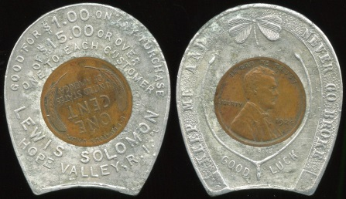

795 GOOD FOR $1.00 ON ANY PURCHASE / OF $15.00 OR OVER / ONE TO EACH CUSTOMER / (cent 1924) / LEWIS SOLOMON / HOPE VALLEY, R.I. // KMANGB / IB / GL, hs 34x40mm, mild pitting. …………………………….…..... G3-($64-$125)

796 RHODE ISLAND MUTUAL / (cent 1948) / LIABILITY INS. CO. / GOOD LUCK // Drive Carefully / (cent) / The Life You Save / May Be Your Own, (Providence), rd 35mm. ………….………..……….……... G5-($16-$32)

797 AUTO OWNERS FINANCE CO., INC. / 68 EXCHANGE PLACE / (cent 1939) / PROVIDENCE, R.I. / GASPEE 2405 / AUTO LOANS // KMANGB, rd 35mm. G5-($16-$32)

===== Virginia =====

798 BICKERS MOTOR CO. / FORD / (cent 1928) / WINCHESTER, / VA. // KMANGB / IB / GL, hs 35x40mm. ……..……… G5-($16-$32)

===== Washington =====

799 CARRY YOUR CLOTHES TO / CLOVER CLEANERS / AND SAVE / (cent 1930) / MEN’S SUITS 75¢ / ANY 1 PC. DRESS, / COAT OR COAT-SUIT $1.00 // KM / AYW / H / GL, (Everett), rd 35mm. …....... G4-($16-$32)

800 WHERE HOSPITALITY CENTERS / HOTEL GOWMAN / (cent 1941) / SEATTLE / T. HARRY GOWMAN / MGR. // KMANGB / IB / GL, hs 35x40mm. ……...……... G5-($16-$32)

===== Wisconsin =====

801 COIN COLLECTING CAPTURES TIME / YESTERDAY, TODAY & TOMORROW / (Wisconsin quarter 2004P) / 116TH ANNIVERSARY ANA CONVENTION / MILWAUKEE AUGUST 8-12 2007 // (clock face with Roman numerals), rd 39mm. ……..………………..…………... G5-($16-$32)

802 GLENN & AGNES WINESBURG / L & L BAR / (cent 1949) / 3000 W. FOND DU LAC AVE. / MILWAUKEE 10, WIS. // KMANGB, rd 35mm. …………………...……... G5-($16-$32)

STICKERED

===== California =====

803 COOKIES / CAFE / ARCATA / CALIFORNIA, gold/black imprint label rd 16mm on Lincoln cent, very scuffed. Listed F-S1. ……..……………….………... G2-($8-$16)

804 MONTEBELLO / LUCKY / PENNY / AUG. 19-20-21 / 1966 / FUN FESTIVAL, white/black imprint label rd 17mm on BU 1966 Lincoln cent. Listed F-S1. …….………... G5-($8-$16)

805 MONTEBELLO / LUCKY / PENNY / AUG. 18-19-20 / 1967 / FUN FESTIVAL, orange/black imprint label rd 17mm on BU 1967 Lincoln cent. Unlisted! …. G5-($8-$16)

===== Wyoming =====

806 I WAS / SPENT AT / KIMBEL’S / DRIVE IN / GREYBULL, / WYO., yellow/black imprint label rd 19mm on 1922S Peace dollar. ……..……………..…....………... G2-($32-$64)

KU KLUX KLAN
KU KLUX KLAN TOKENS, D.E.Birdsell (second edition 1980)

807 COMMEMORATING CALIFORNIA VISIT / (cross) / WELCOME / OF THE IMPERIAL WIZARD // A Compassionate Heart . A Chivalric Head / Hiram W. Evans / 1922 (facing male bust) 1926 / Non Silba Sed Anthar / A Prudent Tongue . A Courageous Will, br rd 31mm. Listed Birdsell KK-220. G3-($32-$64)

MASONIC / FRATERNAL

808 GRAND CHAPTER OF ROYAL ARCH MASONS / CENTENNIAL / YEAR 1954-’55 / (sm: KRRC / STERLING) / (stamped on panel: KEYSTONE / 56) / OF CALIFORNIA // (Masonic symbols, owners mark incuse in center), (San Bernardino), silver rd 32mrn. ………………………………..…… G2-($8-$16)

809 INDIAN CHAPTER NO 1 R.A.M. / INSTITUTED FEBY. 21 1878 / (keystone and symbols) / ONE PENNY / MCALESTER, I.T. // One / (keystone and symbols) / Penny, bz rd 32mm. ……………………..…… G3-($16-$32)

COMMEMORATIVE MEDALS,
EXPOSITION, FAIR, ETC.
SO-CALLED DOLLARS, Harold E. Hibler & Charles V. Kappen (1963)

===== California =====

810 CALIFORNIA PACIFIC INTERNATIONAL EXPOSITION / (buildings) / SAN DIEGO / 1935 // State Of California / (CA State Seal) / Souvenir, bz rd 24mm. …………. G5-($8-$16)

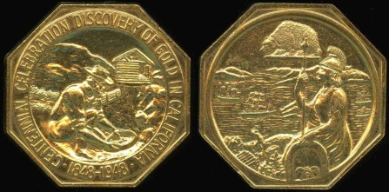

811 CENTENNIAL CELEBRATION DISCOVERY OF GOLD IN CALIFORNIA / (scene of miner panning) / 1848-1948 // (symbols of California), br oc 40mm. Popular slug facsimile in superb condition! …………………………………. G5-($125-$250)

MISCELLANEOUS

812 (GI dog tag) MC. KEWN / PVT. / CO. L. 8. INF. / U.S.A. / (h/am) (a/i) // (blank), al rd 31mm. ........................................ G3-($8-$16)

813 (magic) S. / (devil) / MASTER MAGIC // (same), wm rd 31mm, reeded. G4-($16-$32)

814 (membership card) IN APPRECIATION / ARTHUR W. ALTHOUSE / IS HEREBY GIVEN A / LIFE MEMBERSHIP / BY THE / KIWANIS CLUB / OF PASADENA, CALIFORNIA / OF WHICH HE WAS / PRESIDENT IN 1939 // (blank), all engraved on what appears to be thin silver-plated ?? re 88x62mm. Althouse headed up the Tournament of Roses in 1962. ……………………………………. G3-($16-$32)

815 (Mickey Mouse) 1 TROY OUNCE / SIXTY YEARS / (Mickey Mouse figure) / MICKEY / (sm: © DISNEY / WITH YOU / .999 FINE SILVER // (Mickey Mouse at ship’s helm) / (monogram), cameo proof silver rd 39mm, reeded edge. Issued on 6/15/88, the medal is in a sealed plastic case inserted into the page of a special “book” with inscription COMMEMORATIVE PROOF LIMITED EDITION. The “book” and a descriptive folder with Serial No. 49835 are housed in a special cardboard box stamped Steamboat Willie. A very special item! ……………… G5-($32-$64)
816 (mirror) (beer mug) / A.B. LUNCHEONETTE / AND / BEER PARLOR / 141 DECATUR, CORNER IBERVILLE ST. / “COIB SOIVICE” PLENTY OF PARKING SPACE / TRY OUR SIX COURSE / SUNDAY CHICKEN DINNER 25C / A. BONOMOLA, MGR. // (mirror), (New Orleans, LA), black imprint on white re 78x53mm. When is the last time you had a six-course dinner for 25¢? ………………………...………....... G5-($8-$16)

817 (movie) SEE / “AMERICAN / MADNESS” // Greatest / Picture / Of / The Year, br rd 24mm. A 1932 movie release. G4-($16-$32)

818 (personal, stamped) MARY ZANARDI SAN JUAN CAL. 1925 / (eagle) // (sm, incuse: Pat. 5-15-23 / Geo. W. Heene / Cleveland, O.), al rd 31mm, stencil cut star. …... G3-($8-$16)

819 (pinback) VICTOR / (head of man, facing) / MCLAGLEN) // (pin), white w/blue imprint tin rd 20mm. McLaglen was an English boxer and WW1 veteran who became a film actor in the US starting in the 1920’s. ……………………..…………...... G5-($16-$32)

820 (poker chip) (swastika) // (same), white w/blue imprint pl rd 39mm. Patterson listed. …………………………..……...... G4-($16-$32)

821 (swastika) MADAME (h/am) HENDREN / (doll) / TALKING AND WALKING DOLL // (h/am) / Good Luck / (swastika and good luck symbols) / Keep This Coin And Good Luck Will Follow, gilt bz rd 24mm. Patterson listed variety 2. ……………..………... G4-($16-$32)

822 (tool check) (h/am) / 238 / P.L. & P. CORP. (all incuse black-filled) / (h/am) / (sm, incuse: Patrick & Co. S.F.), br rd 31mm. Probably Pacific Light & Power Company. ……………………………………. G4-($16-$32)

BRIDGE MEDALS
This special assembly of medals and tokens is being offered in multiple piece group lots. Most of the items are in G5 condition.

823 London Bridge, AZ (2); Delaware Memorial Bridge, CT, Clearwater Pass Bridge One Fare, FL. 5 pieces! ............... ($16-$32)

824 All CA: Donner Lake; Alfred Zampa Memorial Bridge; Carquinez Bridge; two different San Francisco-Oakland Bay Bridge; Vincent Thomas Bridge. 6 pieces! ($16-$32)

825 All Madison County, IA Bridge Festival: Imes 1970 (2); Cutler-Donahoe 1971; McBride 1972; Holliwell 1973 (2); Cedar 1973 (2); Court House 1976; Festival 1978; multiple bridges 1979; Holliwell 1980; Cutler Donahoe 1981. 13 pieces! ………………..………... ($32-$64)
826 Cape Cod Canal Bridges, MA; C&O Canal Aqueduct, MD; Rose’s Mill Bridge, MD; The Mackinaw Bridge, MI (4 different); Blue Water Festival, MI. 8 pieces! .. G5-($16-$32)

827 Duluth, MN – Superior, WI; Port of Duluth, MN; Los Alamos, NM; New York Brooklyn Bridge, NY (3 different). 6 pieces! ($16-$32)

828 Astoria Bridge, OR; Waco Suspension Bridge, TX; Corpus Christi, TX; Windsor, Ontario; 1000 Islands Bridge, US-Canada. 5 pieces! …………..…….……..…..... ($16-$32)

829 Previous six lots as a single lot totaling 43 pieces. Winning bid must exceed the total of high bids for the individual lots. How about this as a start on an interesting new collecting topical? ……..………………....... ($125-$250)

A dollar amount range for Estimated Value when provided is for bidding guidance only. Lots may sell for an amount above or below the indicated Estimated Value.
NON-RETURNABLE BULK LOT

830 Mixed lot of 100 older trade tokens, mainly CA, includes a saloon token and a few foreign. Worthy of a serious bid. Lot of 100 pieces …………………..…..… G3-($64-$125)

831 Another similar. .............. G3-($64-$125)

832 Another similar. .............. G3-($64-$125)

REFERENCE MATERIAL

833 Pre-Prohibition CALIFORNIA SALOON TOKENS, by Duane H. Feisel. Profusely illustrated, fully indexed, hard bound 8½x11”, 304 pages, attribution / historical information, numerous go-with items pictured, Certainty of Attribution for all maverick tokens, catalog numbers assigned, Estimated Value for each listing, 300 copies printed, highly praised. Winner of the TAMS 2005 gold Mishler Exonumia Cataloging Award! …... $32 fixed

834 CALIFORNIA ENCASED AND STICKERED COINS, by Duane H. Feisel. 230 pages, imprinted card covers, 8½” x 11”, plastic comb binding, profusely illustrated, fully indexed. First time ever catalog of stickered coins. Introduces and explains the concept of Certainty of Attribution. Special sections on “Non-Traditional Encased Coins,” “Replaced Coins” & “Estimated Value.” Winner of the TAMS 2004 gold Mishler Exonumia Cataloging Award! …..................… $24 fixed

Place your fixed price “bid” to purchase either of these catalogs. Shipping will be by media mail, shipping charges added. Of course, no buyer’s fee!

Wishing you good luck
with your bidding!

Mail, E-Mail or Fax your bids to:
Duane H. Feisel
PO Box 212
Shingletown, CA 96088
(530) 474-4168
COLLECTOR.CA@FRONTIER.COM

UPCOMING SALE
Watch for my next sale – combined floor auction (Part 1) and mail bid (Part 2) – scheduled for March 22, 2014.

The live floor auction will be conducted in conjunction with the Western States Token Society Token Jamboree that will once again be held at the Clarion Hotel in Sacramento, CA. You can expect to see more information about the Token Jamboree in the coming months.

Consignments for this sale can be submitted starting right now and up through February 15, 2014 – however, the earlier the better to allow for advance publicity and the best quality auction catalog presentation. Some exceptional material has already been consigned in anticipation of a great sale!

My usual attractive consignment rates will apply.

