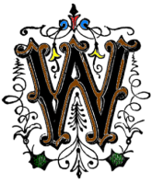

HEELING AREA GENEALOGICAL SOCIETY

The Lookout

Summer 2011 Newsletter Issue

*Our mission is to preserve the history of the people who have gone before us.*

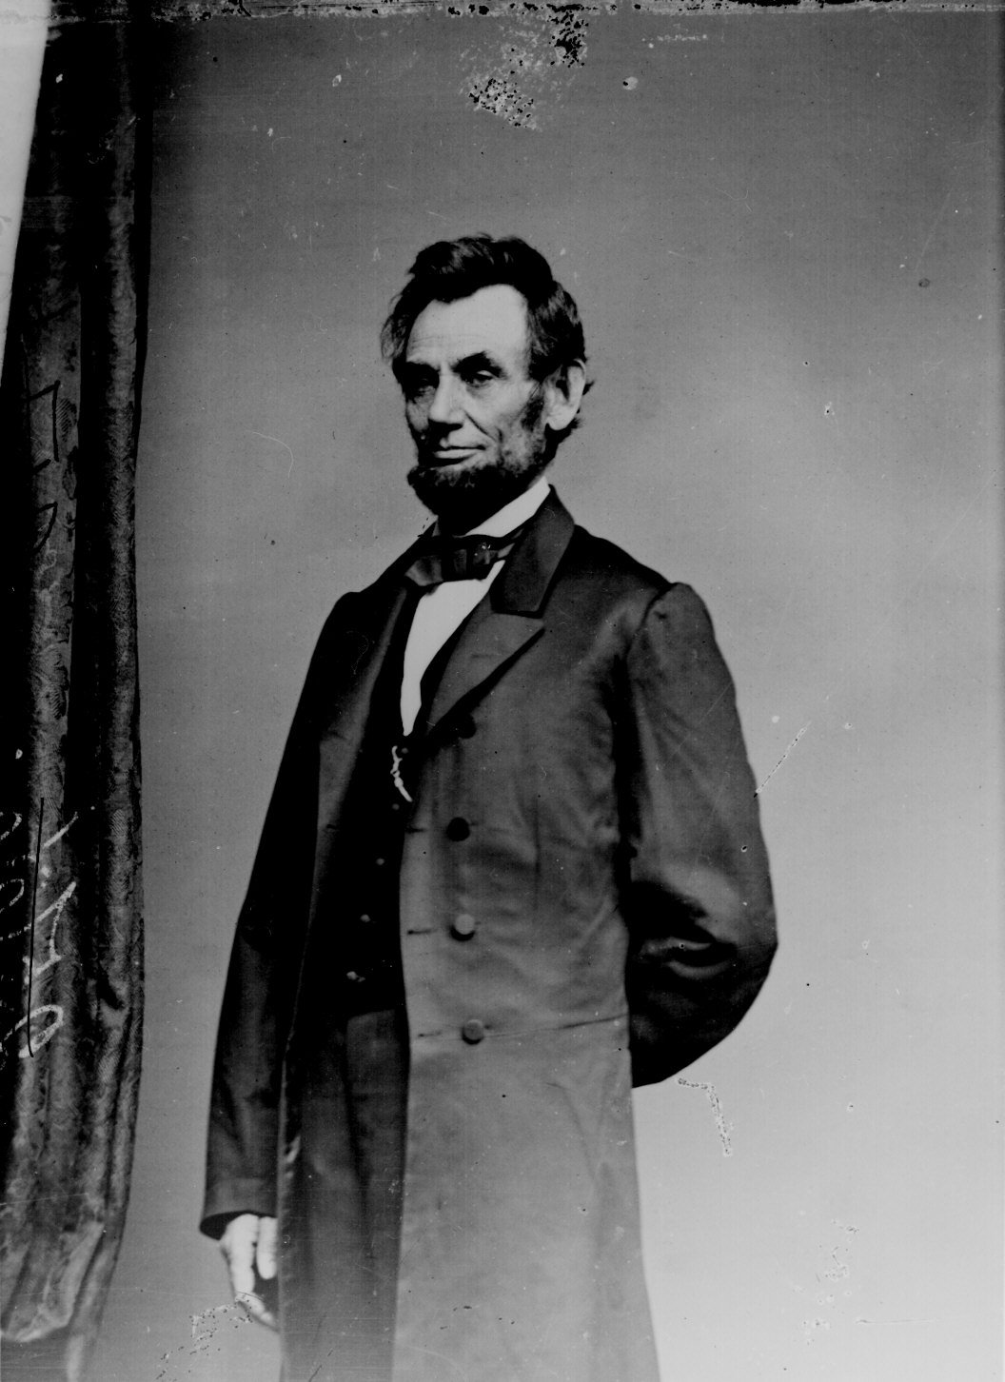

**Wheeling Civil War Genealogy . . .**

**Table of Contents**

Old Tent Cemetery 1

WAGS workshops 2,3

Projects updates 4

From the President 4

Committees 5, 6

Volunteers 7

Happenings in the area 7

Membership form 8

**Published by**

WHEELING AREA

GENEALOGICAL SOCIETY

Deacon Doug Breiding, Editor

P. O. Box 6450

Wheeling, WV 26003-6450

wagswv@gmail.com

**OHIO COUNTY PUBLIC LIBRARY**

52 - 16th Street

Wheeling, WV 26003

304-232-0244

**Library Hours:**

Monday - Thursday: 9am - 9pm

Friday: 10am - 5pm

Saturday: 9am - 5pm

Sunday: 1pm - 5pm

**~~~ WAGS Officers ~~~**

**President:**

Deacon Douglas Breiding

**Vice President:**

Ercella Shelek

**Recording Secretary:**

Sue Erlewine

**Treasurer:**

Jeanne Finstein

**Board of Directors:**

Marjorie Richey (through 2013)

Glenna Dillon (through 2012)

Phyllis Slater (through 2011)

During the sesquicentennial of the Civil War, many people focus on their Civil War roots. For those from what is now West Virginia, those roots may well include ancestors on both sides of the conflict.

Wheeling was a hotbed of activity during the early months of the conflict. Two days after the April 12, 1861 firing on Fort Sumter, President Lincoln issued a nationwide call for 75,000 troops for three-months service. The very next day, thirty men from Wheeling enrolled in a Union Guard, and by May 10 an entire unit, the First Virginia Infantry, mustered into service. The names of those who enlisted can be found on the WAGS website at: <http://www.lindapages.com/wvcw/1wvi/1wvi-appenda.htm>. Many of those men served out their three-months obligation and then reenlisted for three years. Those in the three-year service of the First Virginia/West Virginia Infantry can also be found on a WAGS website at: <http://www.lindapages.com/wvcw/1wvi/1wvi-appendb.htm>. An entire history of the unit, including these rosters, is at: <http://www.lindapages.com/wvcw/1wvi/1wvi.htm>

On May 17, 1861, just one week after the First Virginia Infantry mustered in, Daniel Shriver recruited a Confederate company. Known as the “Shriver Grays,” the company became part of the Stonewall Jackson Brigade. It’s said that the men convinced a local tailor to make suits for them for a secret wedding, making him pledge secrecy. They then provided gray cloth, and the “wedding suits” became Confederate uniforms. A roster of the Shriver Grays and a brief history of the unit are on the WAGS website at: <http://www.lindapages.com/wags-ohio/shriver.htm>

Our Homepage: [www.lindapages.com/wags-ohio/index.htm](http://www.lindapages.com/wags-ohio/index.htm)

Our email: [wagswv@gmail.com](mailto:wagswv@gmail.com)

Recent immigrants and others who lived and worked in the mills in Centre and South Wheeling were almost exclusively pro-Union. However, many of the old-line families of Wheeling felt loyalty to Virginia and so favored the South. A convention in Richmond supported secession if the majority of voters agreed. The vote was taken on May 23, 1861, and secession of Virginia was approved, despite that fact that most voters west of the Allegheny Mountains voted against it. A list of “Traitors in Wheeling” (<http://www.lindapages.com/wags-ohio/traitors.htm>) identified those who voted for secession. On that list were such prominent names as Zane, Hullihen, Sweeney, Riley, Phillips, and Steenrod.

The Special Census of 1890 is a good source of names of men who served in the war (almost all Union), survived the war, and lived in Ohio County at the time of the census. Widows are also listed. The census, along with many other Civil War links, can be found at: <http://www.lindapages.com/wags-ohio/index.htm>

While soldiers were enlisting and mustering into service, delegates met in Wheeling to debate the future of the western counties of Virginia. The First Wheeling Convention was held on May 13-15, 1861, shortly before the statewide secession vote. Delegates to that convention are listed at: <http://www.wvculture.org/history/statehood/delegateswc1.html>. A brief summary of the convention, including a link to the proceedings can be found at: <http://www.wvculture.org/history/statehood/statehood05.html>. The second convention began in Wheeling on June 11. That story can be followed at: <http://www.wvculture.org/history/statehood/statehood07.html>.

Other suggested sources for Civil War era genealogy include Ohio County census records, particularly those for 1860 and 1870, and Wheeling City Directories. These are not online but can be found in hard copy in the Wheeling Room of the Ohio County Public Library.

An invaluable online source is the Vital Records Research website of West Virginia: <http://www.wvculture.org/vrr/va_select.aspx>. Birth, death, and marriage records are available at no cost for every county in the state. Available years vary from county to county. As of this writing, Ohio County birth records include the years 1820 and 1853 to 1910; death records go from 1853 to 1970; and marriage records are included from 1790 to 1970.

For those interested in general Civil War information and histories, a search online can produce a number of period books with expired copyrights that can be downloaded free of charge. Sites such as Google Books (<http://books.google.com/>) and iPad resources such as iBooks and Free Books offer a wide variety of such books, including such titles as “The Rending of Virginia” by Granville Davisson Hall, “The American Civil War” by General E. P. Alexander, “The Civil War from a Southern Standpoint” by William Robertson Garrett, “Uncle Tom’s Cabin” by Harriet Beecher Stowe, “The Red Badge of Courage” by Stephen Crane, and “The Story of a Common Soldier of Army Life in the Civil War 1861-1865” by Leander Stillwell.

**WAGS Beginner’s Genealogy Classes begin . . .** The Society will begin offering beginner level introduction workshops to genealogy at the Ohio County Public Library. The classes will be about one hour long and will be offered on the odd numbered months of the year. They will alternate from beginning the third Tuesday evenings and Saturday mornings. These options will give most people a chance to work their own schedules to allow them the opportunity to experience the starting of a lifetime pursuit. This is a great opportunity for people to get acquainted with good direction in the discipline of genealogy, see what the Ohio County Public Library has to offer and become WAGS members.

All classes are held in the basement classroom of the library. The class being offered is being repeated throughout the year. It is not a series of classes at this point, but additional classes are under consideration. Our WAGS contact for this project is Doug Breiding. Following is a listing of dates for the year 2011.

May 17, 2011 at 6:30pm July 16, 2011 at 10:00am

Sept. 20, 2011 at 6:30pm Nov. 19, 2011 at 10:00am

**Say What??**

**Oh Those Confusing Genealogy Terms!**

There seems to be confusion among some genealogists as to the difference between an Abstract, an Extract, a Transcript or Transcription and an Image Copy.

Let's first define these terms:

**ABSTRACT** ~~or EXTRACT~~: This is a summary of a document. It is often in point form but can be in complete sentences. It contains all the important details such as names, places and dates.

**EXTRACT:** This is an exact copy of a portion of a document. Original spelling and grammar are retained

**TRANSCRIPT & TRANSCRIPTION:** This is an exact copy of a document. The entire document is written out exactly as found. No corrections or changes are made to the original. Punctuation, upper and lower case letters, any errors are kept as is. Misspellings are not corrected.

**IMAGE COPY:** A microfilm of a document. It could also be a photocopy, camera image or scan. Be careful to note whether the Image Copy is of an original document, transcript or extract.

Is it an exact copy of the original document, typed out or written out by a third party? If so, it's a Transcript or Transcription.

Perhaps you are looking at a microfilm of an original document (for example a church record or a census record). That is an image copy.

You might have found a book which gives summaries of wills. The full details of each will is not provided, but the book gives the main points - name of deceased, date of death, names of those mentioned in the will, date of signing and/or probate and names of witnesses. That is an Abstract

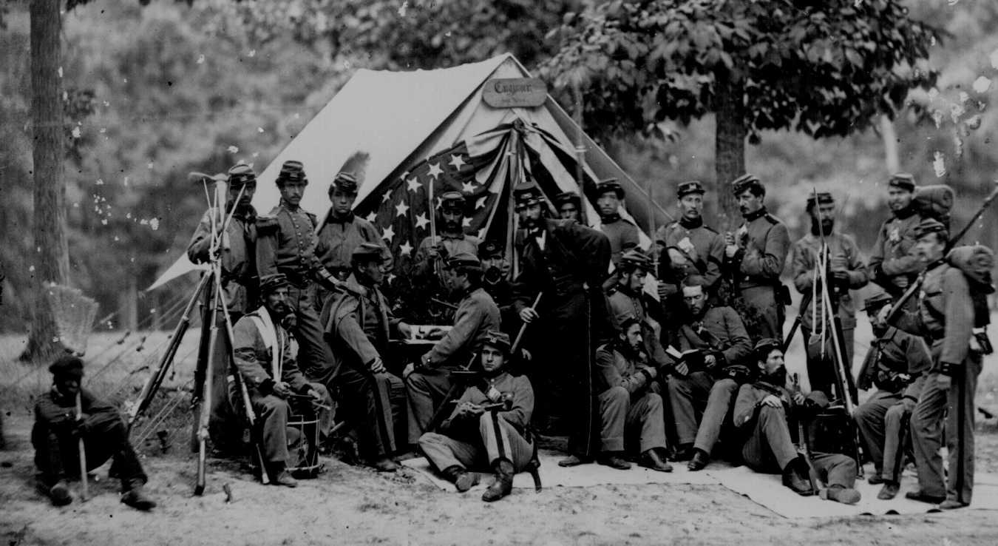Civil War Roots Workshop

As the Civil War began one hundred fifty years ago, residents of Wheeling had divided loyalties. Although Wheeling was located in a “southern” state, its industrial makeup made it more in tune with northern business interests. While most Wheeling citizens favored the Union, many – including some very prominent citizens – supported the Confederacy. But whichever side they were on, Wheeling people were definitely involved. Many enlisted in the military of one side or the other, some became home guards, some were part of the formation of the government of the new state, while others provided more indirect support. Their contributions – large and small – made Wheeling and the new state of West Virginia a vital part of those turbulent times.

WAGS would like to help those who have Wheeling roots from that period to research their family histories. The group will offer a Civil War Roots workshop on Saturday, June 11 at the Ohio County Public Library. The workshop will begin at 1:30 PM with a general overview of genealogical research, followed by individualized assistance following the general overview. WAGS members will assist participants in locating records of their ancestors and in documenting their involvement in the war. Birth, death, marriage, burial, and census records will be searched, along with records of military service and obituaries.

Although the emphasis will be on Wheeling ancestors, WAGS members will also offer assistance to those whose families lived elsewhere at the time.There is no charge for participants. Young and old are welcome. Our WAGS contact for this workshop is Jeanne Finstein.

**You know when you’re addicted to genealogy when...**

...you get locked in a library overnight and you never even notice.

...you hyperventilate at the sight of an old cemetery.

...you would rather browse a cemetery than a shopping mall.

...you think every home should have a microfilm reader.

...you would rather read census schedules than a good book.

...you know every town clerk in your state by name.

...town clerks lock the doors when they see you coming.

...you are more interested in what happened in 1895 than 1995.

...you store your clothes under the bed and your closet is carefully stacked with notebooks and journals.

...if Mitchel, Davis, and Tenney are household names, but you can't remember what you call your dog.

...all your correspondence begins with "Dear Cousin."

...you have traced every one of your ancestral lines back to Adam and Eve, have it fully documented, and still don't want to quit.

# The WAGS Projects Update . . . .

***Unscheduled needs:*** We are in need of individuals willing to give a few hours from time to time on various projects for the good of the organization. Please consider helping a little to make lighter work for others.

***Scheduled needs:*** We are in need of individuals that could work specific hours in the Wheeling Room. It greatly helps individuals who are doing research to have someone point them in the general direction of information that we have available.

**ONGOING PROJECTS UPDATE:**

**Working the Wheeling Room:**

NEED MORE VOLUNTEERS The duties are helping people locate information to help with their research, reshelve books, and help researcher work the computer and microfilm machine. Please consider helping out.

**Orientation for new WAGS Members:**

NEED SOMEONE to show new WAGS members what is available and what WAGS has to offer. Bill Maxwell volunteered for this position, but we need more help.

**Obituaries:**

Esther Custer is working on the project. Glenna Dillon is working on the *Memorials.*

**Reporters for the Newsletter is for everyone to help out.**

**CURRENT PROJECTS UPDATE:**

*Mount Zion Cemetery*, *Stone Church Book 2, Stone Church Book 3, Library Maps ( in the basement ):*

**C:\Users\Doug\AppData\Local\Microsoft\Windows\Temporary Internet Files\Content.IE5\GP6V68DM\MC900045136[1].wmf THE KEEPER OF RECORDS . . .**

*By Doug Breiding*

As you can see from above, we do have some projects underway for the good of WAGS and those doing research. However, there are two concerns that I wish to address to all members.

**Concern One:** When any of us start into a project it is because we see a need for something to be done. If we are working on a project, please have at least one other member of WAGS involved. This could be just to have another person as a “back-up” for the project in case something happens to you or your material.

**Concern Two:** When a group or organization “gives you” original materials and/or records, please know if it was to you personally or because they knew you were a member of an organization that would preserve and make available that said information for the good of the organization. Additionally, make sure that your “back-up person” knows what information you personally have at your home.

The focus for both of these concerns is for correctly making sure the information you are working on is preserved for future generations. That is what we are all called to do here at WAGS, and although we may have a proper sense of pride in our projects, never forget that it is always to be for the good of the cause. We need to make sure that original documentation eventually get stored with WAGS at the Ohio County Public Library.

**COMMITTEES**

(following are various committees in alphabetical order)

Notice: if there are additions or deletions please contact Doug Breiding at deacondougbreiding@gmail.com

**BOOKS & MAPS COMMITTEE**

All Board Members plus Judy Fugate, Mary Staley

The main purpose is to select and purchase resource material for addition to the Wheeling Room collection, although it could be for a private (back room) collection not made openly available to general library patrons. The other duty of the book committee is to produce new local interest resource material.  (Cemetery updates, funeral home listings from years ago, etc.)

**BOOK PRINTING COMMITTEE**

**Bill Maxwell: Contact.**  Phyllis Slater, Marjorie Richey

Prints the self published books, maps, and CD’s for resale. An inventory is taken every 2 – 3 months.

**GENEALOGICAL RECORDS & BOOK DONATIONS**

**Phyllis Slater: Chair.** Diane Rhodes

Files and maintains individual family history research.

When books (donated and/or purchased) are received, they are recorded on a book tracker which is put inside the book along with a sticker stating who donated/purchased the book.

**GENEALOGICAL LOOK UPS**

**Judy Fugate: Chair.** Glenna Dillon, Diane Rhodes

Looks up information on inquiries received from the membership either locally via US mail and email. This could include research at cemeteries, courthouses and other genealogical resources.

**HOSPITALITY COMMITTEE**

**Still to be named: Chair.** Judy Fugate

Provides refreshments at each of the monthly meetings. They keep the receipts of items purchased and then turn in to Treasurer for reimbursement. They are also responsible for setting up the table and then cleaning up after the meeting.

**LOOKOUT (NEWSLETTER) COMMITTEE**

**Doug Breiding: Editor in Chief.**

**Reporters:** Gloria Brinkmeier, Glenna Dillon, Jeanne Finstein, Judy Fugate, Diane Rhodes, Phyllis Slater

**Proof Readers:** Connie Kedward Gorder, Glenna Dillon, Jeanne Finstein

Proofreads any draft or final version of a newsletter or publication sent to WAGS members.

**MEMBERSHIP/ CALLING COMMITTEE**

**Marjorie Richey: Chair.** Patty McKeen

Sends an email a few days prior to monthly meetings reminding members of the WAGS’S meeting. The email includes subject matter, time and place. Also, they call people on the phone who do not have emails reminding them of the meeting and the program, time and place.

**NOMINATING COMMITTEE**

**Sue Earlewine: Contact.** Judy Fugate, Bill Maxwell

Finds members willing to serve as officers for the next election.

**PROJECTS**

**Judy Fugate: Chair.** Sue Earlewine,

Keeps track of the various projects in which people are involved. If members are working on a project associated with WAGS, it needs to be recognized and updates reported.

**Backroom Organization**

**Marjorie Richey: contact.** Judy Fugate, Bill Maxwell

**Cemetery Project**

Records interments and entombments, their locations and any other information that is available.

*Mount Zion Cemetery* – Bill Maxwell

*Greenwood Cemetery*  - Minter & Patricia Shrader, Judy Fugate

**Civil War Project**

Jeanne Finstein, Chair;

**Genealogy Workshop (beginner’s level)**

This workshop is a one hour presentation of how to do genealogy for those with little to not prior experience.

**Doug Breiding: Chair.** Lou Yurkovitch

**Obituary Files Project**

**Esther Custer: Chair.** Ercella Shelek, Glenna Dillon, Memorials

Cut out obits from the local newspapers and prepares 3 x 5 cards with certain information on the cards put in the drawer labeled obituaries in the back room.

NEED TO FIND SOMEONE TO FILE THE OBITS

Currently, Memorials are cut from Wheeling News Register.

**PUBLICITY**

**Ercella Shelek: Contact.**

The VP sends an email giving the details of the specific monthly meeting. She then prepares an email and sends to the Intelligencer.

**SPEAKERS FOR MEETINGS**

**Ercella Shelek: Chair.**

Considers the recommendations of the WAGS Members with interest and focus on topics of interest to the Society. This person also introduces the guest speaker at the meetings.

**SPONSORSHIPS**

**Doug Breiding: Chair.**

Offers support and guidance to groups that are getting involved in activities pertaining to Genealogy.

**WPHS GENEALOGY CLUB:**

Jeanne Finstein, Gloria Brinkmeier

**WEBSITE**

**Linda Fluharty: Editor in Chief.** Phyllis Slater, Mary Staley, Doug Breiding

Gives WAGS a web presence and means of being able to be contacted.

**WELCOMING COMMITTEE FOR NEW MEMEBERS**

**Bill Maxwell: Chair.**

Offers after the monthly meetings a way for new members to get acquainted with what we have available. Introduces them to other members of the Society and explains to them the purpose of the group.

C:\Documents and Settings\dbreiding\Local Settings\Temporary Internet Files\Content.IE5\SB4A0DQ2\MC900322859[1].wmf

C:\Documents and Settings\dbreiding\Local Settings\Temporary Internet Files\Content.IE5\SB4A0DQ2\MC900322859[1].wmf

**WHEELING ROOM VOLUNTEERS:**

Mondays Bill Maxwell 10am – 1pm

Tuesdays Judy Fugate 1pm – 3pm

Diane Rhodes 3pm – 5pm

Wednesdays Frank Bush 10am – 1pm

Diane Rhodes 3pm – 5pm

Thursdays Minter & Patricia Shrader 10am – 2pm

Diane Rhodes 3pm – 5pm

Fridays Glenna Dillon 11am – 2pm

Diane Rhodes 2pm – 5pm

No one volunteered for weekends yet

HAPPENINGS AND EVENTS OF OTHER ORGANIZATIONS IN THE AREA

**The South Wheeling Preservation Alliance (SWPA):** Contact: Ginger Kabala

The South Wheeling Preservation Alliance is focusing on  the gathering of oral histories this spring.  It holds regular community speaker meetings at Trinity Lutheran Church on the 4th Tuesday of  every month.  Larry England will speak about the Wheeling Tile factory on 4-26-11.

**The Ohio County Public Library’s Lunch With Books** programs slated on Tuesdays at noon. For more information contact Sean Duffy [lunchwithbooks@yahoo.com](mailto:lunchwithbooks@yahoo.com)

* **April 12:** The Forgotten First Campaign: Western Virginia, 1861 with W. Hunter Lesser (Sesquicentennial Speakers Bureau)[WHEELING CIVIL WAR 150]
* **April 19:** Making Stuff Up on the Internet: How New Media Helps Us Tell New Stories with author James Foreman
* **April 26:** The Benwood Mine Disaster with Joseph A. Tellitocci
* **May 3:** The Whistling Irishman: Danny Murtaugh Remembered with author Colleen Hrocich
* **May 10:** Ohio Valley Cold Cases (unsolved murders and missing persons) with investigative reporter and true crime writer Fred Connors
* **May 17:** Heir to the Throne with author Chris Berhalter
* **May 24:** The Case of Sarah Lucy Bagby with historian John Vacha, Director, History Day, Case Western Reserve University[WHEELING CIVIL WAR 150]
* **May 31:** Class, Religion, and Ethnicity in Wheeling’s Polish Community with Hal Gorby

**Greenwood Cemetery Blue and Gray Tour – Sunday, May 22, 2011**

1526 National Road, Wheeling, WV

Visitors to this historic cemetery will hear costumed presenters relate first person accounts of their experiences during the Civil War. Two separate tours will each feature seven characters, including both Union and Confederate sympathizers. Among those featured will be John Carlin, Captain of Carlin's Battery – a Union artillery company, and Daniel Shriver, Captain of the Confederate counterpart Shriver Grays. Others are a northern-supporting newspaper editor, a prominent Union surgeon, a female Confederate smuggler, and a diehard Confederate soldier who was buried in his uniform many years after the war was over.

Continuous walking tours will run from noon until 5:00 PM, with the last tour beginning at 4:30. Parking will be available at Wheeling Park, with limousine shuttle service to and from the cemetery. There is no charge.

Sponsored by Friends of Wheeling, West Virginia's oldest historic preservation organization.

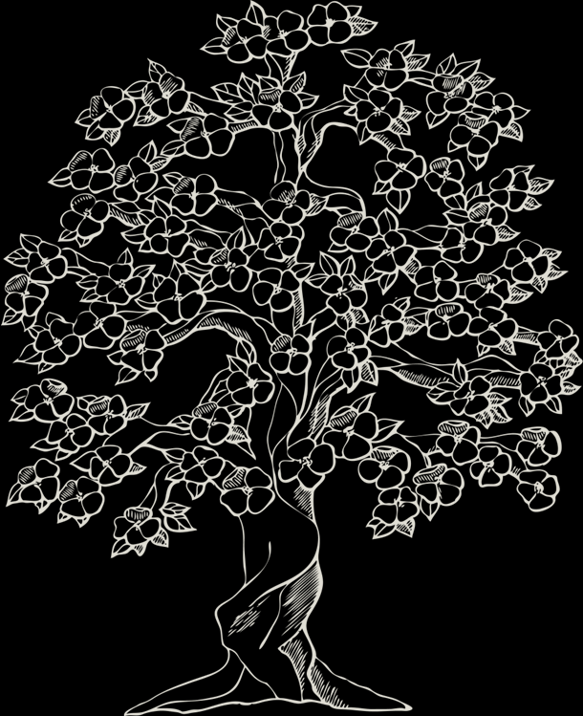**WHEELING AREA GENEALOGICAL SOCIETY**

**MEMBERSHIP APPLICATION**

Membership in the Wheeling Area Genealogical Society is $10.00 per individual for the year from January 1 to December 31. Membership includes the newsletter, *LOOKOUT*, published in March, June, September and December. Back issues of the membership year will be mailed on receipt of dues. Queries .50¢ a surname to no-members, free to members. Meetings are 2nd Saturday of the month at 1:00pm at the Ohio County Public Library, Wheeling WV. There is NO December meeting. Make checks payable to WHEELING AREA GENEALOGICAL SOCIETY, P.O. Box 6450, Wheeling WV 26003-6450

**PLEASE PRINT THE BELOW INFORMATION**

Name: _______________________________________ _____________________________ _____________

Last First Middle

Address: __________________________________________________________________________________

Street

Mailing Address (if different from above): _______________________________________________________

______________________________________________________________________ ____________ _______________________

City State Zip

Home Phone: _(__________)__________________________

Enclosed is my check for $10.00 ___________ Check one: 🞏 NEW 🞏 RENEWAL

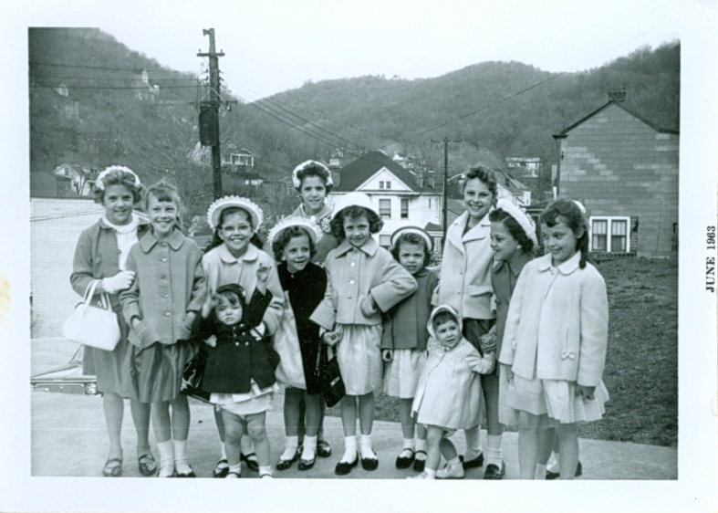

Spring Fashion in 1963