Finding Your Center – Finding Your Front and Rear Roll Center
by Curtis Dietzsch on September 30, 2010
Email
Facebook
Twitter
Print
5 Comments
Understanding the handling characteristics of a car is kind of like putting together a puzzle. At the beginning, there are just a bunch of pieces and it is impossible to see the picture. As the pieces of the puzzle are assembled it starts to become apparent what the picture might be and it becomes easier to see how the rest of the pieces fit together. The picture is not revealed completely until the last piece has been put into place. Unlike the store bought puzzle where all the pieces are included, with vehicle handling, we have to find all the pieces first and then attempt to fit them together if we have any hopes of figuring out what the picture looks like.
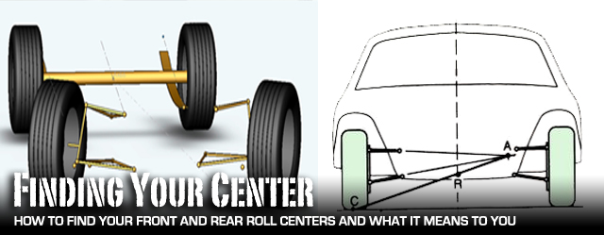Understanding how to find the roll centers at the front and rear of the car and how they affect its handling is one piece of the puzzle. It takes some time and effort but it is important to try to understand how it fits with the rest of the handling puzzle.
What is the Roll Center?
The Society of Automotive Engineers (SAE) defines the roll center as, “the point in the transverse vertical plane through any pair of wheel centers at which lateral forces may be applied to the sprung mass without producing a suspension roll.”
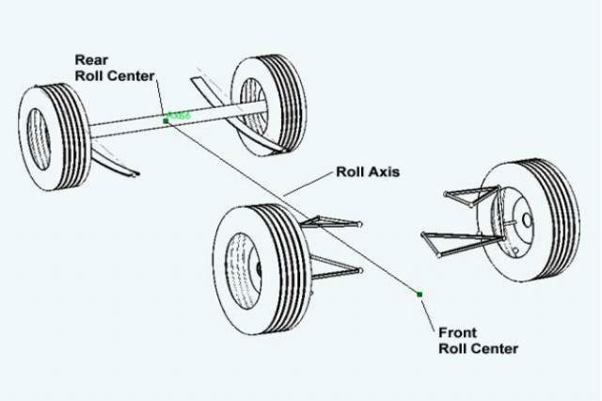
The roll axis is a line that connects the front roll center to the rear roll center. The body of the car (sprung weight) rotates about this axis when it leans during cornering.
The roll center, as its name implies, is the center of rotation for a suspension system. There is a roll center for the front suspension and rear suspension. Depending on the type of suspension, the roll center can be an actual pivot point or a virtual point in space and they don’t necessarily lie along the center line of the vehicle. The front roll center is rarely at the same height as the rear roll center. And as SAE’s definition indicates, if the roll centers of a car are at the same height as the sprung mass’ Center of Gravity (CG), it will not exhibit any body roll during a corner.
If you draw an imaginary line between the front and rear roll center, this line is the roll axis of the car. When the body of a car leans in a corner it pivots about its roll axis.
Why find the Roll Center?
Why would one want to find the roll center of their car? Understanding where a car’s roll centers are located helps in predicting how the car reacts while cornering. It is one of many puzzle pieces that influence the handling characteristics of the car: spring and wheel rates, shock dampening, CG location, track width, wheel base, and many others. Knowing where the roll center is in the front of the car gives an idea of what the wheels will be doing as the nose of the car dives under braking or leans in a corner. Without roll center information, one cannot estimate how much the camber angle of the front wheels will change during suspension travel or how much body roll will be present while cornering.
Roll Center Location
Each suspension configuration has a roll center. The location of the roll center is determined by the position and attachment points of the suspension arms.
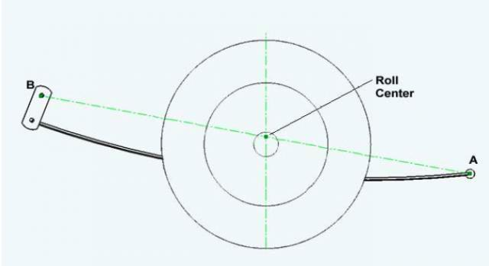
The roll center for a leaf spring suspension is found by drawing a line between the center of the forward attachment point (A) and the center of the upper shackle attachment point (B). Where that line crosses the vertical center line of the axle is the roll center. The roll center height is the vertical distance from the ground to roll center.
Leaf spring rear suspensions are found on many older American cars, including Novas and older Camaros. It is a suspension found commonly in Street Stock and Bomber classes. The roll center for this type of suspension is found by creating a line that connects the center of the front attachment point to the center of the rear attachment point (looking from the side of the car). The roll center is located where this line crosses the vertical center line of the axle and is centered between the rear wheels.
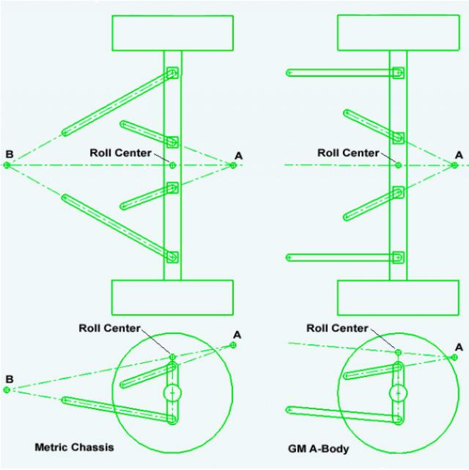
The roll center for a GM metric chassis (shown left) is found by drawing a line between the theoretical intersection of the upper links (A) and the theoretical intersection of the lower links (B). The roll center is located where the line crosses the vertical center line of the axle. The roll center for a GM A-Body (shown right) is found by drawing a line parallel to the lower links through the theoretical intersection of the upper links (A). The roll center is located where the line crosses the vertical center line of the axle.
The four link suspensions found on the GM A-Body and Metric chassis are also common among the ranks of Saturday night racers. The roll center for these styles of suspension can be found by drawing a line between the theoretical intersection of the upper and lower links. The roll center is located where this line crosses the vertical center line of the axle.
The double A-arm independent suspension, also referred to as a wish bone or Short-Long Arm (SLA) suspension is the preferred front suspension used in racing today. It is used at almost every level of racing (the sprint car is one notable exception). It consists of two control arms (A-arms) for each wheel. The control arms typically form the shape on an “A”, hence the name “A-arm”. Each control arm is attached to the chassis at two points and attached at a single point to a steering knuckle. They control the location of the front wheels relative to the body and determine the path of the wheel as it moves up and down through its suspension travel when it encounters a bump, a pot hole, or a turn. The location of the roll center for this type of suspension can vary wildly based on the length and inclination of the A-arms. The first step when finding the location of the roll center for an SLA suspension is to locate something called the instantaneous center.
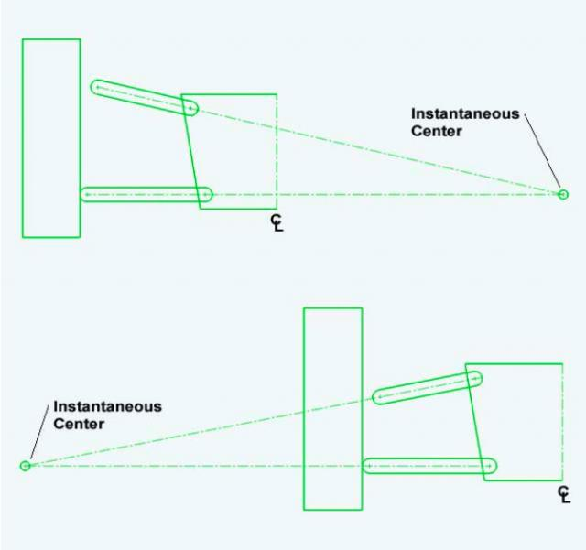
The illustrations above show how the location of the instantaneous center can vary significantly with suspension geometry. The top illustration shows the upper control arm slopping in, toward the center of the car. This places the instantaneous center on the suspension side of the wheel. The bottom illustration shows the upper control arm slopping out toward the tire. This places the instantaneous center on the outside of the wheel. Many older muscle cars have this geometry (pre-1970 Camaros, pre-1973 Chevelles, pre-1975 Novas) and it is not preferred.
Instantaneous Center
Each wheel of an independent suspension has an instantaneous center and it is the point in space that the wheel rotates about as the suspension compresses or rebounds. The wheel can be thought of as being connected to a “virtual swing arm” that pivots about the instantaneous center. The instantaneous center can be located almost anywhere and its location is defined by the geometry of the suspension. The instantaneous center can be located above or below ground and it can be located on either side of the wheel. And it moves. As the car rolls and the suspension compresses the relationship between the suspension arms changes. As this happens the location of the instantaneous center changes too.
The location of the instantaneous center can tell what the wheel does as it moves through it suspension travel. It can tell whether it will gain negative camber (lean in) and if so how quickly. If the instantaneous center is to the inside of the wheel (suspension side) then the wheel will gain negative camber as the suspension compresses (e.g. outside wheel when the body rolls during a corner, both wheels under braking). If the instantaneous center is outside the car (away from the suspension) the tire will have a tendency to tip out as the suspension is compressed (this is not good). The camber changes more slowly with a longer “virtual swing arm” and can change drastically with a shorter one. If the instantaneous center is far above or below ground (e.g. a lifted 4WD truck with independent front suspension) the track width of the vehicle can increase substantially when the suspension encounters a bump.
Having a suspension that gains negative camber as the body of the car rolls is beneficial. It helps keep the tire perpendicular to the ground during cornering which maximizes tire contact with the track.
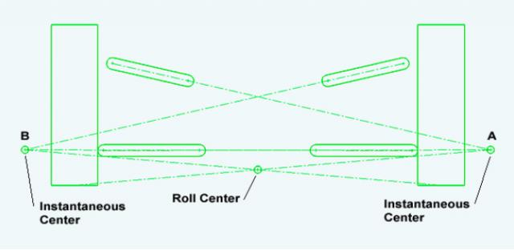
The roll center of an SLA suspension can be found by drawing a line from the center of the contact patch of the left tire to the instantaneous center for the left wheel (A) and a line from the center of the contact patch of the right tire to the instantaneous center for the right wheel (B). The roll center is located where these two lines cross. If the suspension is symmetrical the roll center will be located along the center line of the vehicle. If the suspension is not symmetrical the roll center location can be located to the left or right of center (depending on the geometry).
Front Roll Center Measurements
Finding the roll center at the front and rear of a car requires a lot of simple measurements. Taking some of these measurements is a real pain in the arse, especially with the engine in the car. But with a little effort all the necessary information can be collected.
The location of each attachment point for the suspension needs to be measured as accurately as possible (I attempted to measure within 1/16 of an inch). The height off the ground and the location longitudinally and laterally is needed. For the front suspension this includes the center of the chassis-control arm attachment points and the location of the pivot points for the upper and lower ball joints. The axis of rotation for the control arms and the ball joints is what is of real interest. Also needed is the location of the center of the contact patch for each tire.
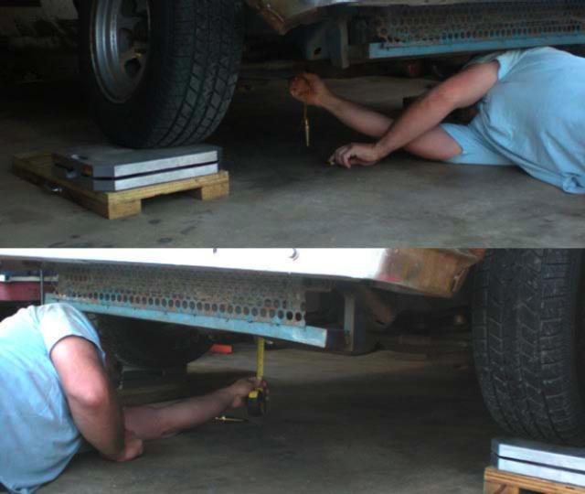
With the car set on blocks the location of each suspension point was marked on the floor using a plumb bob and a grease pencil. The distance from the ground for each point was noted. Don’t forget to subtract the block height from the measurements when inputting the data.
I took all of these measurements with a faux driver in the car and with a full tank of fuel (this is how I scale the car too). My driver consists of a set of cylinder heads and some other pieces of ballast to approximate my 225lb girth in the seat of the car and near the pedals. I set the car on some blocks to give me a little more room to make the measurements. Then I took a plumb bob and started marking locations on the floor and measured the height off the ground. The locations of the lower control arms were easy to get. The rest of the front suspension points were obstructed in some fashion so that I couldn’t make a mark directly on the floor. The upper control arms were blocked by the chassis. The upper ball joints were obstructed by the steering knuckle and lower control arm.
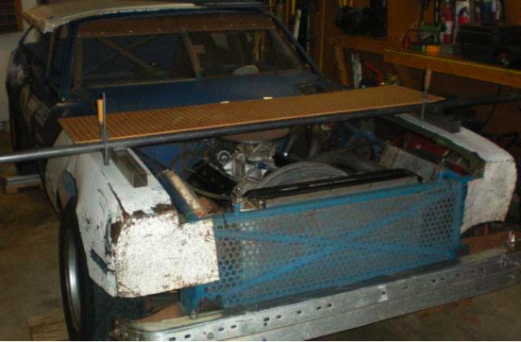
The upper suspension points are impossible to get to from the bottom of the car. I clamped a piece of peg board to a piece of tubing and positioned it over the upper suspension pivot points parallel to the floor.
To get the upper control arm/ball joints measurements, I took a piece of peg board (anything rigid and flat will work) and positioned it parallel to the floor above the control arms. Using the plumb bob, I marked the locations of the ball joints and control arms on the board and noted the vertical distance. I also marked two more spots on the board that had an un-obstructed view of the floor. Using the plumb bob I made corresponding marks on the floor and noted the distance between the board and floor. I did this so I knew the relative position of the points on the board to the points on the floor.
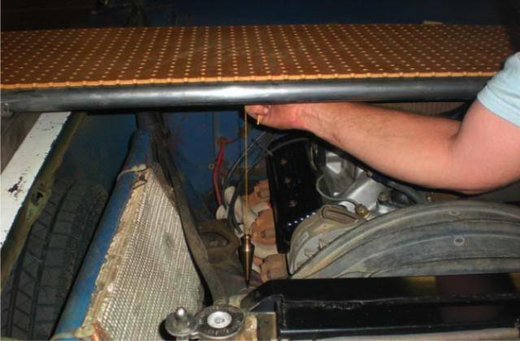
The locations of the upper control arm and ball joint pivot points were marked on the board with the help of the plumb bob.
Rear Roll Center Measurements
All the same measurements were needed for the rear roll center. These measurements were much easier to take. There were fewer locations to measure and none of the points were obstructed so I could mark the locations directly on the floor. Using the plumb bob, I marked the locations of the pick up points for the front and rear of the leaf springs and then marked the location for the center of each rear tire.
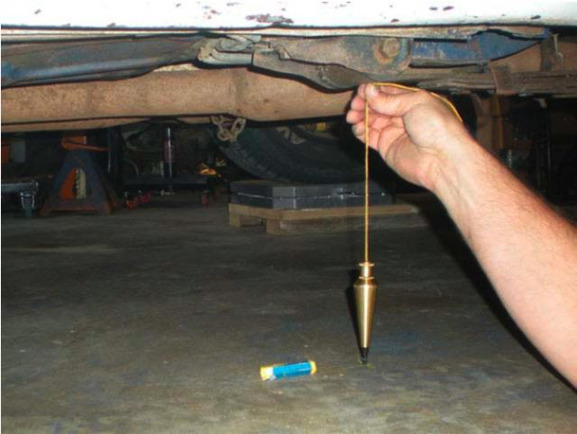
The process of locating and measuring the suspension points had to be repeated at the rear of the car.
GM A-bodies and Metric chassis both have four link rear suspensions. There are a few more suspension points to measure in order to locate the rear roll center for these cars but the process is the same.
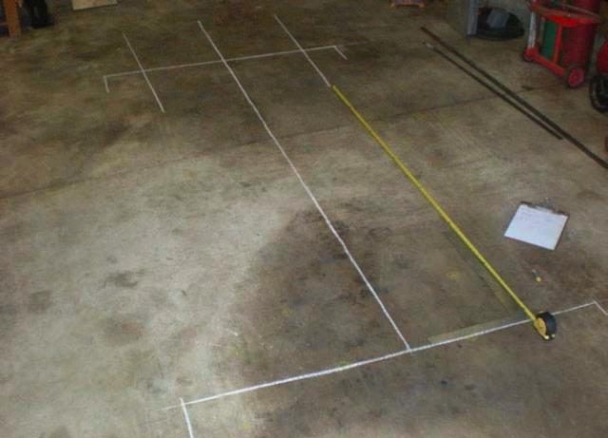
After the car is moved out of the way the plan view of the suspension is revealed. There is a mark on the floor representing the location of each attachment point on the chassis. Unfortunately, they are very difficult to see in the picture. Measurements were taken for each front and rear suspension pick up point.
Once all the appropriate locations had been measured and marked on the floor, it was time to move the car out of the way. I was left with a plan view of all of the suspension points of the car. I drew a couple of axis lines and did a little more measuring to collect the information that was needed. First, a line was drawn through the marks for the center of the front tires. Then, a second line was drawn centered between the two tires, perpendicular to the first line. Where these two lines crossed was my origin. I noted the distance of each suspension point from each of the two lines.
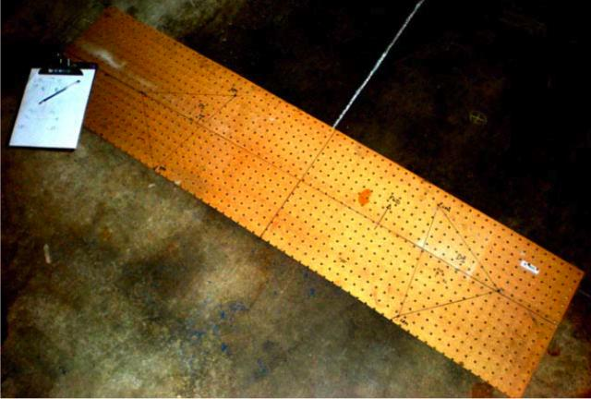
It isn’t pretty, but it contains all the information I needed: the locations for the upper control arms and ball joints with the relative position to the lower suspension.
I was able to transfer the origin point and axes from the floor to the board with the upper suspension locations. This allowed the location of the upper suspension points to be measured relative to the lower suspension points (which is what is needed). The measurements in the longitudinal and lateral directions along with the height above the ground for each of the suspension points gave me enough information to reconstruct the suspension geometry.

Using the measurements
Once armed with all the measurements there are several options:
1. The first option is to do it the old fashioned way with paper models. I first saw this technique in a book called “Tune to Win” by Carroll Smith. This is how I did it in college when I didn’t have access to any other options and it was very helpful. Models of the control arms, tires and suspension attachment points are cut from paper in quarter scale using the measurements that were taken, and then assembled on top of a back drop. Once all the pieces have been traced and cut out they can be tacked together. The paper suspension can be moved around and modified to see how it works.
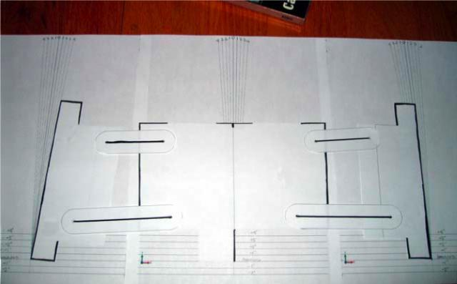
Low tech suspension analysis at its best. If there are no other options this will allow some rudimentary analysis of the suspension. I have used it and it is helpful but nowadays I would choose another option.
2. The second option is to purchase suspension software. There are a ton of programs out there ranging in price from $79 to over $300. The information is input into the program and it will calculate the instantaneous/roll center and can show how it moves as the car deals with lateral forces. I have never used one of these programs and don’t know how user-friendly they are or exactly what information can be extracted from them. If you are interested in finding your roll centers this seems a lot more useful than the paper models, especially for as little as $79.
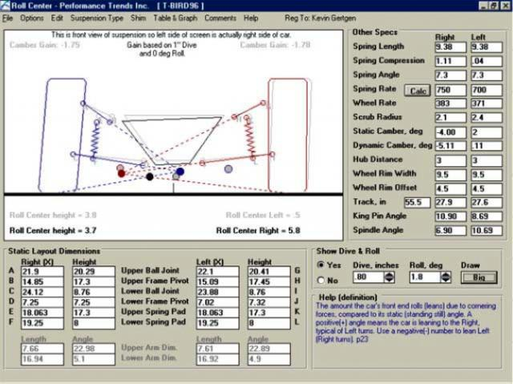
Here is a screen shot from a suspension analysis software from Performance Trends. I have never used the software but wanted to show an example of what to expect. This software is $80.
3. The third option is to put the information into CAD software. Typically, CAD software isn’t cheap but there are some open source (free) CAD packages that are relatively powerful. The down side is that the information has to be input manually. The CAD software doesn’t just spit out the answer. You have to understand what information you want and get it yourself. The advantage (as I see it) of using a CAD package is all the information that has been collected on the garage floor can be used to determine many other things about my car. I can measure the alignment (caster, camber, toe), the camber curve, caster gain during suspension travel, anti-squat, and anti-dive on my car if I am willing to spend the time (the suspension software may be able to do this as well). Since I have access to a 3D CAD package, I input the information gathered into the system to determine the roll centers at the front and rear of my car.
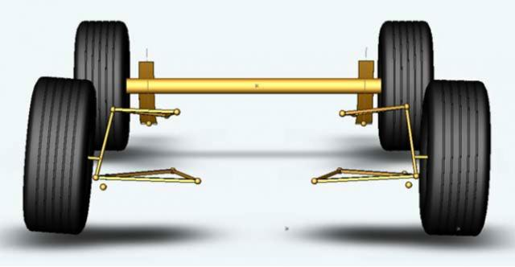
This is a simple representation of my car’s suspension geometry. It took me several hours to input all the information and create the 3D models. I can make adjustments to arm length and attachment points to see what affect they have on the suspension. I can turn the wheels and make the body roll. If I didn’t have access to CAD software, I would have ponied up for suspension analysis software.
My Roll Centers
The upper and lower control arms are nearly parallel to each other on my car’s front suspension. This positions the instantaneous centers very far from the wheels and creates virtual swing arms that are very long. The virtual swing arm lengths are approximately 182” for the LF wheel and approximately 229” for the RF wheel. This results in a front roll center that is very low to the ground. In my case it is a 1/4” above the ground. My front suspension is not quite symmetrical and this shifted the roll center approximately 19” to the left (toward the driver side) of the vehicle center line.
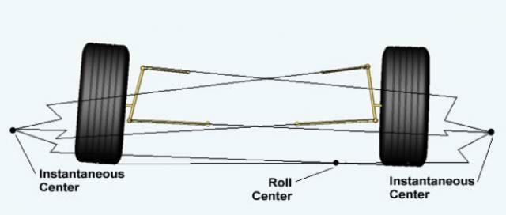
This illustration shows the location of the front roll center on my car (looking from the front of the car). It is located 1/4” off of the ground and 19” to the left of vehicle center line (toward the driver side).
The long virtual swing arm for the RF wheel indicates that as my car rolls in the corner the RF wheel will roll with it. In my case the RF wheel will gain only 1/4° of negative camber per inch of wheel travel. This means if I want the RF tire to remain perpendicular to the track while cornering I better adjust the alignment so the RF wheel has enough static negative camber to offset the body roll.
Finding the location of the rear roll center was a much easier task than finding the front. There were fewer points to measure and only one line to draw. The roll center is centered between the two rear tires, which is essentially along the center line of the chassis. It is 12.55″ above the ground, which in my case is almost at the center of the axle tubing.
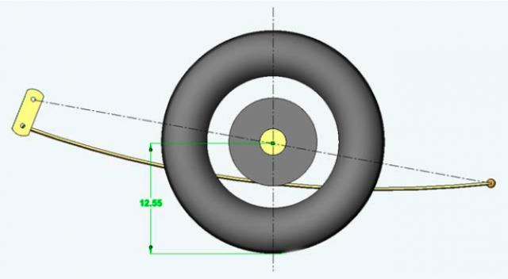
The rear roll center of my car is located 12.55 inches above the ground, centered between the rear wheels.
How to adjust the Roll Center
Adjusting the roll center location of an SLA front suspension is almost unlimited if the A-arm lengths and attachment point locations can be modified. This is not allowed in the Street Stock class I run in. Therefore, making adjustments to the roll center location is very limited. Increasing/decreasing the ride height of the car will move the roll center up or down slightly. This can be done by using spring spacers between the spring and spring bucket.
AFCO (and probably other manufacturers) makes an upper and lower ball joint with an extended stud. The use of these ball joints changes the inclination of the upper and lower control arm slightly which in turn shortens the “virtual swing arm” and will raise the roll center of the front suspension to some degree. Unfortunately, this ball joint is not available for my Nova (at least not to my knowledge).
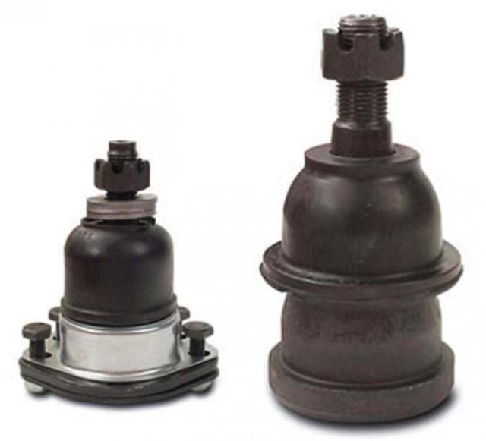
AFCO offers extended stud ball joints to raise the front roll center.
Just like the SLA front suspension the roll center location for the four-link suspensions found in the GM A-Body and Metric Chassis are very adjustable. It requires changing the inclination and lengths of the links. Typically this requires changing the attachment points of the suspension links. These kinds of modification are not allowed in the Street Stock class which therefore makes roll center adjustments very limited.
The roll center at the rear of the car with a leaf spring suspension is not quite as adjustable, even if the rules allow. Again, increasing/decreasing the ride height of the car will move the roll center up/down. This can be done by adjusting the thickness of the lowering blocks between the axle housing and leaf spring. However, the CG of the car will move up or down with the roll center (this is true for the front and the rear of the car). Unless some of the weight in the car is relocated to compensate, the distance between the roll center and CG will remain unchanged (for the most part).
What’s this Boil Down to?
Unfortunately, there isn’t much that can be done to relocate the roll centers while staying within the Street Stock rules at the tracks I run. However, understanding where the roll centers are is still advantageous. On these race cars, this is the first step in understanding how the wheels will react to a bump or hard cornering. Roll centers helps determine how to set the static camber on the front wheels. Estimating and making corrections for how much the body roll or how load is transferred in a corner, we need to know the location of the front and rear roll centers. Knowing the location of the roll centers is an important piece of the puzzle that we need in order to really understand the handling of our race cars on the track.
Spending the time to find your roll centers, and understanding how roll center is affected by things like ride height, is critical in making chassis setup decisions that allow your car to go faster through the corners. Find your roll center and you’re on your way to finding yourself in the center of victory circle.

