Catnip Mouse Pattern

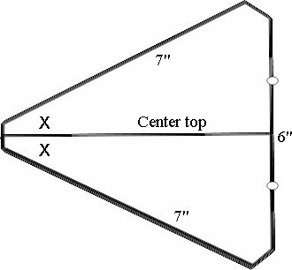

© 2004 Northwest Wings of Love

